|  |  |
| --- | --- |
|  | **Qatar University**  **College of Engineering**  **Department of Computer Science and Engineering** |

Senior Project Report



**SMART PARKING RESERVATION SYSTEM (SPRS)**

**Project Group Members:**

Ameer Mraiza (201204547)

Yousef Tarek Attata (20130829)

Abdelaziz Ibrahim Issa (201201070)

Mostafa Mohamed Hasanein (201204717)

**Supervisor**: Dr. Osama Shata

**2017**

This project report is submitted to the Department of Computer Science and Engineering of Qatar University in partial fulfillment of the requirements of the Senior Project course.

# Declaration

This report has not been submitted for any other degree at this or any other University. It is solely the work of us except where cited in the text or the Acknowledgements page. It describes work carried out by us for the capstone design project. We are aware of the university’s policy on plagiarism and the associated penalties and we declare that this report is the product of our own work.

Student: Abdelaziz Issa Date: 26/5/2017

Signature:

Student: Yousef Attata Date: 26/5/2017

Signature:

Student: Ameer Mraiza Date: 26/5/2017

Signature:

Student: Mustafa Mohammed Date: 26/5/2017

Signature:

# Abstract

The Smart parking reservation system is a project which combines the two aspects of computer engineering and computer science in terms of design and implementation. The main aim of this project is to save time for customers searching for a parking slot at malls and other busy places which offer private parking services. We plan to design a parking reservation software where users can reserve a parking slot in a section while they are at home, they use the app to reserve in a parking section then they receive a code which they will use in order to access the parking facility.

A normal scenario for the system would be that a user approaches the entrance gate where a keypad is provided to take user’s input for the users who already reserved a parking slot using the application. This option will ask the user to enter the passcode which was provided to the user by the application when the reservation was made. Once the code is approved, the gate will open, and the user will be guided to the empty parking slots by looking to the green and red LED’s that placed on the ground which indicate empty or free slots. Moreover, every parking section has a keypad which takes a passcode as input in order to let the user in. Once the user enters his passcode, the section gate opens, and the user can park in any of the empty slots in that section.

# Acknowledgment

We express thanks to Allah for giving us the patience and strength to complete our interim part of this senior project. We would like to express our deepest gratefulness to Dr.Osama shata for providing us the possibility to complete this report and followed us step by step. In additional to the effort that he made with us by providing meetings every week, we cannot forget his advice that helped, motivated and encouraged us to coordinate and write this project till the end.

Table of Contents

Declaration 2

Abstract 3

Acknowledgment 3

List of Figures 6

List of tables 8

1. Introduction and Motivation 9

1.1. Problem statement 9

1.2. Project significance 9

1.3. Project objectives 10

2. Background and related work 10

2.1. Background 10

2.2. Related work 11

2.2.1. Smart parking reservation system using SMS 11

2.2.2. Smart Parking Solutions Inc 12

2.2.3. Parking Monitoring Control System 14

2.2.4. Smart Car Parking System Based on IoT Concept 15

2.2.5. automatic car parking system 16

3. Requirements analysis 18

3.1. Functional requirements 18

3.1.1 Use case diagram 19

3.2. Design constraints 21

3.3. Non-functional requirements 22

3.4. Design standards 24

3.5. Professional Code of Ethics 25

3.4 Assumptions 26

4. Proposed solution 26

4.1 Solution overview 26

4.2. High level architecture 27

4.3. Possible Solutions and tradeoffs 29

4.4 Selected solution 31

4.5. Hardware/software to be used 33

4.5.1. Hardware to be used 33

4.5.2. Software to be used 36

4.6 Hardware design 37

4.7 Structural model 45

4.8. Behavioral model 46

4.8.1 Sequence Diagrams and activity of Cancel reservation 46

4.8.2 Sequence Diagrams and activity of Change password 48

4.8.3 Sequence Diagrams and activity of check in section 50

4.8.4 Sequence Diagrams and activity of checkout 52

4.8.5 Sequence Diagrams and activity of Create account 54

4.8.6 Sequence Diagrams and activity of Reserve parking 56

4.8.7 Sequence Diagrams and activity of take me there 58

4.8.8 Sequence Diagrams and activity of View profile 60

4.8.9 state diagram of login and reserve parking 62

4.9 Database design 63

4.10 user interface design 67

4.11 Design pattern 75

5. Implementation 76

5.1 Tools and Framework 76

5.2 Novelty in implementation 82

5.3 Implementation Difficulties 83

5.4 Actual images of various modules 89

5.5 Actual Design description with pictures and diagrams 92

6. Testing 93

6.1 Black box testing 93

6.2 Performance testing 104

6.2 Hardware components testing 106

6.2.1 ultrasonic sensor hc-sr04 testing 106

6.2.2 4×4 matrix keypad testing 107

6.2.3 Servo motor testing 107

6.2.4 16x2 LCD display using I2C testing 108

6.3 normal senario testing 109

7. Evaluation of the impact of the engineered solution 119

8. Project plan 120

8.1. Project milestones 120

8.2 Project timeline 121

8.3. Anticipated risks 122

9. Conclusion 124

9. Student reflections 126

9.1. Yousef’s reflection 126

9.2. Abdelaziz’s reflection 127

9.3. Ameer’s reflection 127

9.4. Mostafa’s reflection 128

References 129

Appendix 130

1.Use case specification: 130

2.Test cases. 158

# List of Figures

Figure 1:Smart parking reservation system using SMS ARC 12

Figure 2: Smart Parking Solutions Inc 13

Figure 3: Parking Monitoring Control System 14

Figure 4: Smart Car Parking System Based on IoT Concept 15

Figure 5: Automatic car parking system architecture 16

Figure 6 : Use case Diagram 19

Figure 7: High level architecture 1 27

Figure 8: High level architecture 2 28

Figure 9: Waterfall model 32

Figure 10 :NodeMCU model ESP8266 33

Figure 11 :ULTRASONIC SENSOR - HC-SR04 33

Figure 12 : MINI SERVO - POSITIONAL ROTATION 33

Figure 13: CLEAR RGB COMMON CATHODE LEDS 34

Figure 14 :16 KEY KEYPADS 34

Figure 15 :16X2 SERIAL LCD MODULE 34

Figure 16 :FULL-SIZE BREADBOARD and JUMPER WIRES 34

Figure 17 :WALL ADAPTER POWER SUPPLY - 5V DC 3A (BARREL JACK 35

Figure 18 : Arduino mega 35

Figure 19: NodeJS logo 36

Figure 20: WebStorm logo 36

Figure 21: Android Studio logo 36

Figure 22: stripe logo 36

Figure 23: Digital Ocean logo 36

*Figure 24: NodeMCU* 37

Figure 25 : Connectivity diagram of the barrier module (Breadboard view) 38

Figure 26 Schematic diagram of the barrier module 39

Figure 27 Connectivity diagram of Parking indicators module 40

Figure 28 Schematic diagram of Parking indicators module 41

Figure 29 Connectivity diagram of user authentication module 42

Figure 30 Schematic diagram of user authentication module 43

Figure 31 : Arduino mega 44

Figure 32 Reservation schema 63

Figure 33 Mall schema 64

Figure 34 User schema: 65

Figure 35 Payment schema 66

Figure 36 Login activity 67

Figure 37 sign up activity 68

Figure 38 Main menu fragment 69

Figure 39 sections fragment 70

Figure 40 Settings fragment 71

Figure 41 reservation history details 72

Figure 42 reservation history 72

Figure 43 reservation fragment 72

Figure 44 mall’s login page 73

Figure 45 mall's main page 74

Figure 46 side view of design model 86

Figure 47 : top view of the model 86

Figure 48 : customer trying to enter the parking 87

Figure 49 : Actual image of user authentication module 89

Figure 50 actual image of barrier module when an object placed over the sensor. 90

Figure 51 actual image of barrier module when an object not placed over the sensor. 90

Figure 52 actual image of parking availability indicators module (Empty parking) 91

Figure 53 Figure 54 actual image of parking availability indicators (reserved parking) 91

Figure 55 : wiring diagram of the whole hardware design 92

Figure 56 Response time graph 105

Figure 57 : Ultrasonic testing serial printer 106

Figure 58 keypad 107

Figure 59 keypad testing using serial printer 107

Figure 60 :servo motor 107

Figure 61 actual image of lcd testing 108

Figure 62 LCD scanner 108

Figure 63: mall’s stripe account 116

Figure 64 :gantt chart 121

# List of tables

Table 1: Related work comparison 17

Table 2: use case description 20

Table 3. Technical design constraints 21

Table 4. Practical design constraints 21

Table 5: possible Solution No.1 29

Table 6 :possible Solution No.2 29

Table 7 : possible Solution No.3 29

Table 8: possible Solution Comparison 30

Table 9 :Hardware to be used table 33

Table 10 : Software to be used Table 36

Table 11 hardware frameworks 82

Table 12 challenges 87

Table 13 Black box testing 92

Table 14 Summary table 103

Table 15 :7. Evaluation of the impact of the engineered solution 118

Table 16 Project milestones 119

Table 17: Anticipated risks 121

Table 18: risk levels 121

Table 19 : Anticipated risks 122

# Introduction and Motivation

## Problem statement

Most people waste a lot of time trying to find a parking slot in private parking services, it can get very frustrating especially on weekends which makes the outing a bad experience. According to a questionnaire we made, the average time for people to find a parking slot on weekends in malls such as Villaggio and city center is about thirty minutes. Moreover, the problem is not only when they enter the parking, it’s when they try to exit the facility as well. The aim of our system is to fix the traffic issues in such facilities. We try to enhance the experience for the visitors where we try to make the parking time does not exceed ten minutes. Our vision is to divide all parking’s in the chosen facility into sections and allow the users to reserve a parking slot in a section before reaching the facility.

In our system, parking slots in the facility will be divided into sections, for example each section will take up to thirty parking slots. Each section will have a gate where the gate only opens if the user enters the correct reservation code. Users will reserve a parking slot in their desired section. Using this method, we know that each visitor will know exactly where to go, and they will not waste their time driving around the facility looking for a parking and causing traffic for no reason. Furthermore, we will be able to tackle the traffic issues inside parking facilities and minimize the average time to find a parking.

## Project significance

The importance of this project will be mainly about saving time for people who care about reaching their destination on time without stressing about of how much time they are going to waste searching for parking spot. This project will bring a great value to all mall visitors and will make their experience much better and more memorable. The outcomes of the project will have great value if done perfectly, it will solve many issues that has not been addressed before. Improving the visitors experience will have many positive effects, malls that use our system will have a better reputation and the number of visitors will increase.

The project that we designed will solve the Irregular traffic in the parking facilities. The impact of not having a solution to the problem would be the unnecessary stress and time wasting of the visitors, because it always takes a long time for users to find an empty parking spot especially in times when traffic is congested in the parking area.

The idea of the project can also benefit the stakeholders. In other words, owners of shops and companies and all facilities that contain parking service will use this project as an income source, for example, pricing the service of pre-reservation. Moreover, Qatar has many facilities that has car parking services, nonetheless, with great services comes great problems and because Qatar has population inflation mainly in the city where all the malls, companies and facilities with car parking services exist. Our project will help in reducing the problem of the irregular traffic in the private parking in the region.

Hithim AL-kabanie post on Al Raya newspaper (is a trusted source) cite the significance of the problem our project which we are trying to address by mentioning the parking crisis at Qatar university which states that “students in Qatar university face a great challenge to find a parking spot and make it in time to attend their lectures”. This is another area where our project can help, student don’t find parking spots, not because of the limitation of parking area, but because of their inadvertently ignorance of empty spots. Our system will indicate the empty spaces for the users, so that they can park immediately without spending time on searching. We want to do this project because we as students and members of the community face this problem at daily basis and we know how much time it takes to find a parking space.

## Project objectives

* Save people's time and stress levels.
* Increase reputation of malls and other facilities
* Enhancing the user’s experience
* Eliminate parking crisis
* Developing a fully functional system

# Background and related work

## Background

People tend to go out to malls, they go for different reasons, whether to buy household items, go out for fun and so on. Here in Qatar, malls tend to be very busy which means a lot of parking traffic occurs, people can spend a lot of time just to find a parking slot and as much time to exit the facility. Most people visit the malls to have a good time, their only fear is when it comes to finding a parking. We made our system to fix irregular traffic issues in private parking facilities and our main target is malls. The major concept of smart reservation parking system is using technology to benefit people whenever they want to park their car. The system will resolve the issue related to the ability of reserving a parking at a specific time. Because no one can deny the need of a system that could insure an empty parking space in the right time and in the right place, our reservation system helps the client to reserve a parking slot by using our android application.

## Related work

### Smart parking reservation system using SMS

Undoubtedly, waiting for a parking during the weekends it causes traffic jam which waste your time. As a result, some smart systems have popped up to make our life easier one of them is the smart reservation parking system. So, this part will discuss the differences and similarities between a related work and our system. One of the systems that we are going to compare with is “Smart parking reservation system using SMS “. According to J.Prasad, G.Vishnu , R.Mohan and S.Sunny The user books the parking spot though SMS massage then GSM modem will get the message and in turn it will send it to the AVR microcontroller using USART communication, the microcontroller process the requested data and check the available spot using the IR sensor.

There are several similarities between our application and the SMS reservation parking. For example, both systems are trying to find a realistic solution to be applied such as we have a very limited number of parkings and we can take advantage out of this by organizing the time for each customer, so the parking might be unavailable currently, but the user will know that this parking will be free after few hours. Not to mention that both applications are friendly used. On the other hand, there are some differences Starting from they are using SMS confirmation message that may cost the user extra charge, on the telecommunications services provider, our code notification is totally free and generated automatically as soon as you register. Also, they are not using any server since they are using a GSM instead. on the other hand they are using different micro controller that does not support WIFI, while we are using WIFI connection in our system which will simplify the connection more and enhance the system because through the WIFI connection you can control the node mcd more easier.

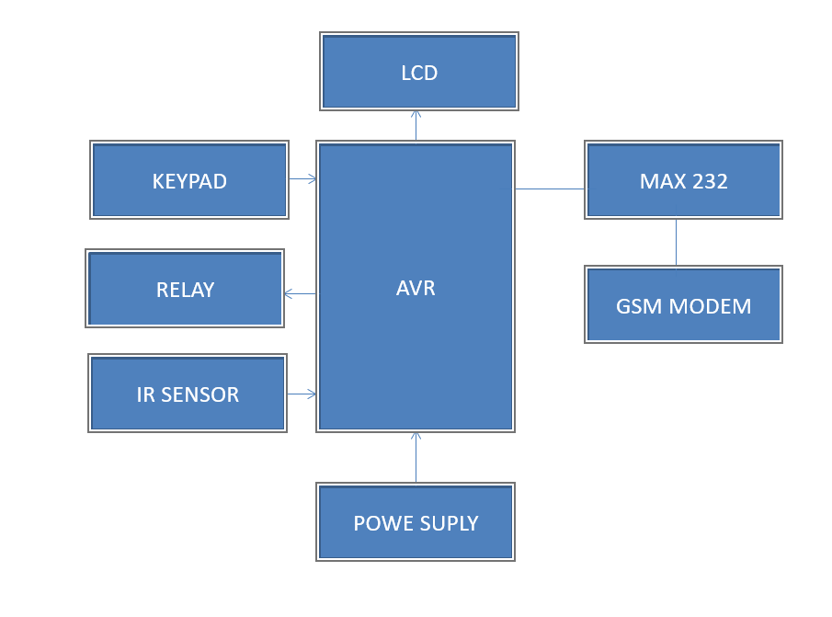

Figure 1:Smart parking reservation system using SMS ARC

### Smart Parking Solutions Inc

The problem that we intend to solve is a global problem, means many advance civilizations are constantly working to find a smart solution for the parking issue. In result many companies and associations work on the same related problem. Smart Parking Solutions Inc is a company which puts its effort to find a smart solution to the challenge of limited parking space. Their idea focused on solving the problem of spaces to increase the capacity and serve more customers by providing robotic parking automated systems. The system allows you to park up to 16 cars conveniently in the space of two with fully automated parking systems that are fully secured and environment friendly. Regardless of the differences in terms of applied method, our idea and the automated parking systems are similar in principle, both focused on solving a similar problem of time lost for users while searching on an empty parking space (the user always knows where to park). The focus of the automated systems is to minimalize the parking spots by using vertical spaces. The way it works is when a user enters his/her car to the base spot then a chain of robotic elevator carries the car to the upper level to let the base spot empty to the next car. This prosses will be repeated each time a car wants to use the system and each time a car moves up and so on, till the robotic elevator is completed filled.

On the other hand, our system consists less mechanical and robotic components, but it includes more algorithms and smart logic to minimize the cost and to work more efficiently. Our system will never provide an extra parking spaces as the automated parking system. However, it will find you an empty space in a section without searching and without complicated costly solution, because we believe that the problem of parking congestion is not limited by increase the capacity of parking spots only, but how it organized. Our system also featured with the reservation feature which allow you to ensure an empty spot in section anytime and anywhere based on customer's desire. If you own a parking lot and want to take advantage of your valuable space to increase your capacity and serve more customers, then Smart Parking is for you. Rather the build multiple stories or spend search for new real estate, Smart Parking is a lean, mobile, flexible and highly scalable solution that lets parking lot owners and operators increase their capacity quickly, at relatively modest cost, and with minimal disruption. Smart Parking has become a widely-deployed mechanized parking solution across Europe and Asia. Smart Parking is powered by software that makes it easy for your operators to use at little risk and with little training. Take advantage of modern technology to increase your capacity, gain new customers and grow your parking business.

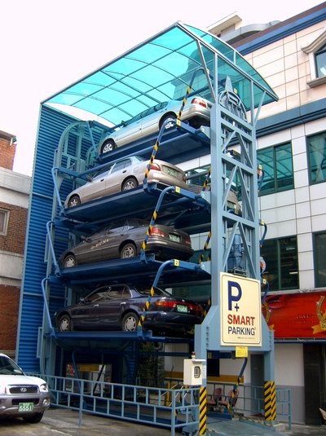

Figure 2: Smart Parking Solutions Inc

### Parking Monitoring Control System

In this project presented by M. Al-Hashmi, A. Al Misbah and M. Al-Qurain (2012), they presented a low-cost and less power consuming smart parking that uses sensors connected to Microchip Arduino mega 2560 that uses them to get information then sends output to LED matrix and database. The user will be given RFID tag to permit them going from the entryway. The system database will show information about the car plate number in and utilize C# as logging Data for security in a database. In our project, the user will get a code which is atomically generated as a notification as soon as the user reserves a parking through the application, which in turn will avoid the user to have a RFID tag with him all the time that’s is possible can be easily lost or damaged. Thus, this will obviate us from using additional components such as RFID Reader which Will simplify the system more.

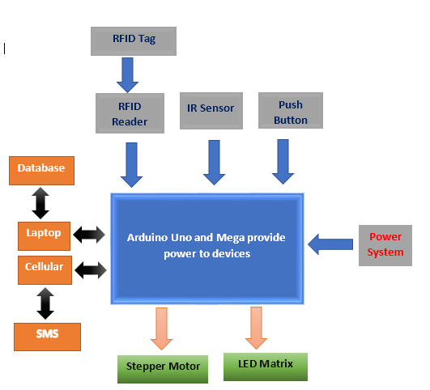

Figure 3: Parking Monitoring Control System

### Smart Car Parking System Based on IoT Concept

In this paper presented by V. Ichake, P. Shitole. and M. Momin (2015), introduces the fundamental idea of utilizing cloud-based smart parking as a great application of the Internet of Things (IoT), the user can access the cloud through a webpage or mobile app which can be used to look for the empty parking slots.

This system contains an Arduino as the main processing unit which gets inputs data from an IR manage the client to know the unfilled parking slot, then uses temperature sensor   
Which in turn alerts to a difference in temperature which is not much different from LDR that sends an alert when the darkness increases. According to the data obtained from these sensors the microcontroller will be updated in such a way that if any of the sensors detect the vehicle directly will send the corresponding output to the cloud.

The HTML page changes to green if there is a free parking slot. On the contrary, the page will turn red if all the parking slots are full. In our project, we will use a Node MCU chip which connected to our server using WIFI for faster connectivity, unlike them they used Arduino which doesn’t support WIFI, in addition to that our project facilitates the user to deal through an android application and easily reserve a parking slot.

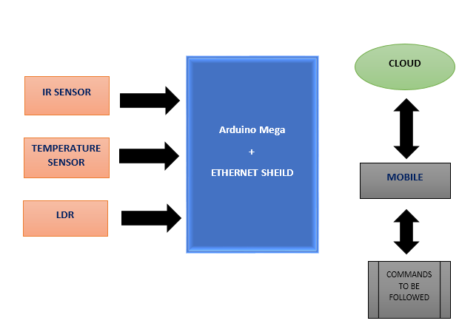

Figure 4: Smart Car Parking System Based on IoT Concept

### automatic car parking system

In this project presented by P. Sohil we can find that it is not much different than our project in terms of the concept and objectives. Except for the concept of reservation which including building software for mobile and web while automatic car parking system aim to atomize the car park in term of size. In terms of Hardware Implementation, we both have LCD to indicate the total number of cars that can be parked on the free space. They used AT89s52 processor to interface between hex keypad, LCD display and serial to parallel converter with parking slot while we used NodeMCU model to establish the connection between the smart parking application (app & web) to control the hardware components. Our project used MINI SERVO - POSITIONAL ROTATION to open or close the section and the main gate on the other hand they used Stepper motor to perform the mechanical operation to left barrier the in term of software they used Keil u-Vision which is a software development tools for 8051 based microcontrollers. One of its features is generate embedded applications for virtually every 8051 derivatives. In our case we used Android Studio which is the official IDE for Android development, and we are going to use it to develop a mobile application for the parking reservation system.

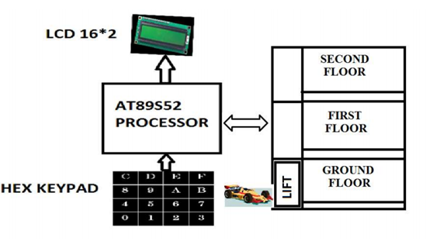

Figure 5: Automatic car parking system architecture

Table 1: Related work comparison

In this section we are comparing the hardware components and connection type.

|  |  |  |  |
| --- | --- | --- | --- |
| **Project Name** | **Microcontroller** | **Sensors / Actuators** | **Type of connection** |
| (SPRS)  Our’s | NodeMCU model ESP8266 | * Ultrasonic * Servo Motor * Keypad * LCD * RGB LED | Wi-Fi 2.4 GHz, support WPA/WPA2 |
| Smart Parking Solutions Inc | Mbed | Load sensor | None |
| Parking Monitoring Control System | Microchip Arduino mega 2560 | * IR * RFID Reader * LED Matrix * Stepper motor | SMS |
| Smart Car Parking System Based on IoT Concept | Arduino Uno | * IR * LDR * Temperature | web site |
| Smart parking reservation system using SMS | ATmega32 | * IR | SMS, GSM |
| Automatic car parking system | AT89s52 | * IR * Hex keypad * LCD | None |

# Requirements analysis

## Functional requirements

* The signal is sent from the sensors to the micro controller to operate tasks such as: turning the motor 90 degrees if the input indicated opening the gate. Moreover, If the ultrasonic sensor detects that a parking spot is free, it will send a signal to Arduino mega microcontroller which is programed to turn LEDS to red.
* work-flows performed by the system consists of sequence of processes through which a piece of work passes from initiation to completion of the parking reservation system. It starts when the system registers the user’s information and store it as a new client in the database or update registered user’s information. Then the system updates the status of the parking slot from “free” to “reserved" in case of a reservation operation. The system sends a code to authenticate the user.
* The main users to the system is any car driver who intends to reserve a parking slot in section in a specific time.

### 3.1.1 Use case diagram

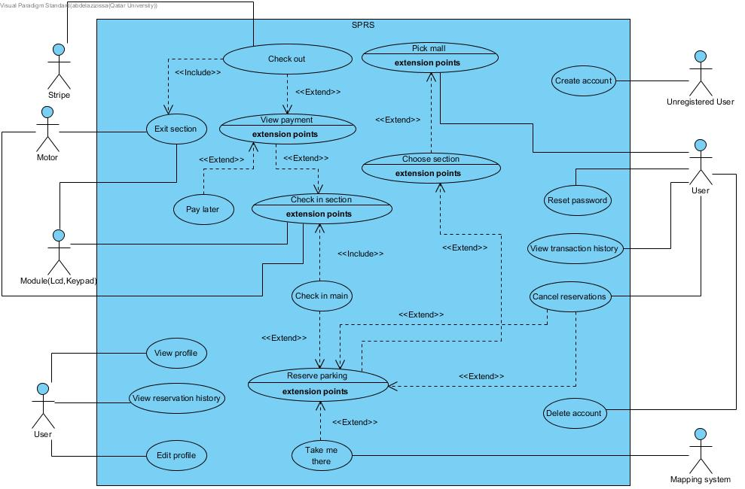

Figure 6 : Use case Diagram

Table 2: use case description

|  |  |
| --- | --- |
| **Use case** | **Brief description** |
| **Create account** | Unregistered users want to register in the system, they enter needed information to successfully create a new account. |
| **Change password** | User wants to change his current password to a new one. |
| **Cancel reservation** | If the user reserved a parking but does not need it any more, he can cancel his reservation. |
| **Reserve parking** | User wants to reserve a parking space in the chosen mall. |
| **View profile** | User wants to see his account information. |
| **Edit profile** | User wants to edit some of his information in his profile. |
| **View transaction history** | User wants to view all transactions he made. |
| **Choose section** | User wants to choose a section in chosen mall. |
| **Pick a mall** | User wants to choose a mall from the mall’s list. |
| **Check out** | User want to pay so that he can check out. |
| **View reservation history** | User wants to view all his previous reservations. |
| **View Payment** | User wants to see how much he needs to pay |
| **Delete account** | User want to delete his account. |
| **Take me there** | User want directions to the mall. |
| **Pay later** | User viewed his payment but decides to pay later. |
| **Check in main** | User reaches the main gate and would like to check in. |
| **Check in section** | User reaches the section gate and would like to check in. |
| **Exit section** | User exits section successfully. |

## Design constraints

Table 3. Technical design constraints

|  |  |
| --- | --- |
| **Name** | **Description** |
| Mobility | This system provides a platform where it can be accessed using an Android application for cell phones. |
| Modifiable | If the facility decides to add more parking slots in addition to the existing ones, the system should be able to handle such situation |
| Response Time | Server should respond once the user enters a pin code and checks the input and gives the result in duration of 2 seconds. |
| Security | All user’s data must be encoded and hashed. No access of any kind to user’s data by the system or other actors. |
| Scalability | The system should handle the growth of network traffic by using a good enough webserver and by using asynchronous processing at the back end. |

Table 4. Practical design constraints

|  |  |  |
| --- | --- | --- |
| **Type** | **Name** | **Description** |
| Economics | cost | The cost of full working prototype should be less than 500 QR |
| Social | Usability | The application and the website should be clear and simple to the user with minimal software knowledge. |
| Social | Customer appeal | The mobile application and website should be neat and well presented to the user. |
| Sustainability | Maintenance | All components should be replaceable and easily installed and removed and we can achieve this because each module will be independent from the other. |
| Health & Safety | Safety | Insure that a barrier should not close while a car is passing |

## Non-functional requirements

1. **interoperability:**

Our application will support all phones that use android, now our application won’t be supporting iOS devices. Moreover, we will be developing a website so if the user owns a PC and is able to use a web browser, he will be able to use our system.

1. **Security:**

We have sensitive information about the users for example user’s passwords, Data security will be play a big role in this project. First, we are going to use secure socket layer to make sure the data reaches the server and back to the app safely and that they are encrypted so that we avoid malicious users. Moreover, credit card information will not be saved on the system since it can be dangerous to store such information. Users will use the Stipe’s api to pay directly by entering their information. We are going to apply salt and hash for the user’s password, to summarize, these are the steps we are going to take in terms of security:

* 1. Use secure socket layer
  2. Apply salt and hash for passwords
  3. Avoid saving credit card information.
  4. Minimize the chance of other users guessing pin codes that do not belong to them and others stealing existing pin codes. (unauthorized users)
  5. Adding a limit to amount of times the user can cancel their reservation (avoid wasting mall’s resources by banning users)
  6. Users are only capable of reservation one parking space at a time
  7. Avoid users from leaving the facility without paying the actual amount that they need to pay.

1. **Availability:**

The server should be up 24 hours a day. Users will be notified if some maintenance is needed to be done. We achieve this by purchasing a good quality webserver through trusted providers.

1. **Performance:**

Since the whole idea of our project is about saving time, we need to make sure that all functionalities work as quickly as possible. There are a couple of steps that we need to make sure we achieve:

* 1. Visitors should be able to register successfully within 2 seconds.
  2. Viewing all the mall for the first time should not take longer than 2 seconds.
  3. Viewing all available parking slots to the user within a mall for the first time should take less than 2 seconds.
  4. The time needed to Checkout of the mall or the facility will depend on the api used by the user, for example, stripe should take less than 4 seconds
  5. Viewing transactions made, and user’s information should not take longer than 2 seconds
  6. Updating any profile information can take up to 2 seconds.
  7. Reservation creation should take less than 2 seconds.
  8. Deleting an account should take less than 2 seconds
  9. Data changes that displayed to user should be real time (malls information, sections information)
  10. Cancelling a reservation should take less than 2 seconds.

## Design standards

1. **Wireless Standards 802.11b/g/n.**
   1. **802.11b**

IEEE extend to an older version 802.11 to newer version 802.11b in 1992, 802.11b is able to support up to 11 Mbps of bandwidth.

* 1. **802.11g**

802.11g is more like a combination of the 802.11a and 802.11b , where it is able to support 54Mbps and has frequency of 2.4 GHz. Moreover, 802.11g has backward compatibility where it’s access points can work with the previous model 802.11b wireless network adaptors.

* 1. **802.11n**

802.11n which is known as Wireless N, it was made as an improvement to the 802.11g in terms of the bandwidth, it utilizes a couple of signals and antennas (known as MIMO). Moreover, it can provide up to 300 Mbps of bandwidth.

1. **TCP/IP (Transmission Control Protocol/Internet Protocol)**

standard protocol of the internet. We use it in the Android application to communicate and interact with the reservation system.

1. **HTTP/HTTPS**

Hyper Text Transfer Protocol (HTTP) is the World Wide Web (Web) foundation for data communication. It is used for the website, the Node JS server and by a REST library to send commands to Arduino. Hyper Text Transfer Protocol (HTTPS) is the secure variant of HTTP used primarily in login pages, and pages where security plays a big role. HTTS authenticates communication between server, and client as well as protects the privacy, and integrity of exchanged data.

1. **I2C**

Inter-Integrated Circuit protocol is for communication between integrated circuits like sensors and microcontrollers.

## Professional Code of Ethics

1. **Accept full responsibility for their own work,** each one of the team members should be able to accept the full responsibility for their work
2. **Review the work of others in an objective, candid, and properly-documented way,** all the work reviewed regarding parking reservation platforms are properly cited and documented in a professional manner although when dividing the workload among the team members we have to consider the area of expertise and experience that each team member has.
3. **Software engineers shall act consistently with the public interest,** we shall not act against any of the public’s interest after our platform successfully works.
4. **Software engineers shall ensure that their products and related modifications meet the highest professional standards possible,** we shall not rely on any bad practices during the development process of the platform and ensure that our work is meeting the professional standards.
5. **Software engineers shall be fair to and supportive of their colleagues,** we shall always work as a team and collaboratively solve problems in the best manner.
6. **Software engineers shall participate in lifelong learning regarding the practice of their profession and shall promote an ethical approach to the practice of the profession,** our education lifeline shall always progress.

## 3.4 Assumptions

1. The project gets all the necessary approval from authorities.
2. No problems with online payment in terms of security.
3. We will have actual multiple users in our application.
4. We will have a proper server to run our application.
5. We will have enough storage space for users on the platform.
6. Server failure should not occur.
7. We have sponsors to help us build our platform.
8. Malls are going to use our application.
9. We assume that users exited the mall when they exit their section gate.

# 4. Proposed solution

## 4.1 Solution overview

Our project proposed a solution of the problem is that most of the people waste their time by looking for a parking when they are going to a mall or any other places. Our aim of the project is to design a system that allow the user to reserve a parking spot to insure the availability of a free space in the parking. We are going to use two platforms to be accessed which is an Android application for cell phones also a website to perform the reservation process also both can be work remotely. We used the platform because it is the most 2 popular platforms used among the users. The system designed to preform many other functions such as online payment using Stripe which will ensure the high level of security during payment process. The system will work with full potential with no waste or energy lost because of efficient design. The system should be designed to be used by majority of people in different ages. The software platform will be designed to be simple and user friendly as much possible.

## High level architecture

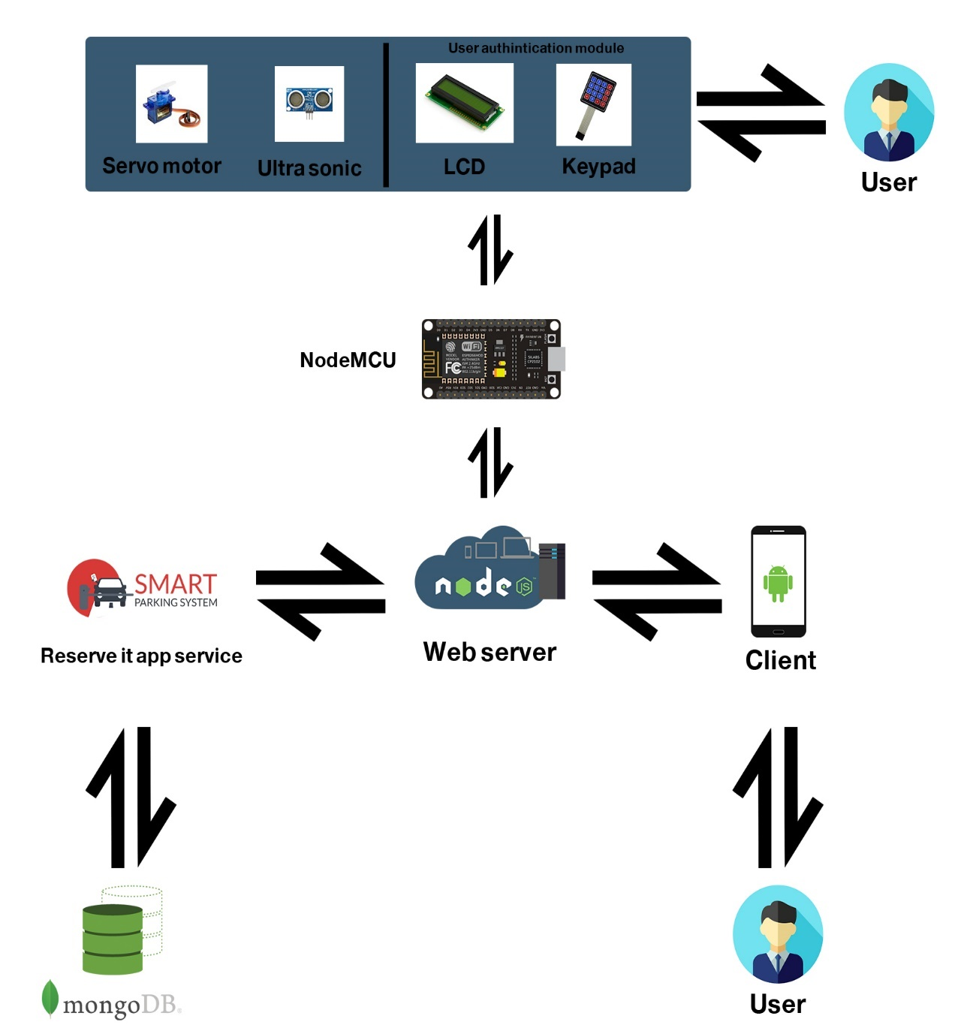

Figure 7: High level architecture 1

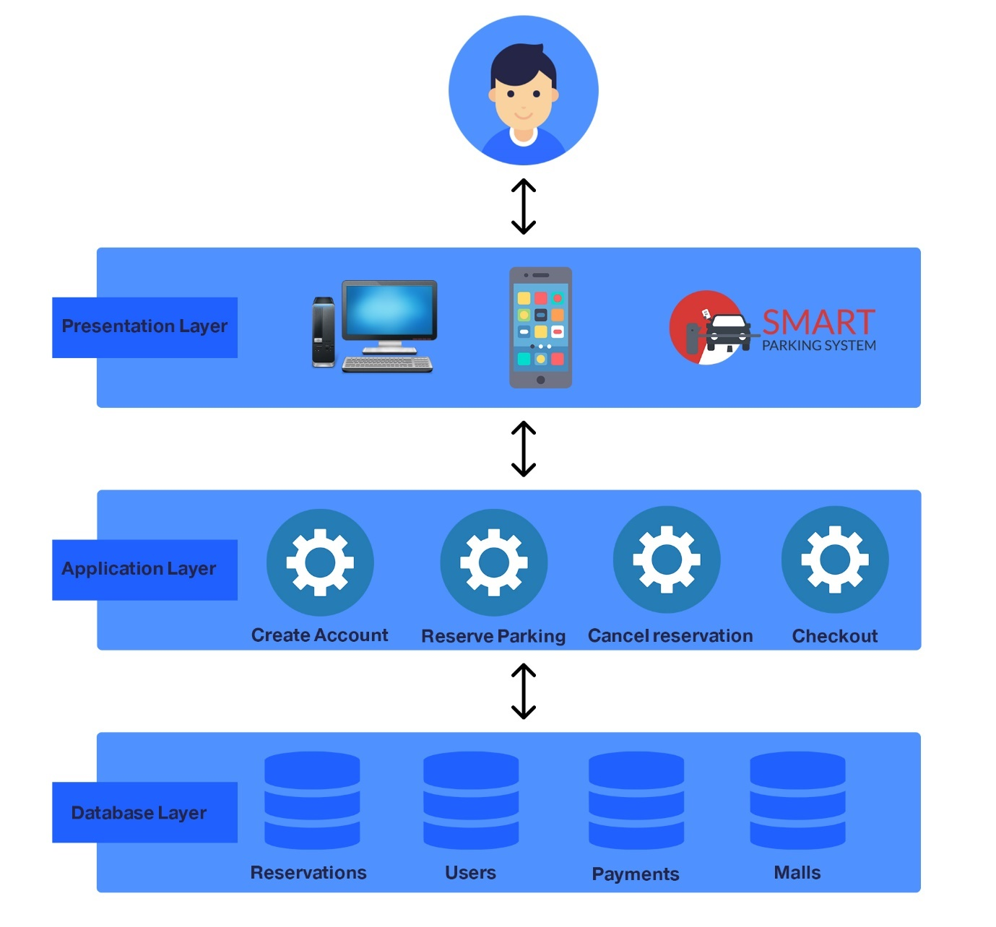

Figure 8: High level architecture 2

As seen in the figure above, the user interacts with the android application which sends requests to web server through the internet, once the service (node js) receives the requests, it does the necessary functionalities and retrieves or sends data to the mongo db database and sends a reply back to the android application to show changes to the user. Moreover, Same scenario happens when the user interacts with hardware for example: entering his pin code using the key pad , the NodeMCU sends request to the server where the it does it functionalities and contacts the database then passes the results back to the NodeMCU.

## Possible Solutions and tradeoffs

Table 5: possible Solution No.1

|  |  |  |  |  |
| --- | --- | --- | --- | --- |
| **Presentation and design patterns** | **Backend** | **Frontend** | **Database**. | **Server.** |
| MVC | node.js /JavaScript | Android for the application and React.js for the website | MongoDB | Cloud server |

Table 6 :possible Solution No.2

|  |  |  |  |  |
| --- | --- | --- | --- | --- |
| **Presentation and design patterns** | **Backend** | **Frontend** | **Database**. | **Server.** |
| MVC | Java EE | Android for the application and jQuery for the website | MySQL | Dedicated server |

Table 7 : possible Solution No.3

|  |  |  |  |  |
| --- | --- | --- | --- | --- |
| **Presentation and design patterns** | **Programming language/platform.** | **Frontend** | **Database**. | **Server.** |
| MVC | PHP | react native for the application and jQuery for the website | MySQL | Dedicated server |

Table 8: possible Solution Comparison

|  |  |  |  |
| --- | --- | --- | --- |
|  | **Solution 1.** | **Solution 2.** | **Solution 3.** |
| **Performance** | High performance, nodeJs on the server side and mongoDB with the cloud service should show high performance | High performance | High performance |
| **Scalability** | Highly scalable since we are using a cloud service. | Not very scalable | Not very scalable since a dedicated server is being used |
| **Modifiability** | Can be modified easily since it’s a document-based DB | Modification will be hard to establish | Modification can be a problem here, with the presence of the SQL DB and the dedicated server |
| **Reusability** | Reusable. | Reusable. | Reusable |
| **Failure tolerance** | Tolerant. | Failures are expected | Failures are expected |
| **Cost** | Fairly low | Expensive | Expensive |

## 4.4 Selected solution

According to the project objectives and aims, our team has decided to choose solution one which is building a platform using node.js express, using mongoDB as our database and our front end will be android for the application and React js for the website. Our system will use MVC design pattern and will be hosted on a cloud server using digital ocean. There are a couple of reasons of why we choose this specific solution.

* All team members agreed especially on node js since we all have studied this course in the university and we have a good experience of how to use it.
* node js goes very with NoSQL databases such as mongoDB, since mongoDB has a JavaScript framework. Therefore, there are no problems when it comes to data conversions and mismatching.
* node js is very fast and it is present everywhere since it is based on JavaScript, a lot of resources can be found online which will help us in our development process
* All members of the team are familiar with android development and we thought that android has the bigger market. Eventually, we will have to develop an application for IOS users.
* We have decided to use mongoDB since it is very easy to scale, and it is schema less which will fit our project requirements.

To summarize, we found this solution to suit our overall skills as team and we found that it meets our project requirements which will make it easier for us to develop the system as a team.

When it comes to development processes, we had many options to choose from but after doing some research, our team found out that the best option for us is to use the waterfall model. The way waterfall model works is that the project is divided into different phases, each phase will be dependent on the previous phase, for example, once we finish the first phase, we will use the output of the first phase as our input for the second phase. The waterfall model can be divided into seven phases: requirements, analysis, system design, implementation, integration and testing, deployment of system and maintenance. This model is very easy to use, it’s sequential which exactly represents what we need in out project. Finally, we found that it will help us divide the work between our team members.

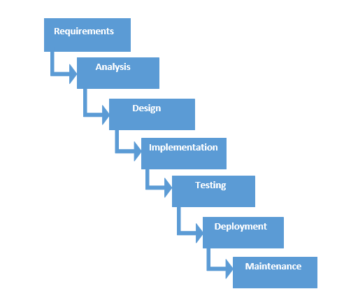

Figure 9: Waterfall model

## Hardware/software to be used

### Hardware to be used

Table 9 :Hardware to be used table

|  |  |  |  |
| --- | --- | --- | --- |
| **Component Name** | **Description** | **Price** | **Image** |
| NodeMCU model ESP8266 | NODEMCU V2 NodeMCU is an open source IoT platform.  It includes firmware which runs on the ESP8266 Wi-Fi SoC. We are going to use this chip to establish the connection between the smart parking application (app & web) to control the hardware components. | 60 QR | https://res.cloudinary.com/www-arduiely-com/image/upload/v1477989507/ejc2rdha8cphsxxyrulr.jpg  Figure 10 :NodeMCU model ESP8266 |
| ULTRASONIC SENSOR - HC-SR04 | We are going to use this sensor to detect whether a car is parked or not | 15 QR | **https://res.cloudinary.com/www-arduiely-com/image/upload/v1477387012/hbo10xrcxwqwcqwgfl6e.jpg**  Figure 11 :ULTRASONIC SENSOR - HC-SR04 |
| MINI SERVO - POSITIONAL ROTATION | It is able to take in 3 to 7 volts and deliver 17.5 oz-in. of stall torque at 0.12 sec/60°.The servo comes with a standard 3 pin power and control cable. It also comes with Single Arm Horn, Double Arm Horn, and Four Point Horn. The motor will be used to open or close section gate and the main gate | 20 QR | **https://res.cloudinary.com/www-arduiely-com/image/upload/v1477385541/ankjsct9xu0guy3ceby6.jpg**  Figure 12 : MINI SERVO - POSITIONAL ROTATION |
| CLEAR RGB COMMON CATHODE LEDS | These 5mm units have four pins - Cathode is the longest pin. One for each color and a common cathode. Use this one LED for three status indicators. The LEDs will be used as an indicator to the user if the parking is reserved or empty by using green and red color. | 15 QR | https://res.cloudinary.com/www-arduiely-com/image/upload/v1477386281/atfnjxkevugfklkwvdaj.jpg  Figure 13: CLEAR RGB COMMON CATHODE LEDS |
| 16 KEY KEYPADS | After the user book a parking spot a code will be generated, the code should be entered by the user in the entrance gate. A basic 16 button keypad for user input. The buttons are setup in a matrix format. This allows a microcontroller to ‘scan’ the 8 output pins to see which of the 16 buttons is being pressed. | 1. QR | Figure 14 :16 KEY KEYPADS |
| 16X2 SERIAL LCD MODULE | with this I2C interface LCD module, you will be able to realize data display in the 16-key keypad via only 2 wires. | 40 QR | Figure 15 :16X2 SERIAL LCD MODULE |
| FULL-SIZE BREADBOARD and JUMPER WIRES | we need to put all pieces together using full size solderless breadboard and jumper wires. | 20+20 QR | https://res.cloudinary.com/www-arduiely-com/image/upload/v1477354013/zpip78vzw7yclkwfzbwq.jpg  Figure 16 :FULL-SIZE BREADBOARD and JUMPER WIRES |
| WALL ADAPTER POWER SUPPLY - 5V DC 3A (BARREL JACK) | This switching supply gives a clean regulated 5V output up to 3000mA. 110 or 240 inputs. | 35 QR | https://res.cloudinary.com/www-arduiely-com/image/upload/v1488876309/rlrxdydekfnka0v79lam.jpg  Figure 17 :WALL ADAPTER POWER SUPPLY - 5V DC 3A (BARREL JACK |
| Arduino mega | Arduino mega is the best choice to provide digital lines. We need | 15 QR | Image result for arduino mega  Figure 18 : Arduino mega |
| Power banks | Power banks are the best power supply to our system because it has stable current and supply 5V which is exactly what we need. | 200 QR | Image result for power bank |

### Software to be used

Table 10 : Software to be used Table

|  |  |  |
| --- | --- | --- |
| **Software** | **Image** | **Description** |
| Node JS | https://lh5.googleusercontent.com/eq39Jx6kop-IyJUTYoDO49YN8TH2KqXirKFSqStr77Q6zP4vQ8j9Nx5Pui0QLozQ3ECFqOuF_R4TCrAThSa0Na_-IBVQrDIzCxh8TI_fQXvKelw8V8OWukgOFpYWTYvclUynesrl  Figure 19: NodeJS logo | Node JS is an open source, cross-platform JavaScript runtime environment for executing JavaScript code server side. |
| WebStorm | https://lh3.googleusercontent.com/C66D36kRSwJS-MFt8mZ-BQ02Z4_ICk2yCmlVCgbEohe2NX7IIWsV2wz5TaamMK98BgMjA0mIRJVa3ZuCJjSvQWRUUSN3rFWInQKZvzxr5kvhUNIJfoP4Hf7cGR_ARYffEZ9-abtU  Figure 20: WebStorm logo | WebStorm is a cross-platform IDE primarily for web, JavaScript and TypeScript development. |
| Android Studio | https://lh6.googleusercontent.com/jTvi6UxK1jbVlVwhfCD0vq2tQoF305WO86a6fDMDvc9Q-t-6C9acI10janx4Sq3pdawF8nmT8UIf3lYLRIhe-387lXfUGVKqZpkfU4Oln3CtelwOJ8_t5qEk1LPIhE5H0cO3gXDh  Figure 21: Android Studio logo | Android Studio is the official IDE for Android development, and it provides the tools which is needed to build a mobile app. |
| Stripe API | C:\Users\Ameer\AppData\Local\Microsoft\Windows\INetCache\Content.MSO\C75B4014.tmp  Figure 22: stripe logo | Stripe is an API that provides payment services and secure access to protect resources that can handle the payment process securely. |
| Digital Ocean | https://www.digitalocean.com/assets/media/logos-badges/png/DO_Logo_Vertical_Blue-6321464d.png  Figure 23: Digital Ocean logo | Digital Ocean is a platform that provides cloud infrastructure and it will handle the back-end for the system. |

## 4.6 Hardware design

NodeMCU microcontroller was the best choice for us because of its affordable price and its high processing power compared to other microcontrollers such as Arduino Wi-Fi. NodeMCU is Arduino-Compatible so it is easy to use and has an excellent documentation available. Also, the NodeMCU is an open-source firmware and development kit that is gaining an increasing reputation in the field. To sum up the NodeMCU was chosen for its main features

1. WI-FI enabled.
2. Open-source.
3. Interactive.
4. Programmable.
5. Low cost.
6. Simple.

It has an Arduino-like hardware IO, which reduces the redundant work for manipulating and configuring the hardware. In addition, it can be coded like an Arduino or interactively in Lua script. NodeJS style network API that is Event-driven for networking applications.

Specification: ESP8266 chip includes: GPIO, PWM, IIC, 1-Wire and ADC all in one board, USB-TTL , plug & play, 10 GPIO, every GPIO can be PWM, I2C, 1-wire, and PCB antenna.

It is very well documented and more reliable than the WEMOS mini and has more support. In addition, it is cheaper and simpler than the Arduino connected to ESP-8266EX chip [20].

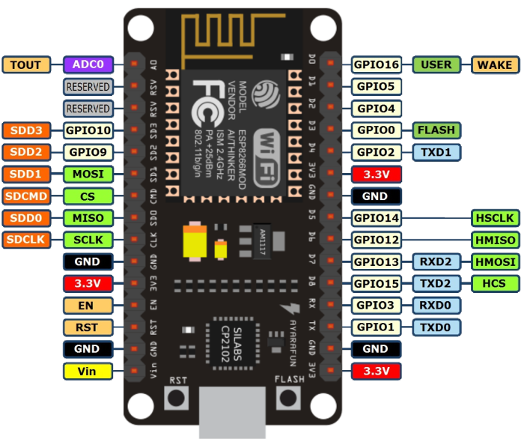

*Figure 24: NodeMCU*

**ESP-8266EX chip features:**

* 802.11 b/g/n Wi-Fi
* Integrated low power 32-bit MCU
* 10-bit ADC
* Integrated TCP/IP protocol stack
* Wi-Fi 2.4 GHz, support WPA/WPA2
* Wake up, and transmit packets in < 2ms
* Operating temperature between -40C ~ 125C

Figure 25 : Connectivity diagram of the barrier module (Breadboard view)

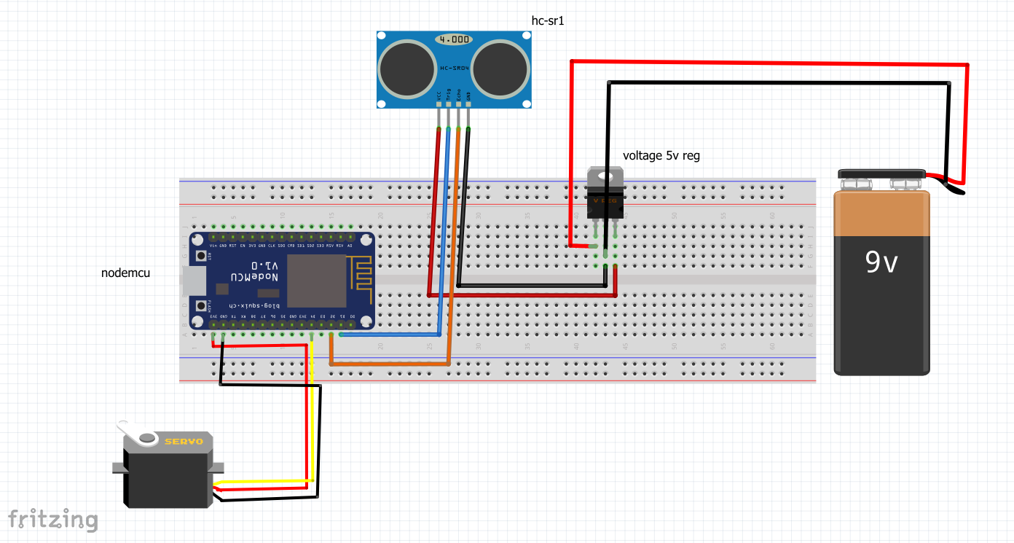

Figure 26 Schematic diagram of the barrier module

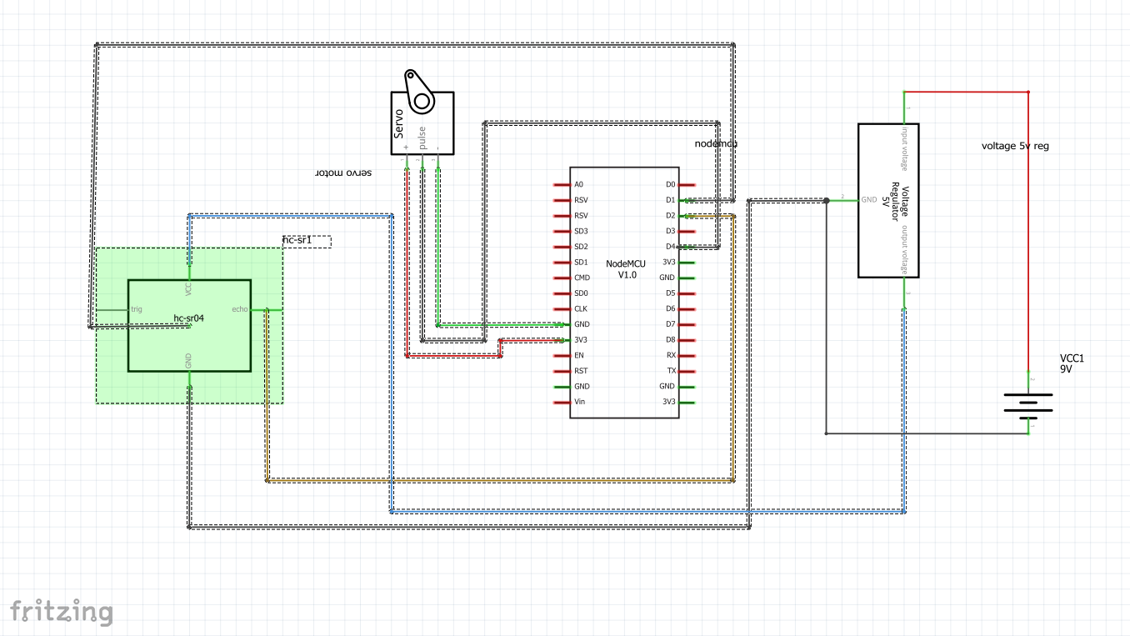

The above graphs show the mechanism of the barrier in the entrance and exit. In entrance side the barrier will be opened only if the user enters the pass code correctly. When the user enters the pass code correctly, the microcontroller will call a function which will allow the ultrasonic sensor which will be placed behind the barrier to sense the car. When the car is placed over the sensor the motor will open the barrier. The motor will hold the barrier until the car moves forward and it is no longer over the sensor then it will wait for 5 second to get closed and return to default position. For powering we used 9V battery with 5V regulator. Since the NodeMcu microcontroller provide only 3.3v and that’s not enough to power the ultrasonic so it needs an external 5V to work. Finally, the exit barrier works exactly the same way.

Figure 27 Connectivity diagram of Parking indicators module

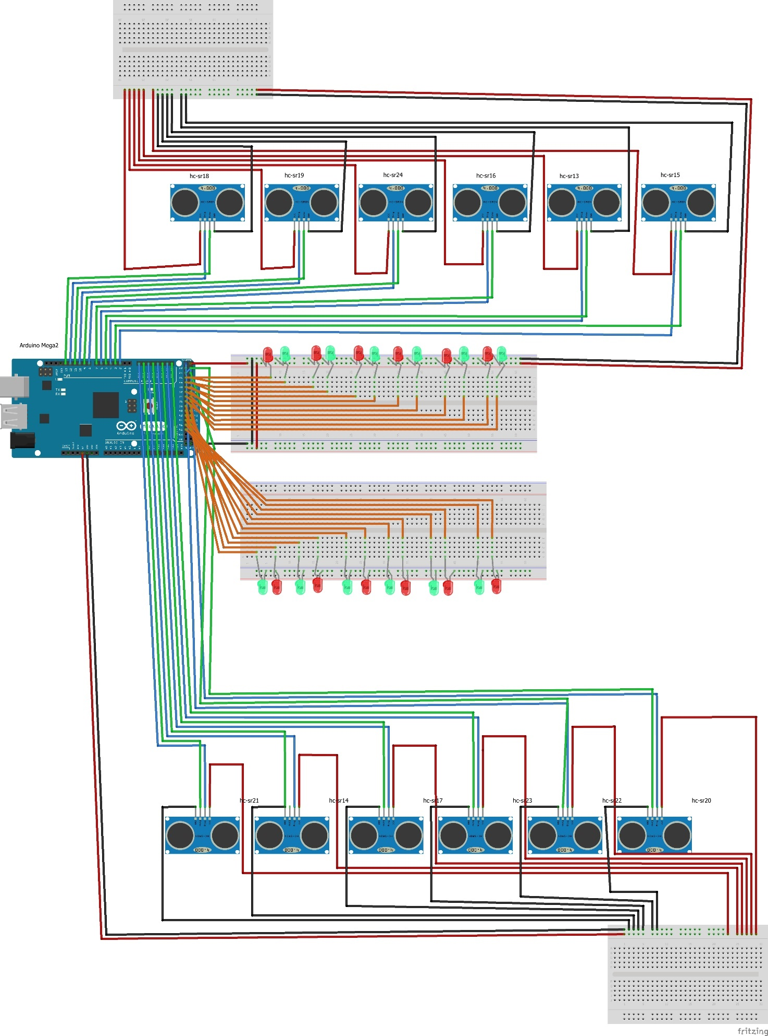

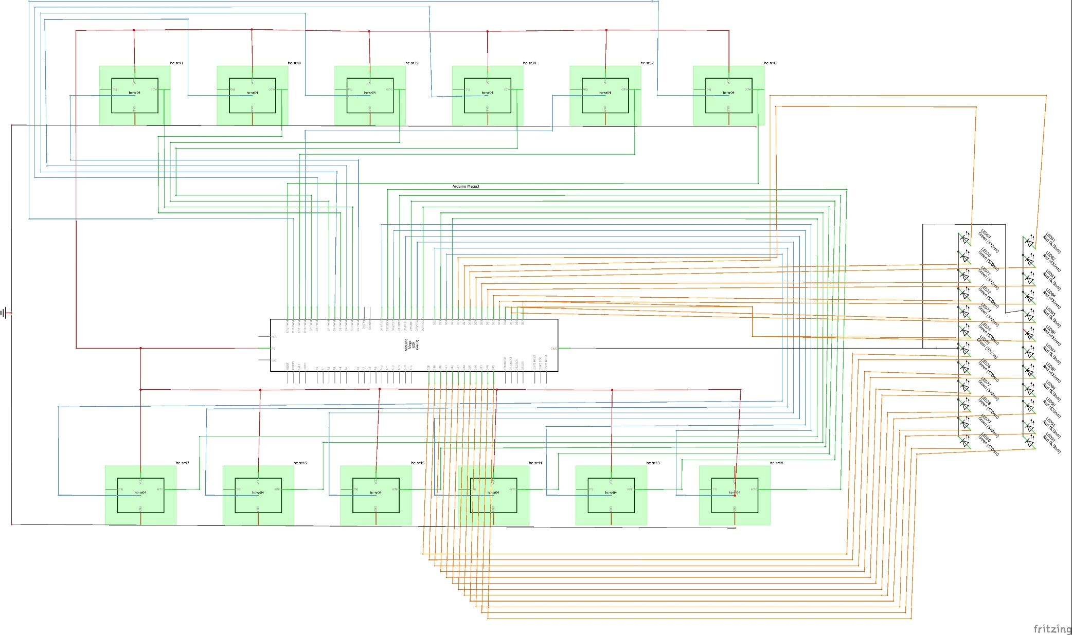

Figure 28 Schematic diagram of Parking indicators module

The above diagram shows how the parking indicators module is connected which indicates 12 parking spots. The idea is very simple, once the car park at the parking spot there will be an ultrasonic sensor which will indicate that the parking spot is taken, mean while there is 2 LEDs (red & green). If the sensor read a distance more than 10 cm which means there is no car taking that spot, so the green LED will always be on, when the sensor reads a short distance (<10cm) means there is a car took that spot so red LED will be on till the car leave the spot then it will return to green to indicate a free parking spot.

Figure 29 Connectivity diagram of user authentication module

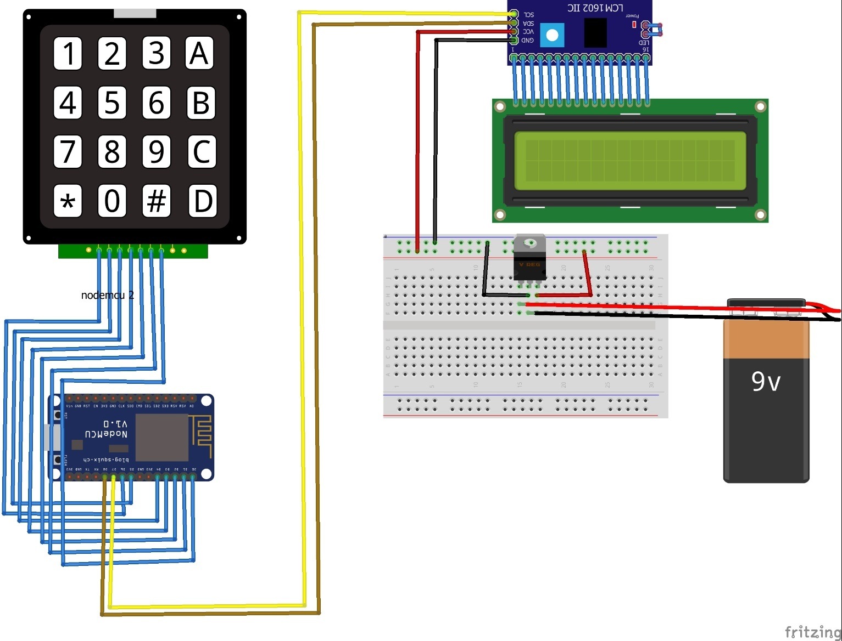

Figure 30 Schematic diagram of user authentication module

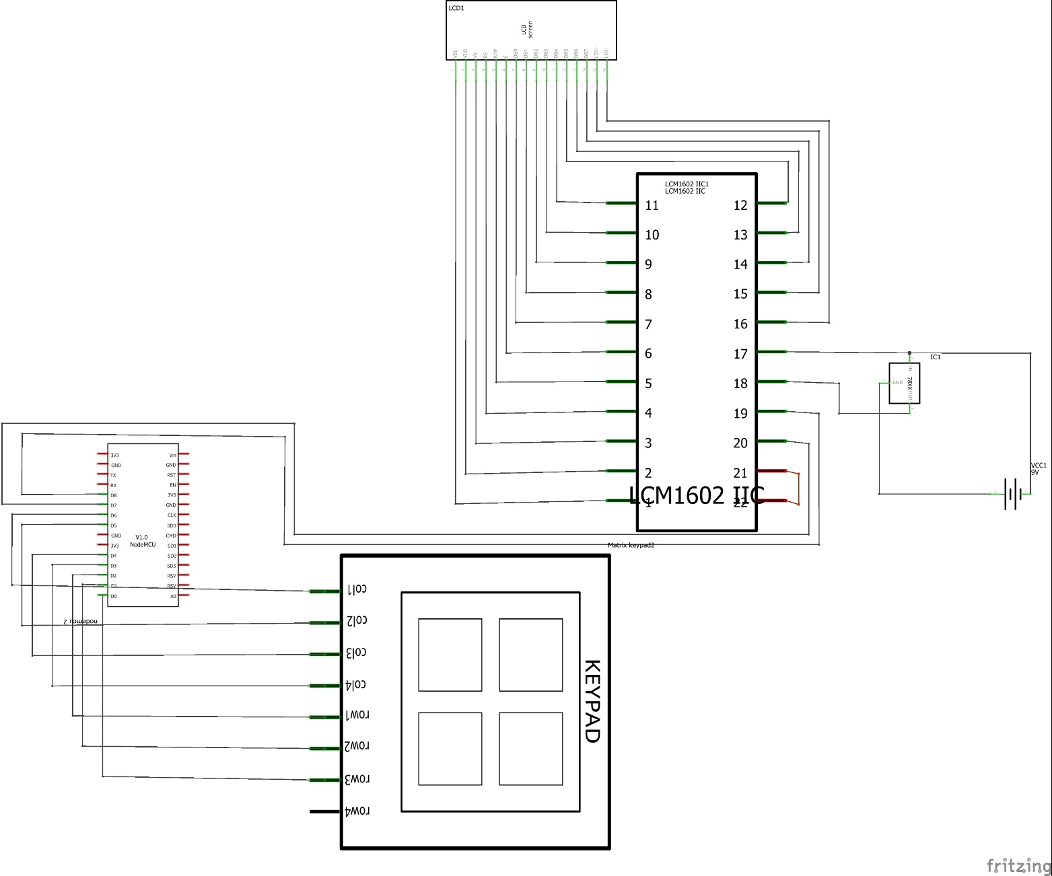

The above diagram shows how the system will authenticate the user on the entrance gate. We used 7 digital lines out of 9 (total number of digital lines in nodmcu) to connect 4x4 keypad to the microcontroller. It can be noticed that we used only 7 pins out of 8 from the key pad so we cancel a whole column in the key pad. The column cancelation helped a lot, because it frees one digital pin in nodemcu which we used it to connect the lcd, in addition we did not find it necessary to use the alphabetic letters in the user’s pass code. I2C is a serial protocol for two-wire interface to connect low-speed devices like microcontrollers, we connect LCM1602 IIC1 to the lcd because it use I2C. For the powering we used 9v battery with regulator to power up the lcd because it need 5v to operate. We mentioned before that there will be a unique code generated by the mobile application to each user when he reserves a parking section, the user will use this code by inserting it on the keypad, at the same time the pass code will be displayed in the LCD screen. The nodmcu will send the code which insert by the user to the server and compare it with the code in the data base, if the code is correct the barrier module will be activated.

Figure 31 : Arduino mega

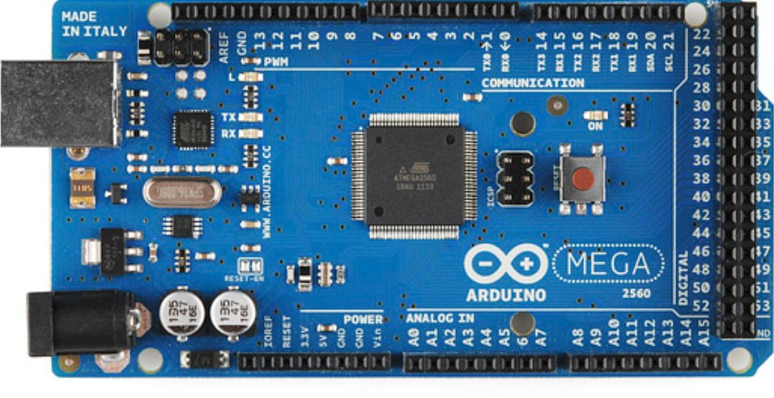

We used Arduino mega for its many digital lines that helped in detect the availability of the parking spots. We used total of 24 digital pins for ultra-sonic sensors (12 for echo and 12 for triggers) and total 24 for green and red LED’s (12 for greens and 12 for reds).

## 4.7 Structural model

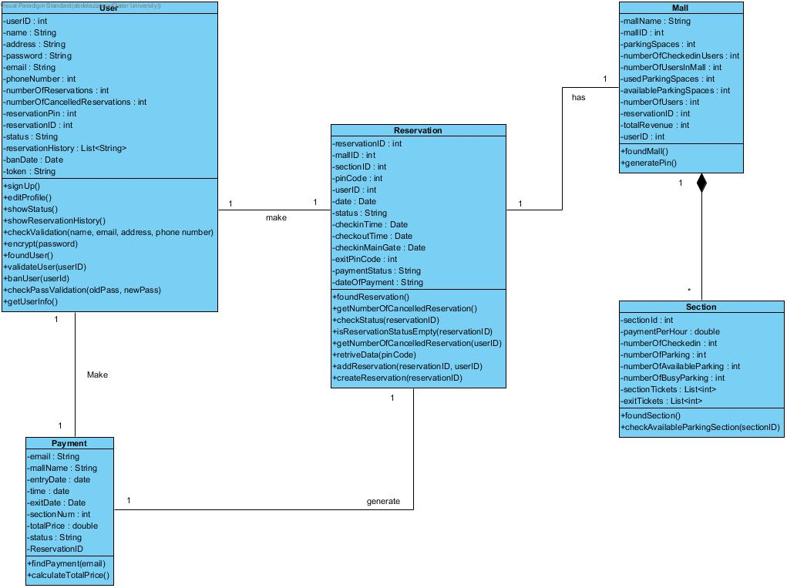

## 4.8. Behavioral model

### 4.8.1 Sequence Diagrams and activity of Cancel reservation

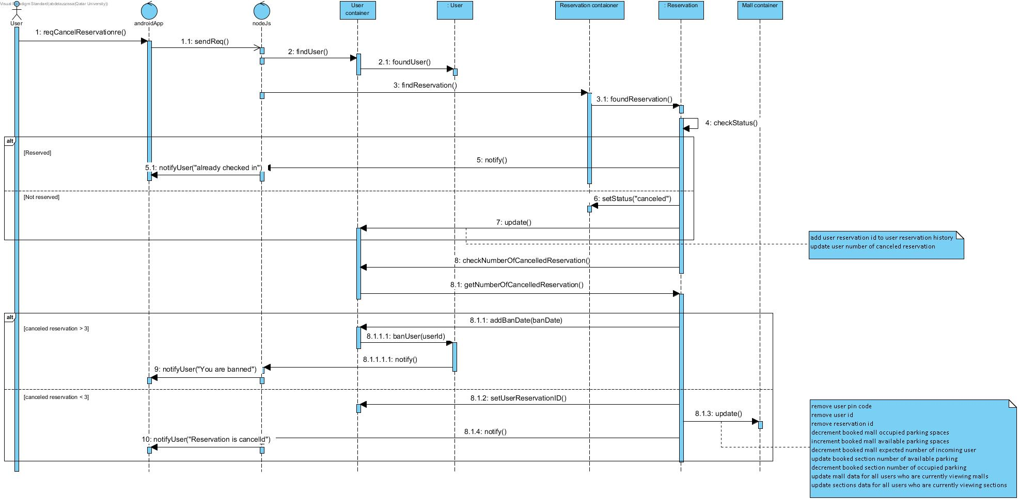

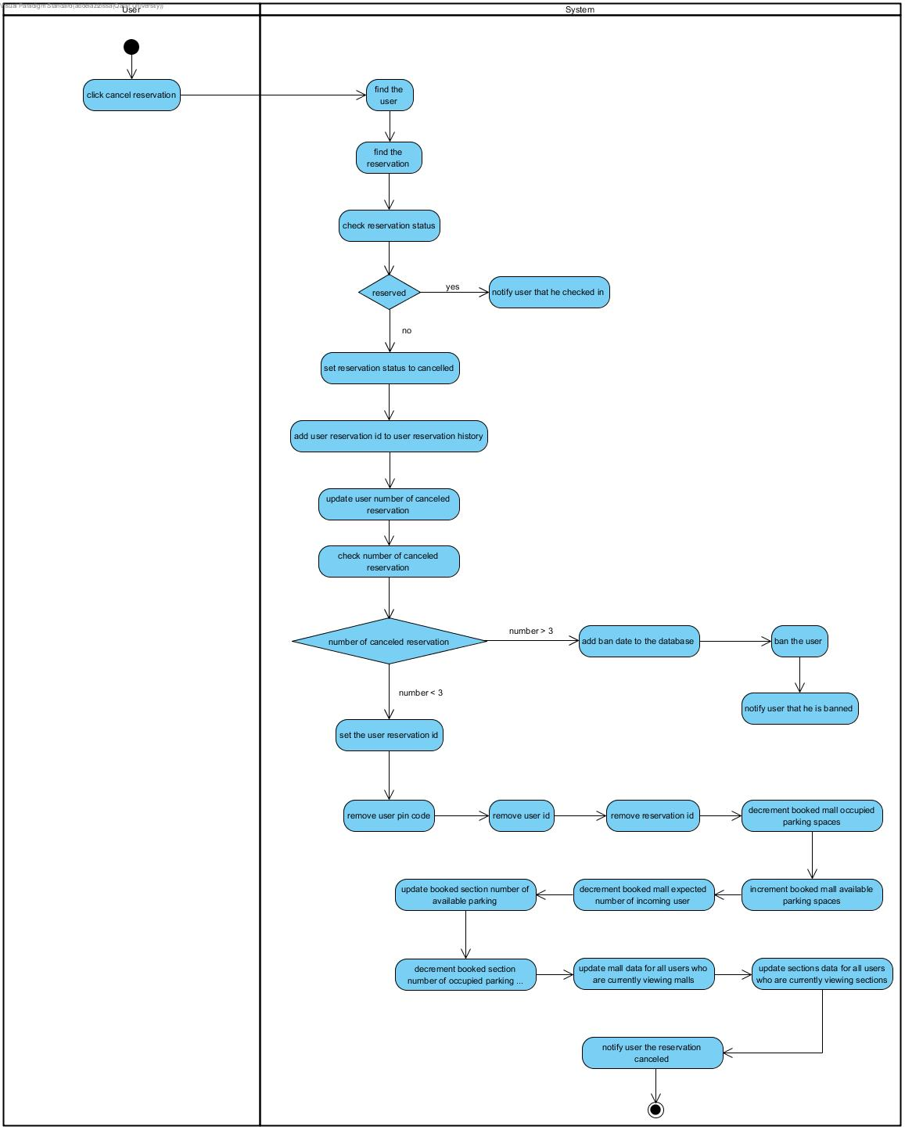

### 4.8.2 Sequence Diagrams and activity of Change password

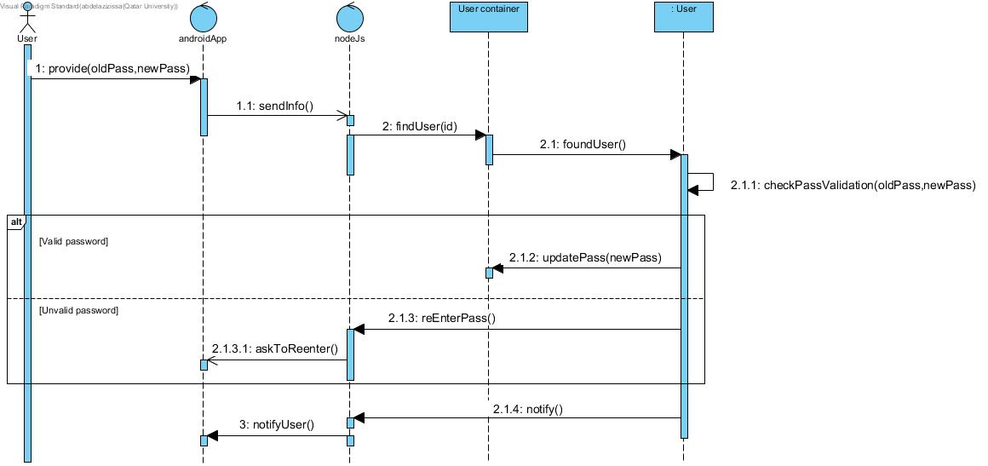

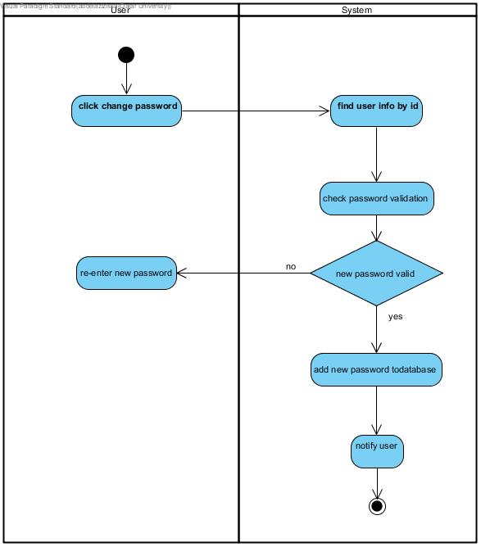

### 4.8.3 Sequence Diagrams and activity of check in section

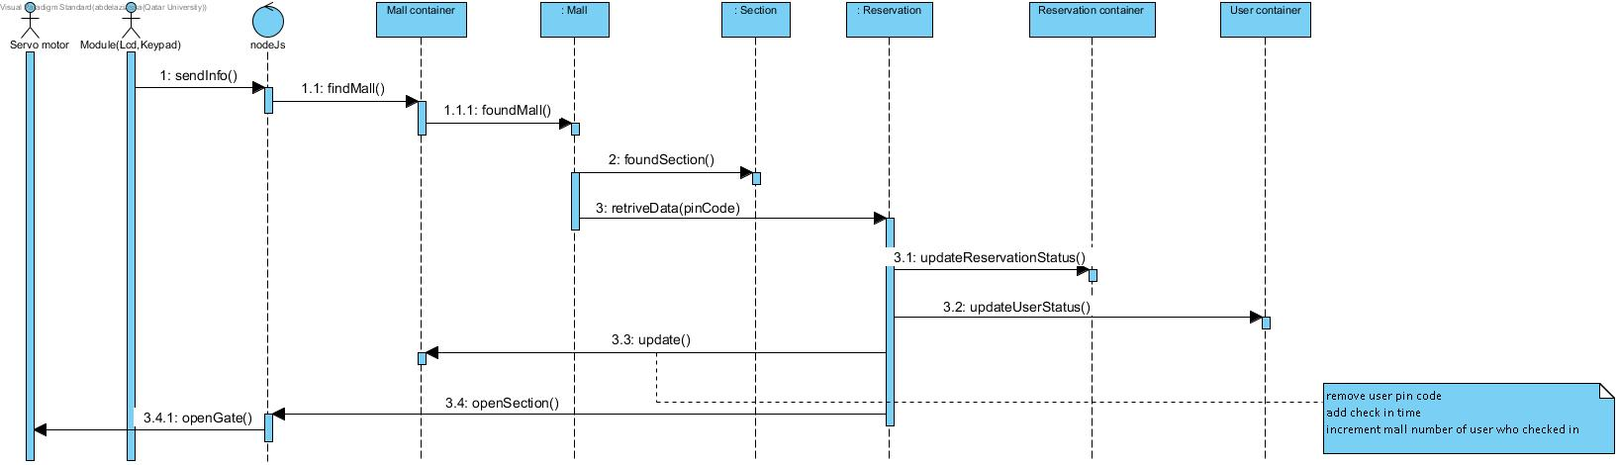

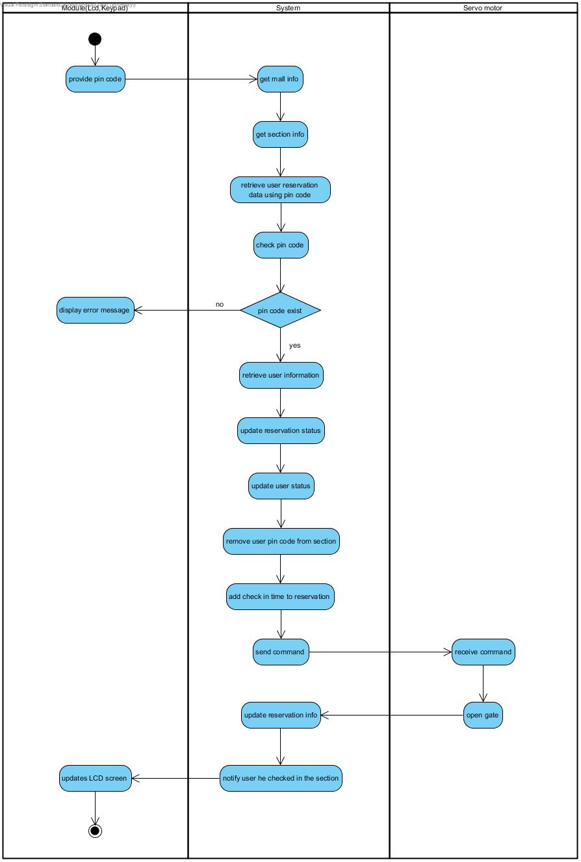

### 4.8.4 Sequence Diagrams and activity of checkout

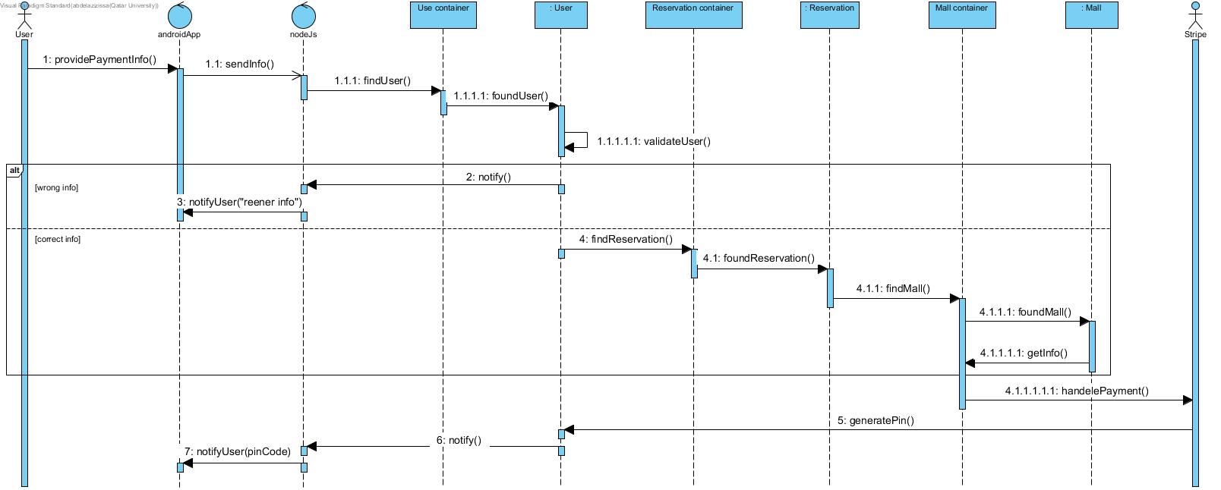

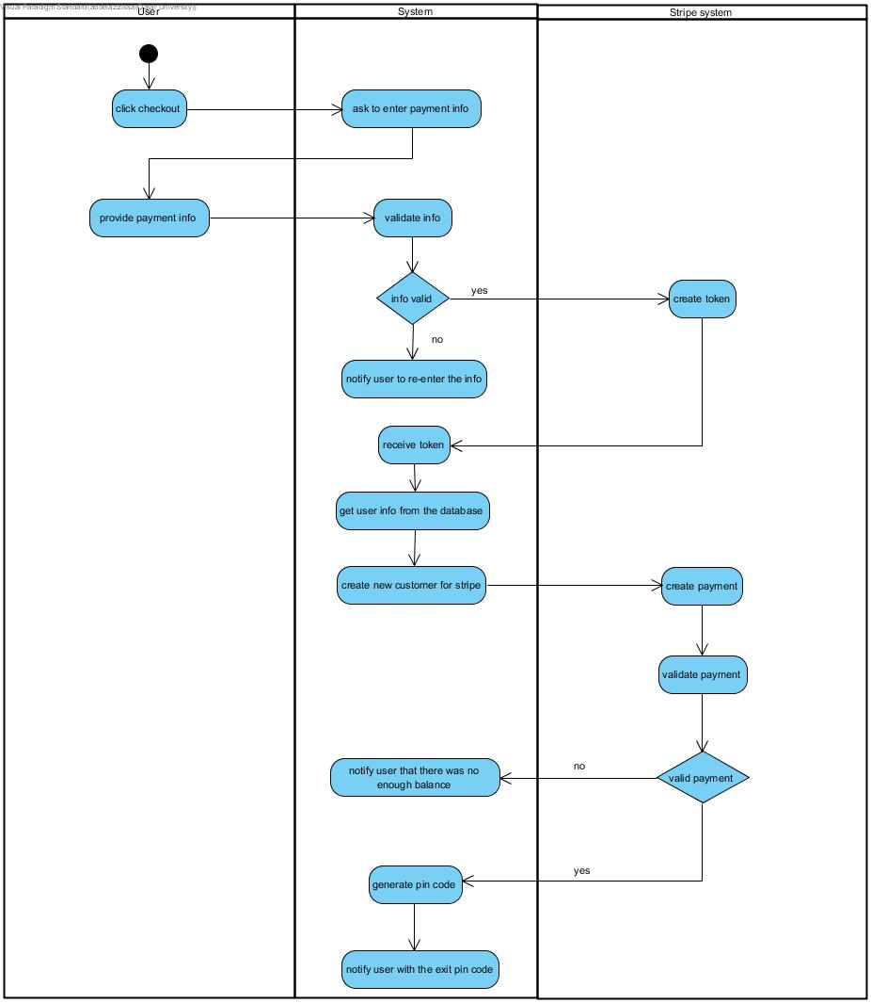

### 4.8.5 Sequence Diagrams and activity of Create account

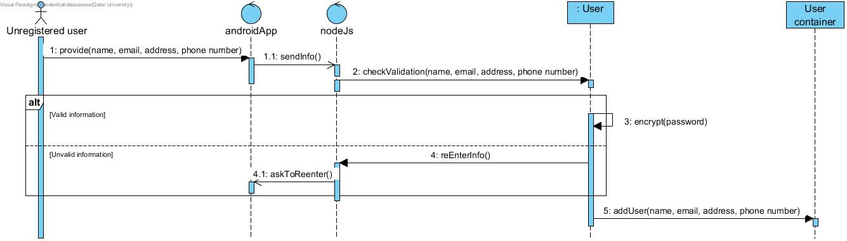

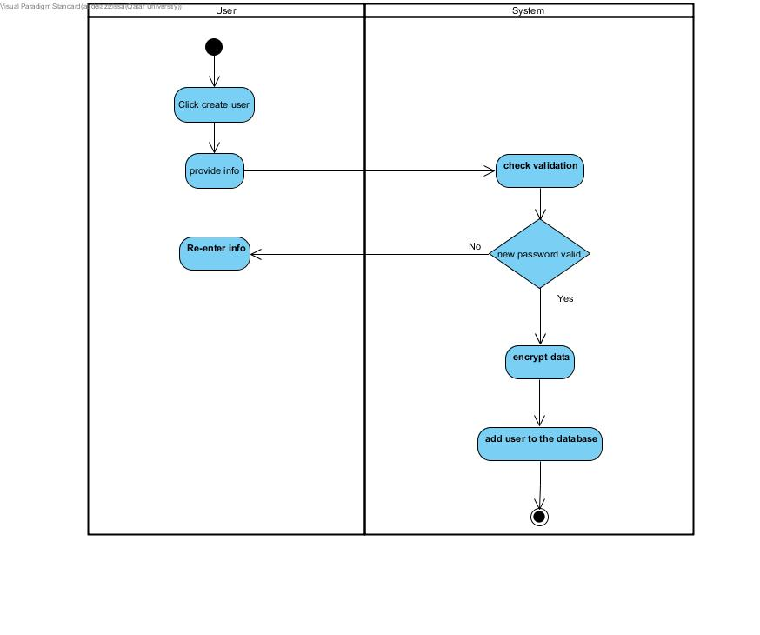

### 4.8.6 Sequence Diagrams and activity of Reserve parking

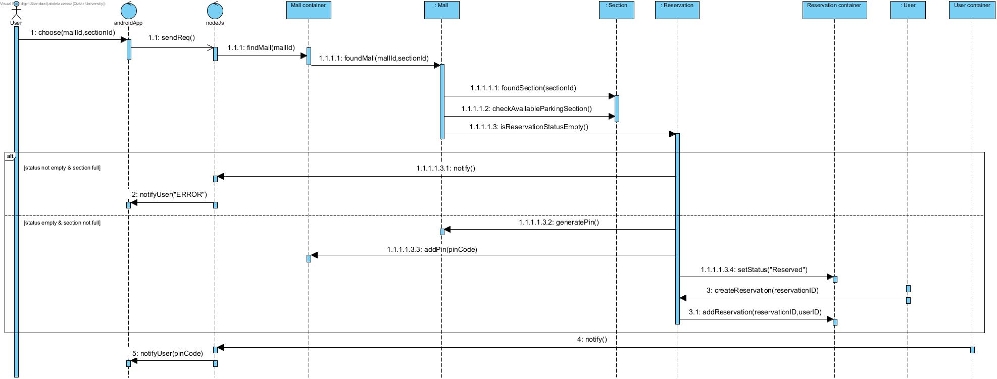

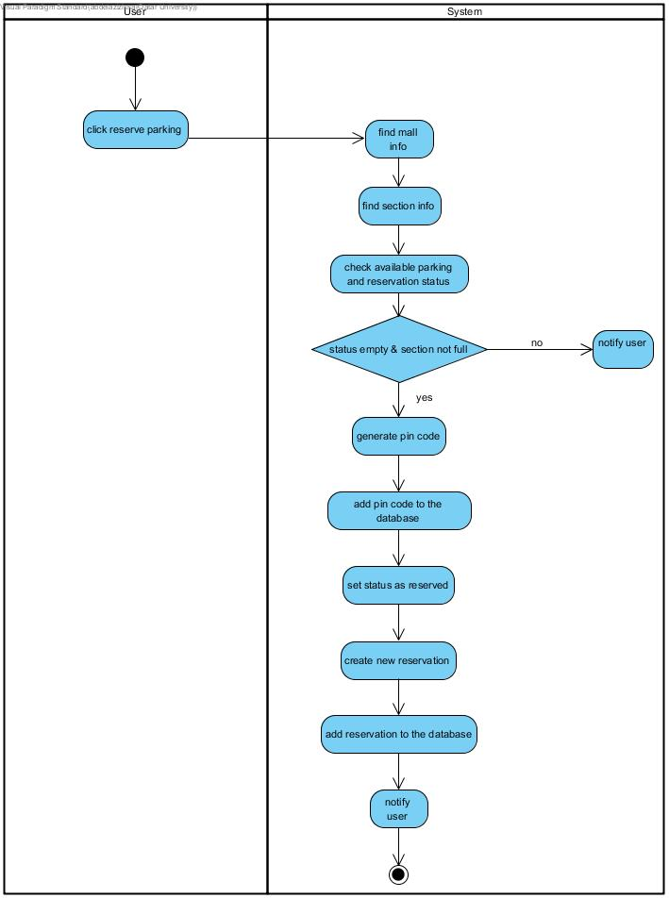

### 4.8.7 Sequence Diagrams and activity of take me there

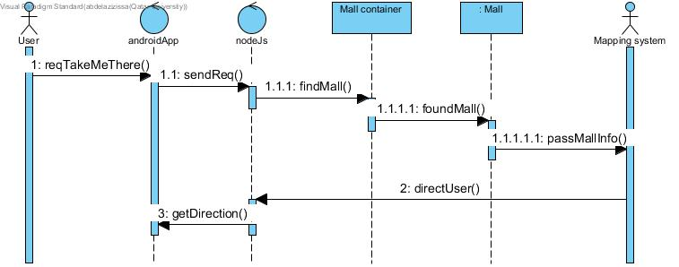

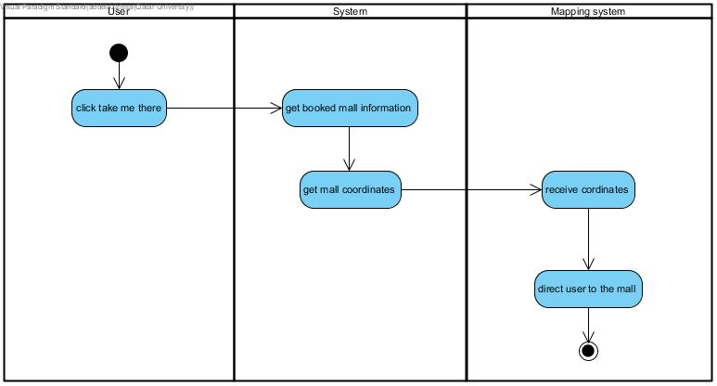

### 4.8.8 Sequence Diagrams and activity of View profile

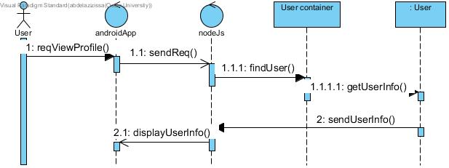

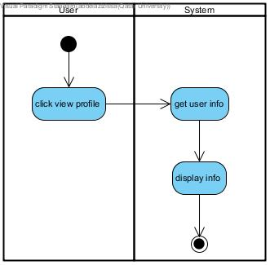

### 4.8.9 state diagram of login and reserve parking

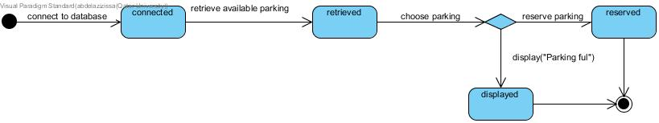

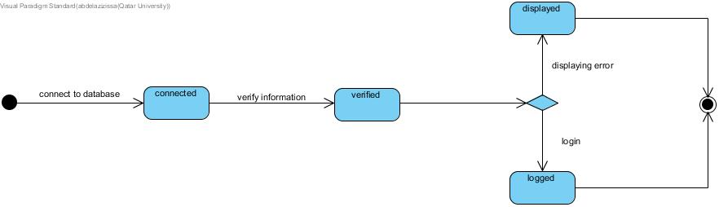

## 4.9 Database design

As mentioned before, we have used mongo db as our database, in our system we had four schemas:

* Mall schema
* User schema
* Payment schema
* Reservation schema

For most functionalities in our system:

1. We retrieve user’s data using his email address which is stored in a shared preference in the application
2. We retrieve user’s reservation data using user’s reservation id
3. We retrieve mall’s data using reservation’s mall id
4. We retrieve payment using user’s email address

Reservation schema:

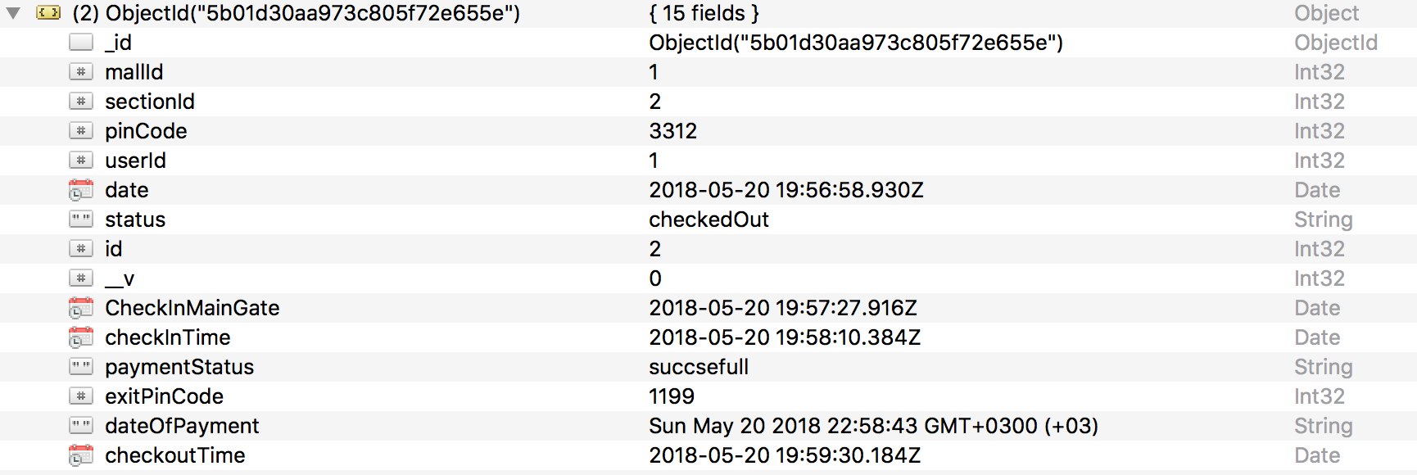

Figure 32 Reservation schema

Mall schema:

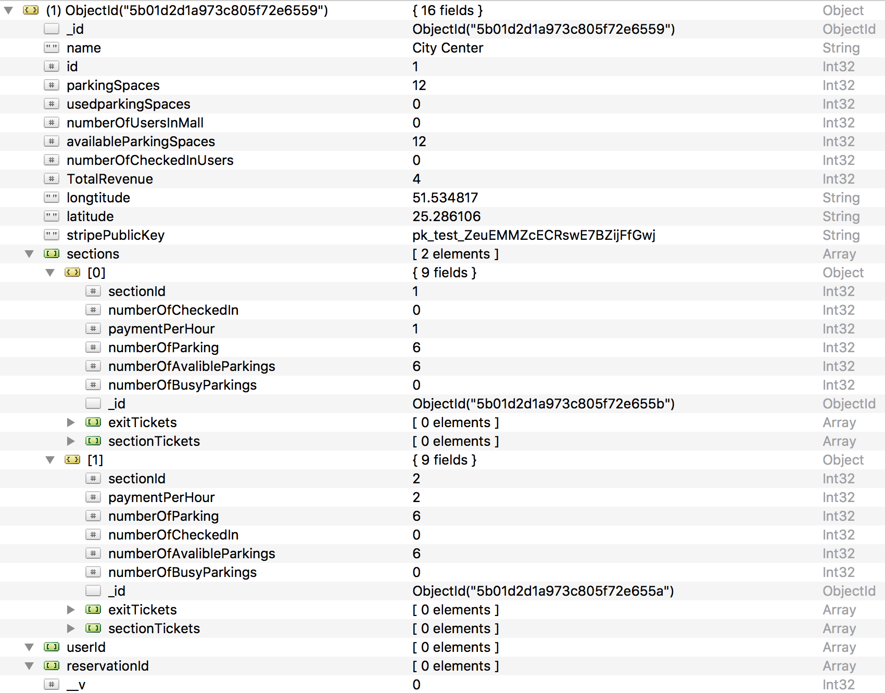

Figure 33 Mall schema

User schema:

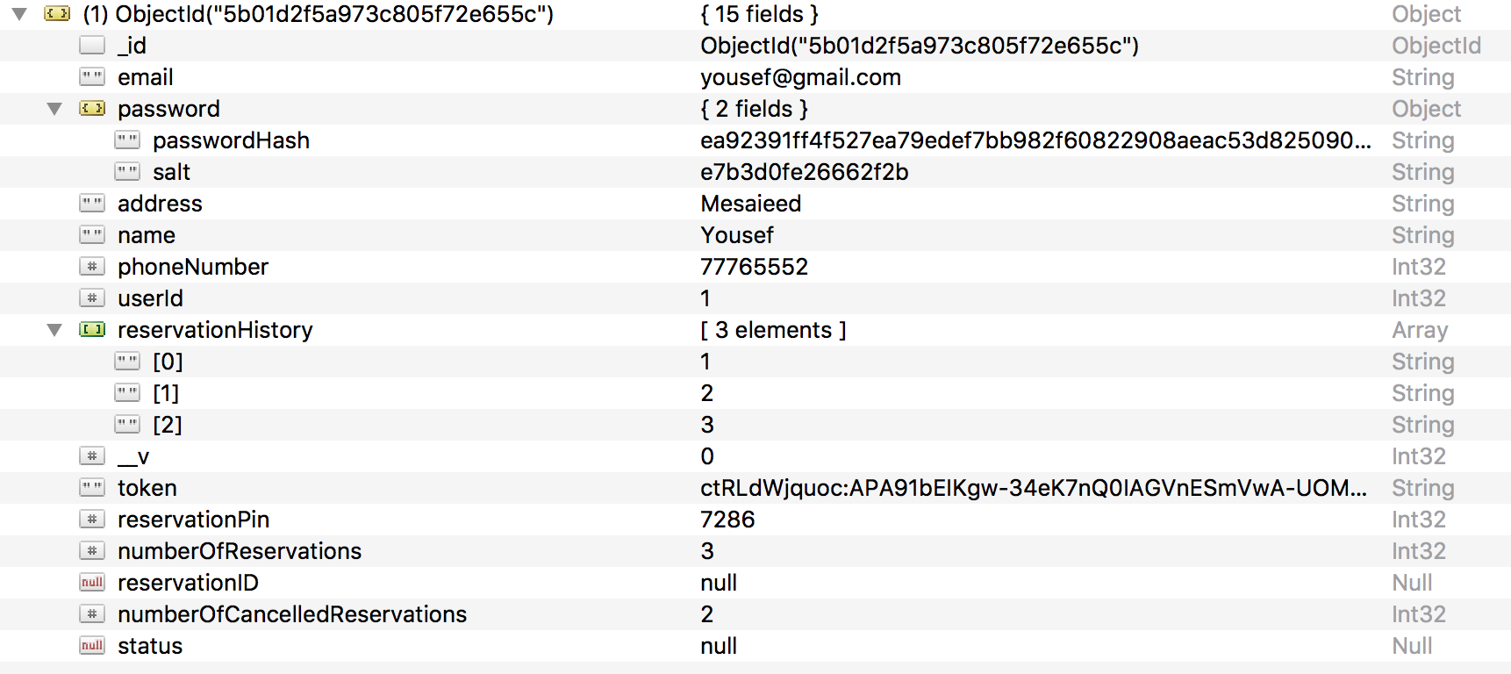

Figure 34 User schema:

Payment schema

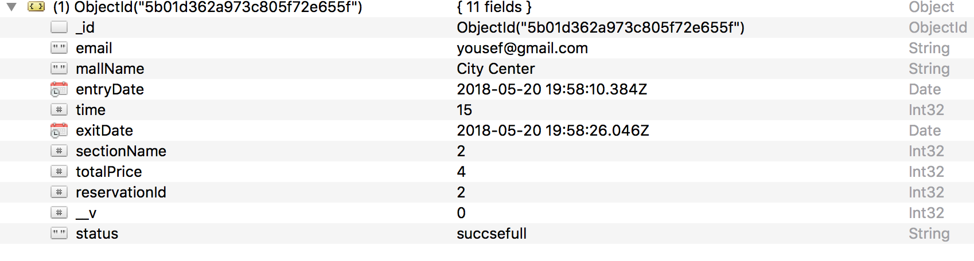

Figure 35 Payment schema

## 4.10 user interface design

Our android application consists of four activities: Login activity, sign up activity, check out activity and main activity:

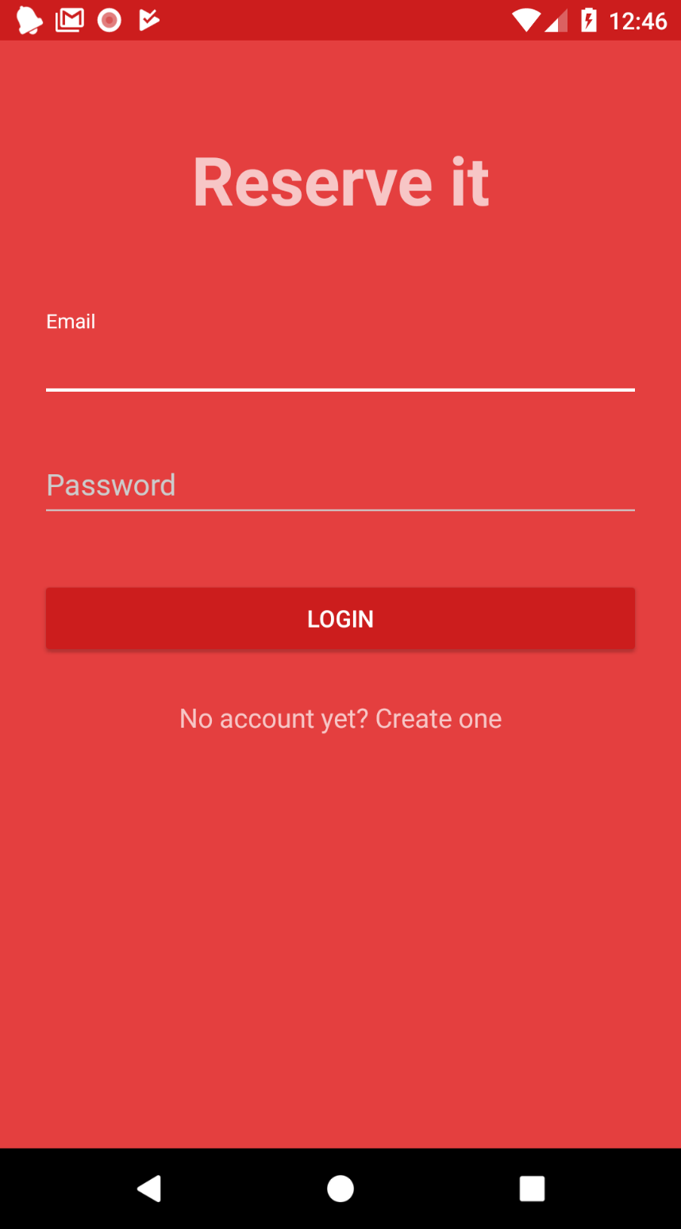

Figure 36 Login activity

**Sign up Activity:**

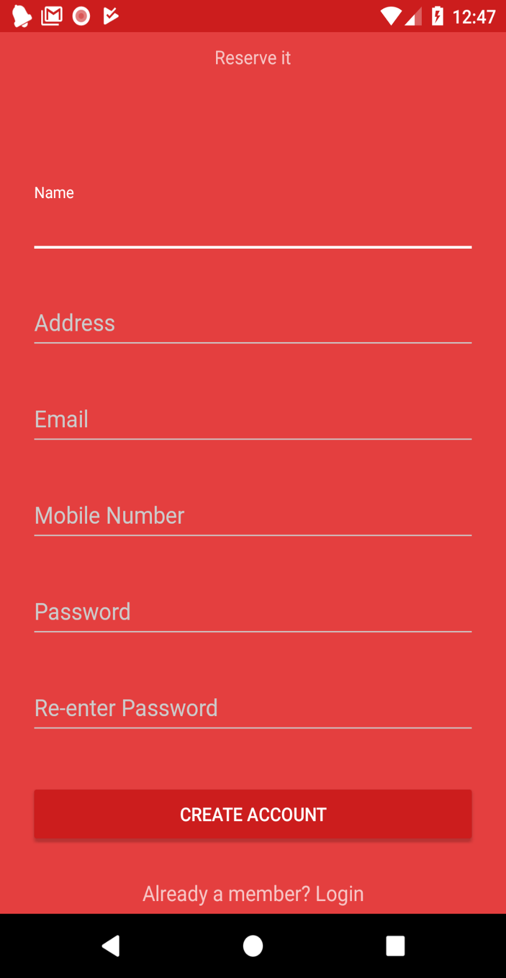

Figure 37 sign up activity

User clicks on “no account yet” to visit the sign-up page

**Main menu Fragment:**

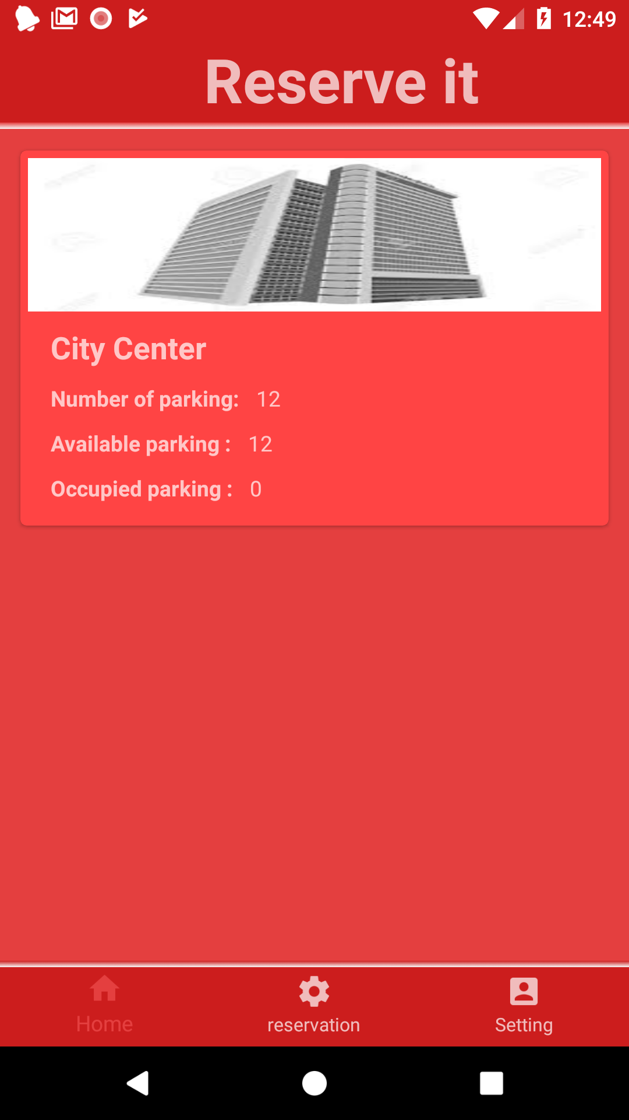

Figure 38 Main menu fragment

User is directed to the main menu page once login is successful

Section information and booking Fragment:

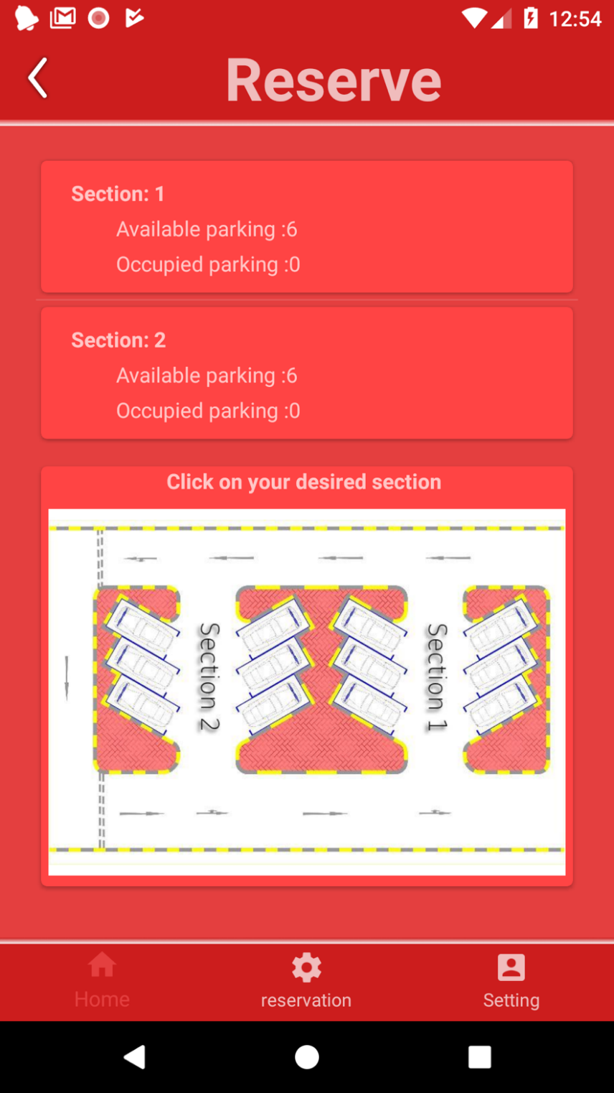

Figure 39 sections fragment

* once users click on the mall’s picture in the previous page, users will be redirected to this page where they can choose a section by clicking on the image on the section desired and see sections information.
* User can return to the main menu by:
  + Pressing small arrow at top left.
  + Pressing on the main menu icon
  + Pressing the back button.

**Settings page:**

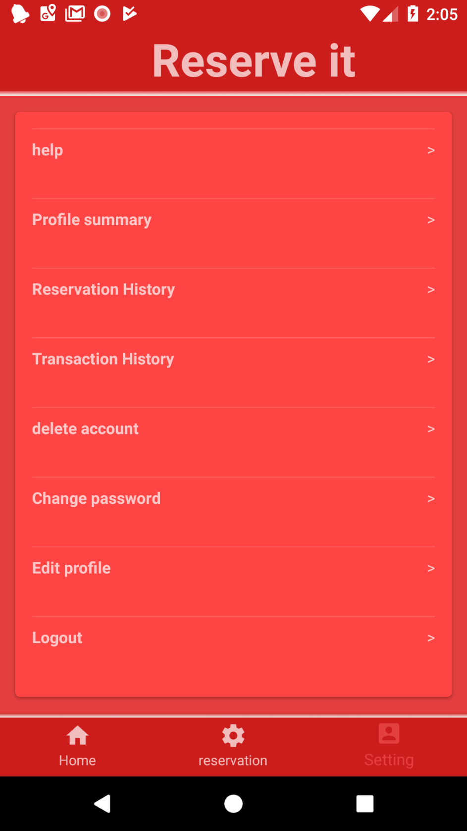

Figure 40 Settings fragment

**Reservation history:**

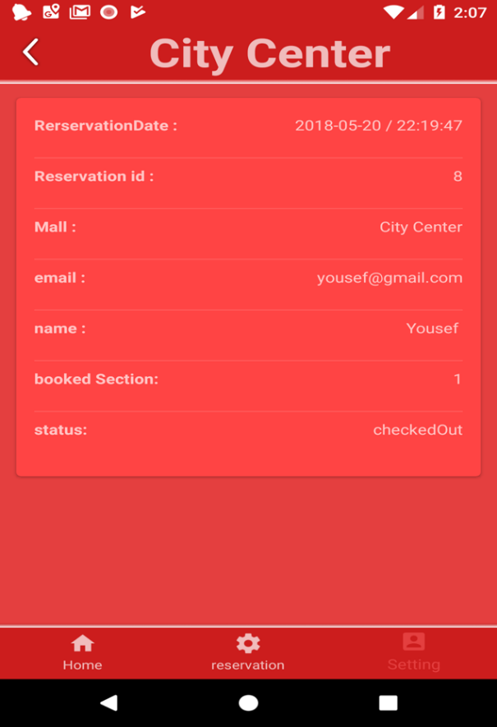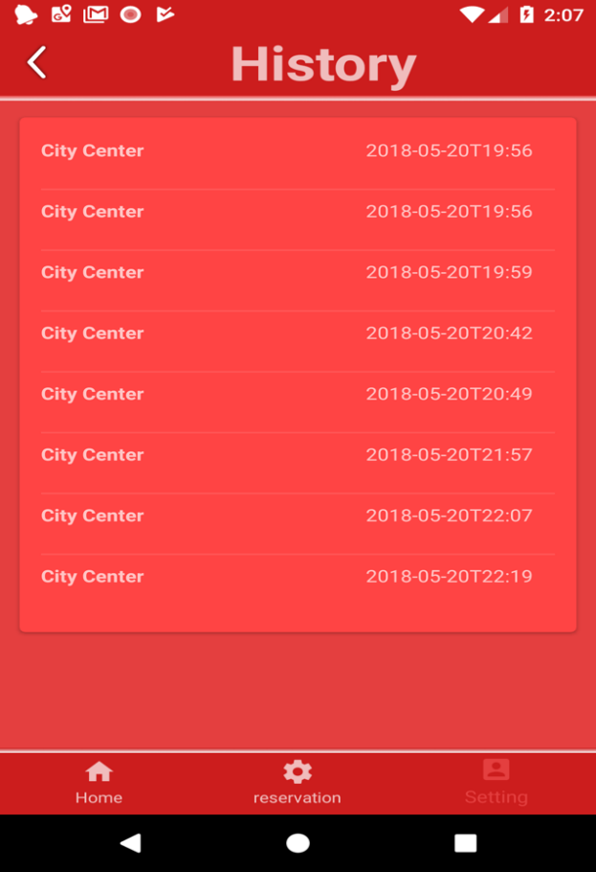

Figure 41 reservation history details

Figure 42 reservation history

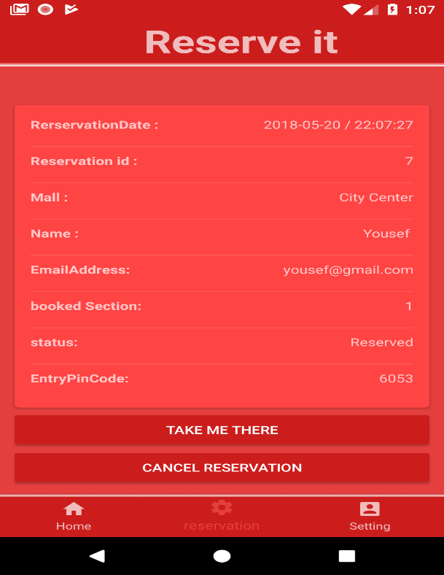

Figure 43 reservation fragment

**Mall’s interface, Login page :**

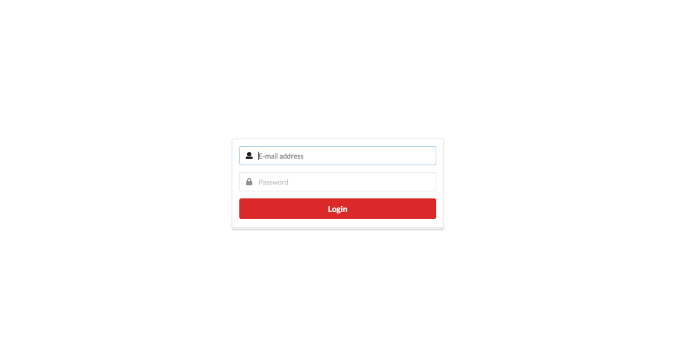

Figure 44 mall’s login page

**Main page for the malls where all the statics are seen:**

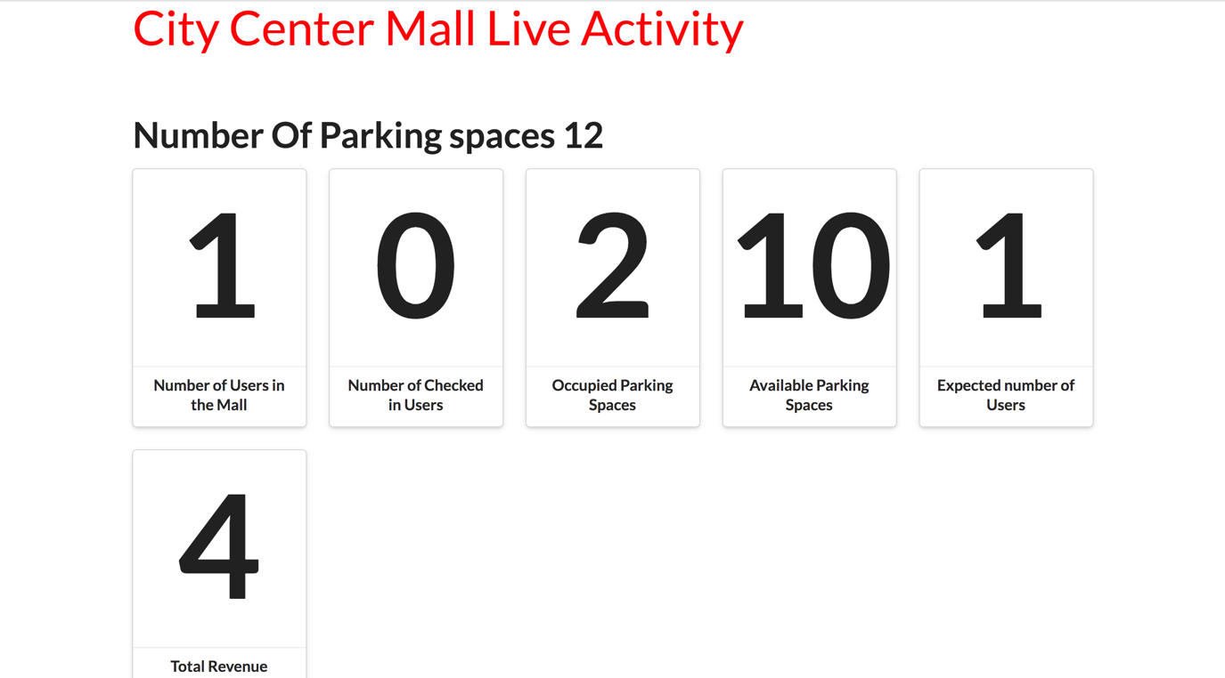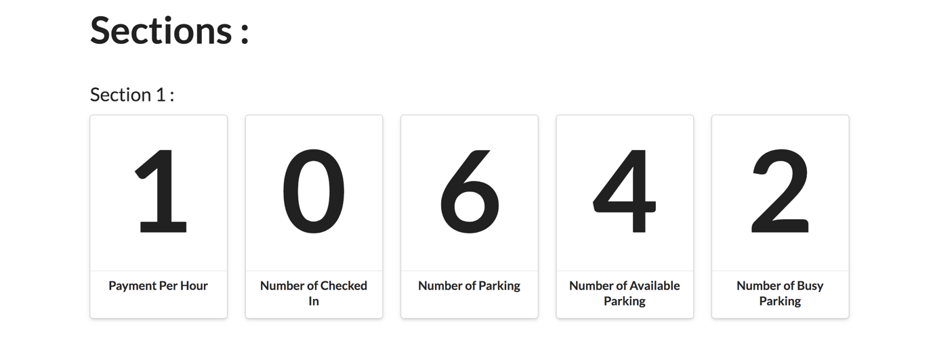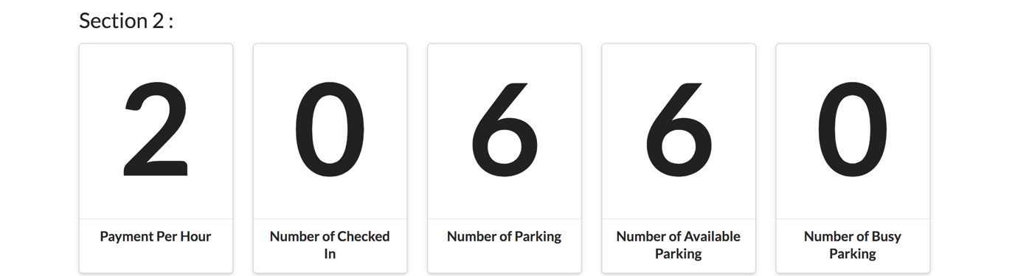

Figure 45 mall's main page

## 4.11 Design pattern

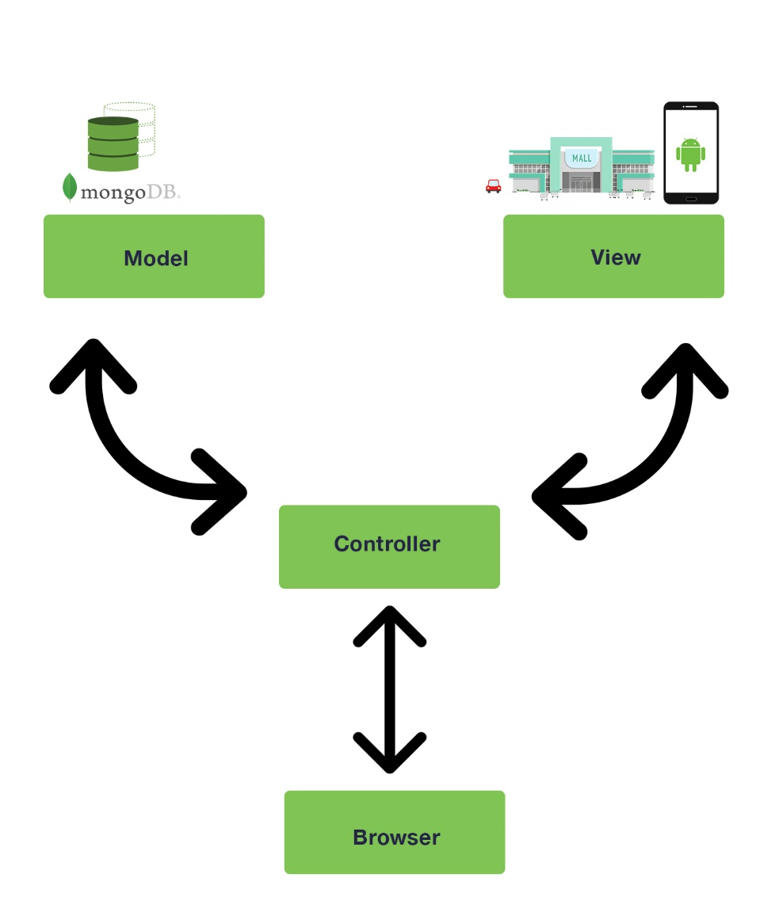

MVC Desgin Pattern

In our project, we have used the MVC design pattern. The MVC which stands for Model, View and Controller suits our system perfectly and has an advantage which is the separation of concerns. In our system, the controller’s purpose is to manage traffic and sends it where it needs to go. Moreover, the view is the interface that the user interacts with. Finally, the model is where the application logic exists and where the data is passed. There are several advantages for using MVC for example, MVC supports for asynchronous technique, also any changes in the model does not affect other aspects of the architecture. To conclude, the MVC was very important to use in our project.

# Implementation

## 5.1 Tools and Framework

In our project, we have used a couple of tools and frameworks that were crucial and made a big impact on our project. Previously, we have mentioned in our proposed solution that we are going to use Node.js as our server-side JavaScript environment since it is a very powerful tool and it is used worldwide by the biggest organizations that exist. Moreover, we have used many other tools and frameworks that helped us and each one will be mentioned below, and we will explain why we used each one of them and how they helped us throughout the project.

The main frameworks and tools that we have used in our project are: Node.js, MongoDb, Android, aRest.io, Firebase Cloud Messaging, React.js and Stripe.

**Node.JS**

Node.js is well known for its speed and efficiency and many other aspects, as mentioned before, Node JS is an open source, cross-platform JavaScript runtime environment for executing JavaScript code server side. Here are some examples of how Node.js helped us:

**Speed**: Node.js is known for its efficiency when it comes to managing asynchronous I/O. It uses its V8 engine that makes it very fast and it can handle multiple clients, for example, when multiple users try to make a reservation in a mall.

**Dynamic** **NPM**: Node.js is open source, it has well known shared repository of dynamic tools. There are about 60 thousand modules in the node package manager, in our project we have used multiple packages that helped us throughout the project, here is a list of NPM packages we used for our system:

* [arrest@0.3.0](mailto:arrest@0.3.0) :

This package is used to be able to use the Arest.io framework which will be explained in more details later in the section.

* [body-parser@1.18.2](mailto:body-parser@1.18.2) :

it is needed in our project to handle all our HTTP requests in our system, it is used as a middleware the extracts all the content of the body that is received by the incoming stream then it places it in the req.body , it also parses the JSON data that was sent.

* [express@4.16.2](mailto:express@4.16.2) :

A framework that helps organize the application, it helps build the MVC architecture, it helps handle all the requests, the routes and the views.

* [fcm-push@1.1.3](mailto:fcm-push@1.1.3) :

This package helps us to use firebase cloud messaging, it will be explained in more details later in the section.

* [mongoose@4.12.3](mailto:mongoose@4.12.3) :

This package helps with the ability of communicating with MongoDb database by providing validation and query API in simple way.

* [stripe@5.8.0](mailto:stripe@5.8.0)

This package helps use to communicate with our payment system that was used for our system, Stripe will be explained in more details later in this section.

* + - [moment@2.22.0](mailto:moment@2.22.0):

Moment.js provides native Date object, it was used in our project to add dates to reservations and count the amount of time spent by the users in the mall, it was very helpful especially in our payment system.

* + - Crypto:

Crypto was used to help in the encryption method that was used for the user’s passwords, as mentioned before, we used to crypto to encrypt using sha512 and salt with length of sixteen characters.

* + - Net Module:

Although this is not an NPM package, it is worth mentioning, Net module is a Node.js built in module that provides an asynchronies API for TCP stream. Net module was used in our system for various reasons for example:

1. If the user had the application on the reservation menu and checks in to the main gate, the server will send a command to the android phone so that it refreshes the fragment and change the reservation status from “reserved” to “checked in mall “and remove the “Take me there” button, and the same procedure happens when the user checks in the section or checks out of the mall.
2. The first demo of the project, when we viewed mall’s data to the user such as: “available spots”,” occupied spots” and the section information as well, it was not real time, the user had to refresh the fragment each time to view the new data updates. It was only based on HTTP requests which was not ideal. Net sockets helped us overcome this problem by sending commands from the server to the all android devices every time there is any change to our database and once the devices receive the command, they update all the data if the fragment has focus.

**MongoDb:**

In our project, it was mutual decision by all team member to choose MongoDB since all team members has an experience using it. As known, MongoDB is free source and it is a no SQL database. It uses JSON documents. MongoDB fits our project perfectly due to its several advantages, here are some of the advantages that mongo DB offers:

* It is very easy to scale out
* Very good query ability
* It is schema less
* Storing data as JSON
* Very fast access of data

**Firebase Cloud Messaging:**

In the beginning of the project, we were planning to use firebase as a storage for our data but then we decided to use MongoDb. Although we did not use it for storing data, we have used one of it is functionalities which is (FCM) firebase cloud messaging previously known as google cloud messaging. Firebase cloud messaging is tool made to help deliver messages to mobile applications. In our system, FCM was mainly used for our notification service, here are some examples where FCM what used in our system:

* Notify user with his pin code when user reserves a parking
* Remind user of how much time he has left to reach the mall before his reservation gets cancelled.
* Remind user of how much time he has left after he made a payment until he has to pay again.
* Notify user when he enters the main gate
* Notify user when he enters the section gate
* Notify user if the reservation got cancelled

Although we could have used sockets that were implemented in our project to achieve the same purpose which is the notification service that our application provides. We choose to use Firebase cloud messaging for this matter for several reasons:

* It does not drain the battery as much as sockets do, since it only gets triggered when needed. If we use sockets and make the connection open even if the application is on the background, it would drain the user’s battery.
* In our system, sockets are closed if the application is not in the foreground, hence FCM will help send the notifications to the users’ phones even if the application is on background.

**Arest.io:**

This library had a major impact in our project, In the beginning, our first vision was to have the LCD screen, keypad and the motor on the same microcontroller and that was going to be easy to implement, a normal scenario would be that the pin code from the keypad will be sent to the server and server will reply and based on the reply the motor will be triggered and the gate would either open or stay closed. Unfortunately, we had error in our calculations and we could not fit all the components on the microcontroller since we ran out of pins. Therefore, we had to have the motor on different nodemcu chip and we found it hard to trigger the motor from the server since we have five different motors on five different microcontrollers. After a lot of research, we found this framework and it helped us solve this problem. aRest framework is open source framework and helps to handle communications between the server and remote devices, it makes building iot applications based on Arduino much easier.

A simple example of how we used this framework is that we added a static ip address to each one of the microcontrollers that are holding the motors and we give each microcontroller a unique name that defines which motor its holding, for example the microcontroller holding the motor by the main gate is called (MAIN_GATE). Once the server runs, it connects to all the microcontrollers using their static ip addresses. The server can control any of these microcontrollers when needed. More details will be given in the next section to showcase how we used this framework.

**Stripe:**

At the beginning of our project, we had the intention to use Paypal api to build our payment system, during implementation, unintentionally we came across Stripe api and I read about and it seemed like a very good api to build our system so we decided to give it a go since we have never used It before. Stripe is a company that allows all different types of users to receive payments online. Stripe is known for their fraud prevention and their interface is very user friendly and their documentation was very easy to follow.

**React.js:**

React js is JavaScript library for user interface, it seems like it is on top it’s game right now, so we have decided to use it for the interface for the mall’s system. React has a lot of advantages for example: it is very easy to use, its reusability and Its virtual DOM.

**Java for the Android application:**

There are a couple of languages available when it comes to developing an android application, we have decided to use Java using android studio. We have chosen java since it is the official language of the system, there is a lot advantages for using java for example: most of the recourses that are available online for android development uses java, it is very secure, it is object oriented and there are a lot frameworks and classes that are available for java unlike other languages. In the beginning of the project we were debating whether to use react native and produce both an android and an ios application or just develop for android We choose to go with java for android since using react native could be a little bit risky since not all libraries are supported by react.

To summarize, all the components we used in our project were related to each other and worked perfectly together. For example, mongodb interacts with node js, node js interacts with android and react.js. Stripe and fcm interact with both node js and the android application.

In programing microcontrollers, we introduced many frameworks, we had to deal with special libraries to configure each all of: servo motors, ultrasonic sensors, LCD screen and 4x4 keypad.

The following table shows more details.

Table 11 hardware frameworks

|  |  |  |
| --- | --- | --- |
| Hardware | libraries | Creator |
| ServoMotor | <Servo.h> | Michael C. Miller |
| 16 KEY KEYPADS | <Keypad.h> | Mark Stanley, Alexander Brevig |
| 16X2 SERIAL LCDS | <LiquidCrystal_I2C.h> | Marco Schwartz |
| ULTRASONIC SENSOR - HC-SR04 | <Ultrasonic.h> | JRodrigoTech |

## 5.2 Novelty in implementation

There are a couple of novelty aspects in our project. Firstly, we think our project opens a new idea that was not implement before, it offers a new idea that may help us change the way of thinking about parking systems and how they are developed. Secondly, as mentioned before, we think our system will help our users in many ways, it will decrease their stress levels and worry when it comes to parking their car. Moreover, we believe it will decrease the amount of traffic that we find nowadays in malls or any other private parking facilities especially on weekends.

We believe our system is very user friendly and customers will find it easy to use it. Moreover, our system is built in a way where it’s very modifiable and scalable, for example: we could change the system from being able to reserve a spot in a desirable section to being able to reserve a specific parking spot in the mall, the payment system could be easily changed as well, right now the user gets charged based on the amount of time he spends in the mall and pays before he leaves the facility, this could be easily changed so that the user pays when the reservation is made and the parking spot is reserved for the user for the whole day.

## 5.3 Implementation Difficulties

During the implementation, we have faced a lot of problems in our project. Doing such a project, it was expected to get a lot of errors and a lot of time to spend on heavy debugging. Debugging was one of the biggest challenges we have faced in this project. Moreover, most frameworks we have used in our project are new to almost all team members, it took us some time to understand these frameworks and get used to It. Furthermore, It was quite tough to assign tasks to the team members as well, since we tried to assign suitable tasks for each team member, so that our work is more efficient. Furthermore, one of the toughest challenges that I personally had was how we had to interact and work alongside with the members that were responsible for the hardware in our project. I found it difficult to follow with them and agree on terms in our development phase.

In the previous paragraph, we mentioned the general challenges that we have faced in our project, in this section, we would like to be more specific in implementation areas that we have found most challenging. For example, at the beginning of our implementation, the computer science team understood the needed information from the hardware that will be sent to the server for every scenario, for example (mall id, pin code value) and so on, so that the server does its calculations and gives a reply to the hardware. We made a mutual decision with the hardware team of what exactly is needed to be sent to the server and how the processes will work. A good example would be when the user approaches the mall’s gate since it’s the simplest form of interaction between software and hardware.

Our first implementation was that the server expects to receive the id of the mall and the user’s pin Code then the server checks for that pin code in that specific mall, if it exists, server updates needed data in the database and gives a success reply to the hardware and if it doesn’t exist, server sends a failure reply. Very simple procedure. The issue occurred when we made a miscalculation in the hardware because our nodemcu module did not fit all components needed in that procedure. We wanted to fit LCD screen, motor and the key pad in one nodemcu module but we couldn’t since we ran out pins. That caused an issue because the reply received by the hardware cannot trigger both the LCD screen and the motor to take actions according to the reply for example, if the reply was successful, the LCD screen will print “successful” and the motor will open the main gate so that the user enters the mall.

It took some time to resolve this problem, after some research, we found a library called arrest.io which was mentioned in the earlier section which helps controlling the nodemcu module remotely. Our solution was to place the motor on a different nodemcu module and give that module a static ip address and a unique name that suits its functionality for example (MAIN_GATE_MOTOR). Moreover, arrest allows to you to export functions from the nodemcu module that can be accessed remotely, so we exported a function that opens the gate when the function is called. Once the server starts running, the server connects to all nodemcu modules that are holding the motors. In the server’s main gate function, server receives the pin code and mall id, if the pin code exists, the server remotely calls the exported function which opens the gate and server gives back a reply to the nodemcu that made the request so that it updates the LCD screen depending on the reply.

Another issue that we came across was the payment system. At the beginning of the project we implemented the payment system in such a way where the user needs to pay first to make the reservation. The problem came across when user needed to cancel his reservation, we could not implement the refund method where the user gets his money back after the cancellation. Moreover, it did not seem like a good approach to keep the parking occupied for the whole day just for one user even if the user did not go the mall. The reason why we took his approach at the first place was because our original approach had a problem where users had the ability to keep reserving parking spaces and then cancel their reservations which does not seem feasible.

We implemented the payment system again using our original idea, where the user only pays when he needs to check out of the section. We handled all scenarios that we could think of, for example: when the user reserves a spot, he needs to get to the mall within certain amount of time for example one hour, otherwise his reservation will get cancelled. Furthermore, if the user cancelled more than two reservations, his account will get suspended for a certain amount of time for example ten days. Furthermore, our payment systems start calculating time starting when the user checks in his section until he needs to check out, a normal scenario would be that the user would go to mall and pay using the phone on his way back to his car. First issue came up was that the user could pay straight away once he checked in the system so that he gets charged less amount of money. We handled this issue by giving the user a certain amount of time to leave the section gate using his exit pin code for example 10 minutes, otherwise, the user will need to pay again. We made this part clear by sending user two notifications that reminds him that if he did not leave, he will need to pay again. First notification is sent when the user has five minutes left to leave and the second one is when he has two minutes left to exit the gate. Moreover, we showed the user a countdown that can be seen if he is viewing his reservation page where it shows him how much time he has left to exit the section. Another issue that occurred after implementing the payment system was that we wanted the user to view his payment at any time needed after the user checks in the section so that he is aware of how much he needs to pay at any time while he is in the mall. The problem was if the user viewed the payment fragment, and left his phone on or locked his phone, the payment would not change, the first solution was to make the payment real time but then we thought that the users might get tricked into paying something different than what they saw, so we handled his using different methods for each case, for example if the user left his phone on the payment fragment, the app will redirect itself to the reservation fragment after few minutes.

Finally, one of the most challenging areas in the project, was the implementation of the android application, we found it very complicated while implementing it , the implementation of the application was changed a couple of times during the project , some of the areas that were challenging are the fragment control , since the application is made out of only four activities , everything else in the application was implemented using fragments and the life cycle of the fragments were complicated in some areas as well.

In the hardware side we faced many problems as well, our design contains different components and each component is designed in different ways that suite its purposes for example, our designed plan is to combine ultrasonic sensor with servo motor in one NodeMcu microcontroller but unfortunately the sensor can’t be powered with less than 5v for the controller only supply 3.3v, So we got to use another outer voltage source. Another problem we faced during our implementation in LCD programing we tried to construct a LiquidCrystal_I2C object and pass it the I2C address, width in characters, and height in characters. The address is likely always 0x3F for NodeMCUs, However, this address did not work for us, so we had to dig in to find the solution for this situation. After a lot of search, we find out that Arduino provides an example sketch that scans for I2C addresses and we find out that the addresses that works is 0x27 instead of 0x3F.

Our project is a combination between different aspects, although the project mainly focused on computer science and engineering aspects we introduced to architecture engineering to design the model in proper way. After some researches in architecture engineering we come up with a neat design of a parking area that suit our need to simulate our design.

Figure 46 side view of design model

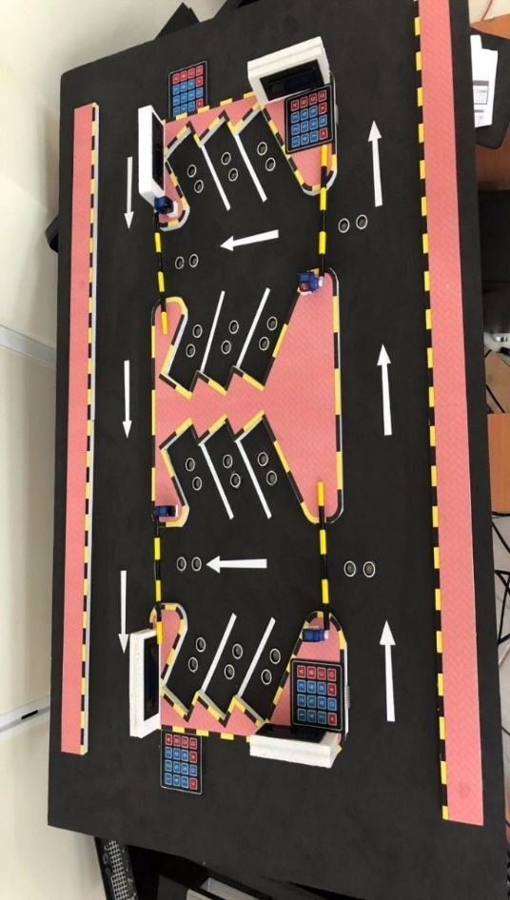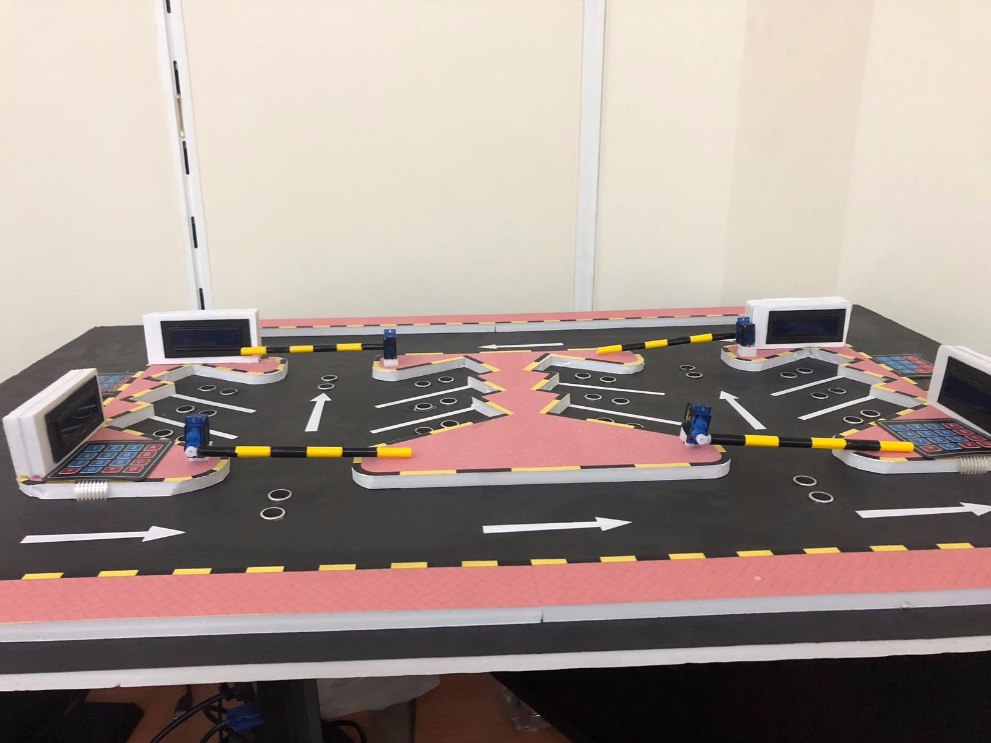

Figure 47 : top view of the model

Figure 48 : customer trying to enter the parking

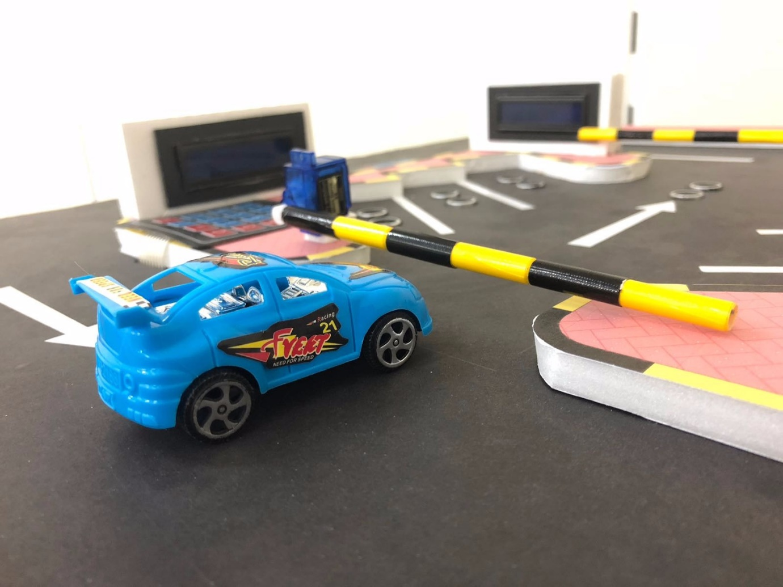

Here is table that summarizes some other small challenges that we have faced during our project.

Table 12 challenges

|  |  |
| --- | --- |
| Problem encountered | Method of addressing it |
| Have no previous experience in using react js | We had to go through many tutorials to understand how it works |
| Limitation of online recourses about arest.io library | We had to do a lot research to know how to use it. |
| Lack of hardware that took time to arrive to Qatar | We had to wait and do whatever we can do on what we currently had. |

## 5.4 Actual images of various modules

Figure 49 : Actual image of user authentication module

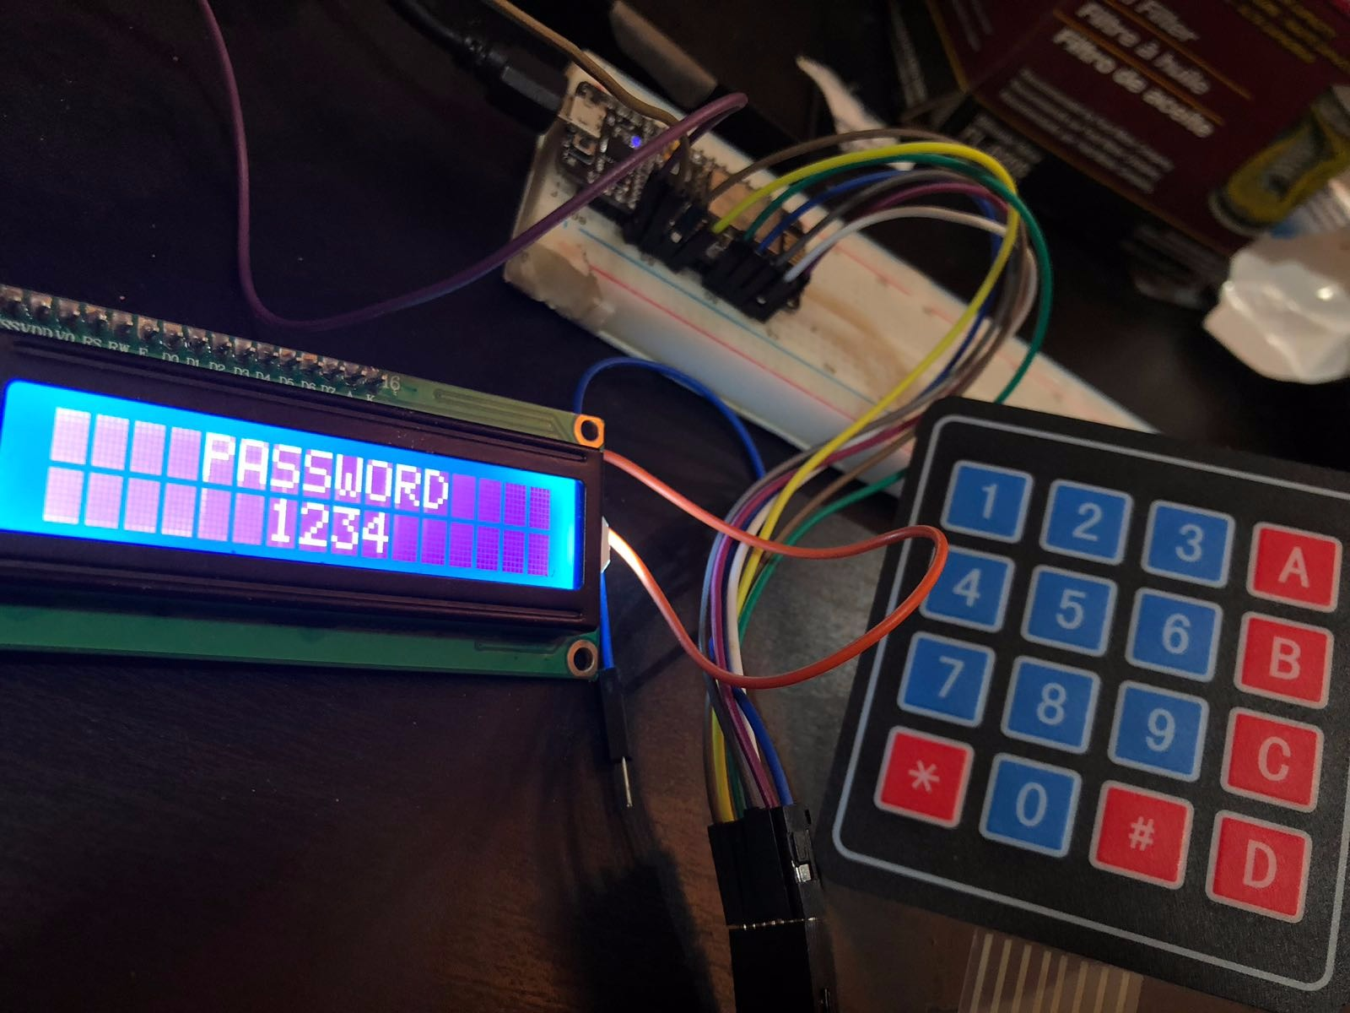

Figure 50 actual image of barrier module when an object placed over the sensor.

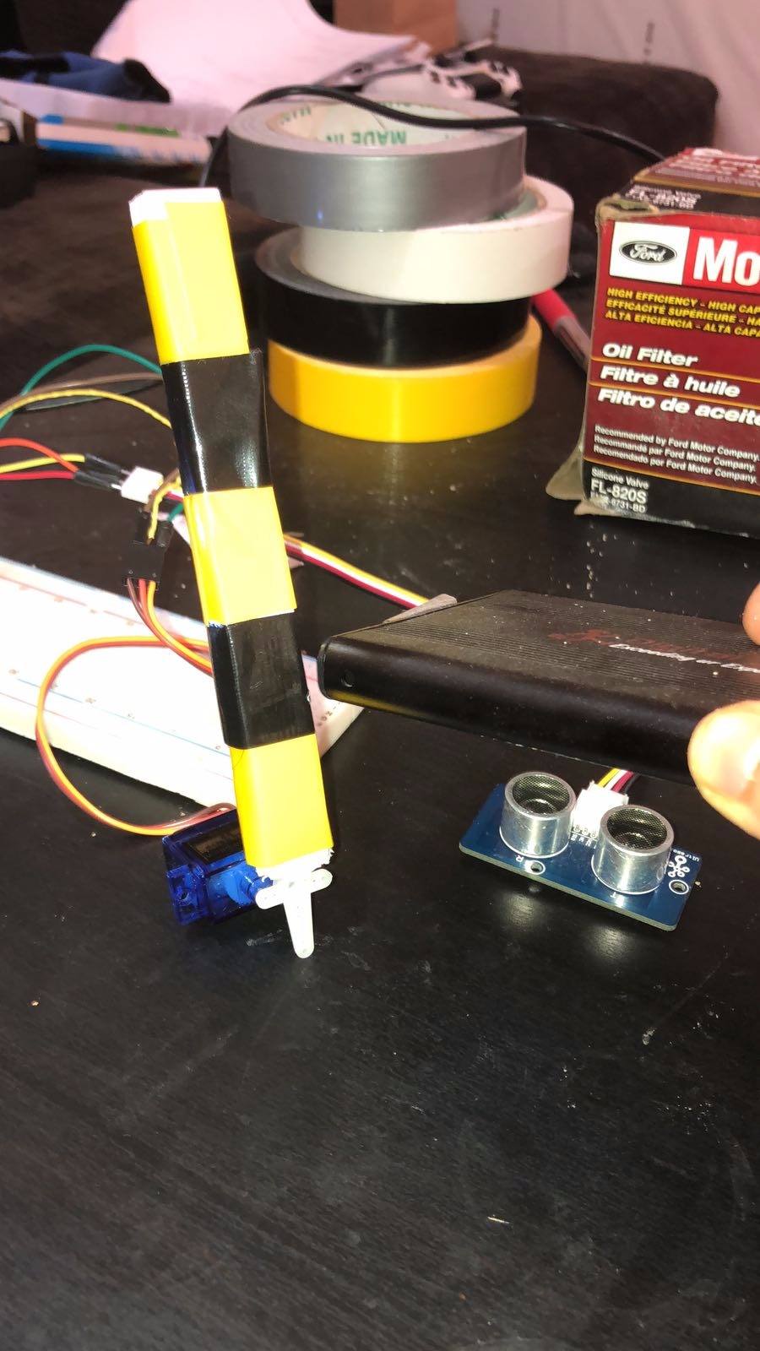

Figure 51 actual image of barrier module when an object not placed over the sensor.

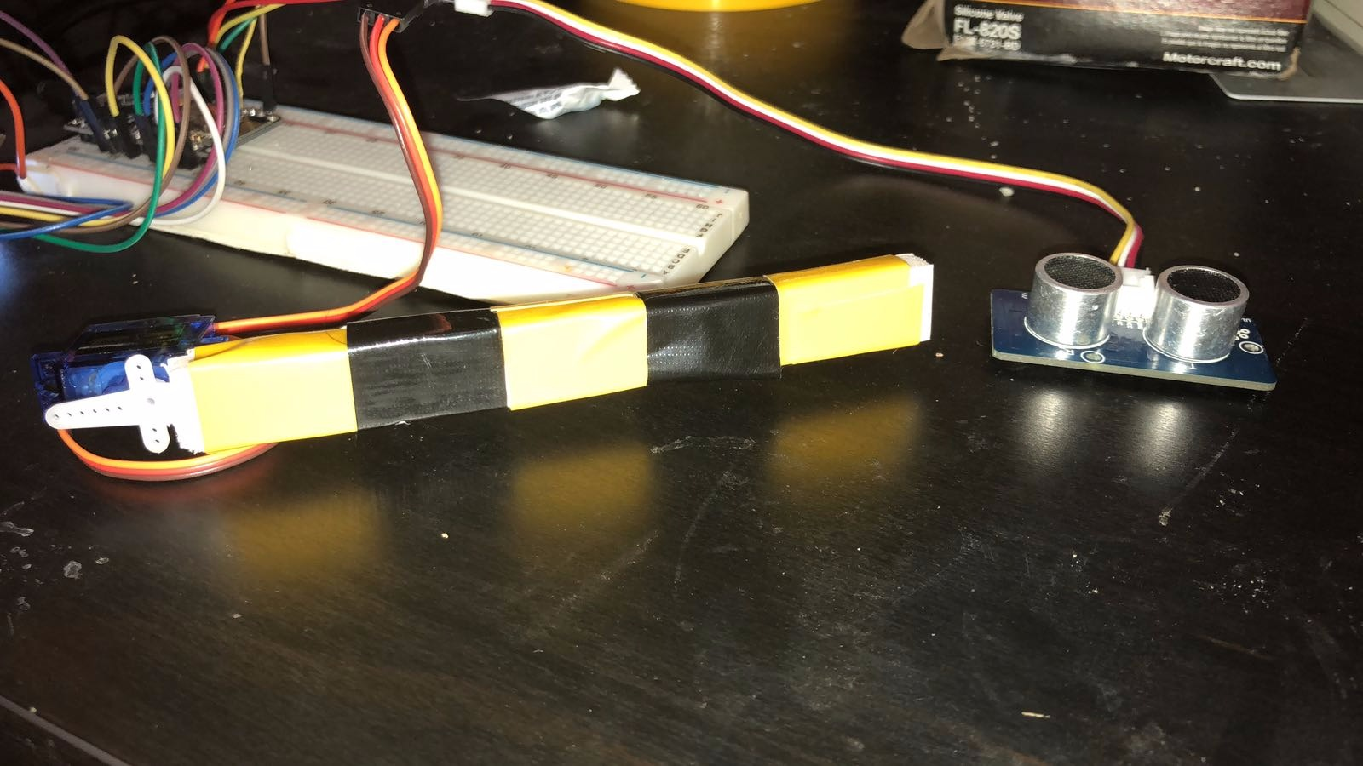

Figure 52 actual image of parking availability indicators module (Empty parking)

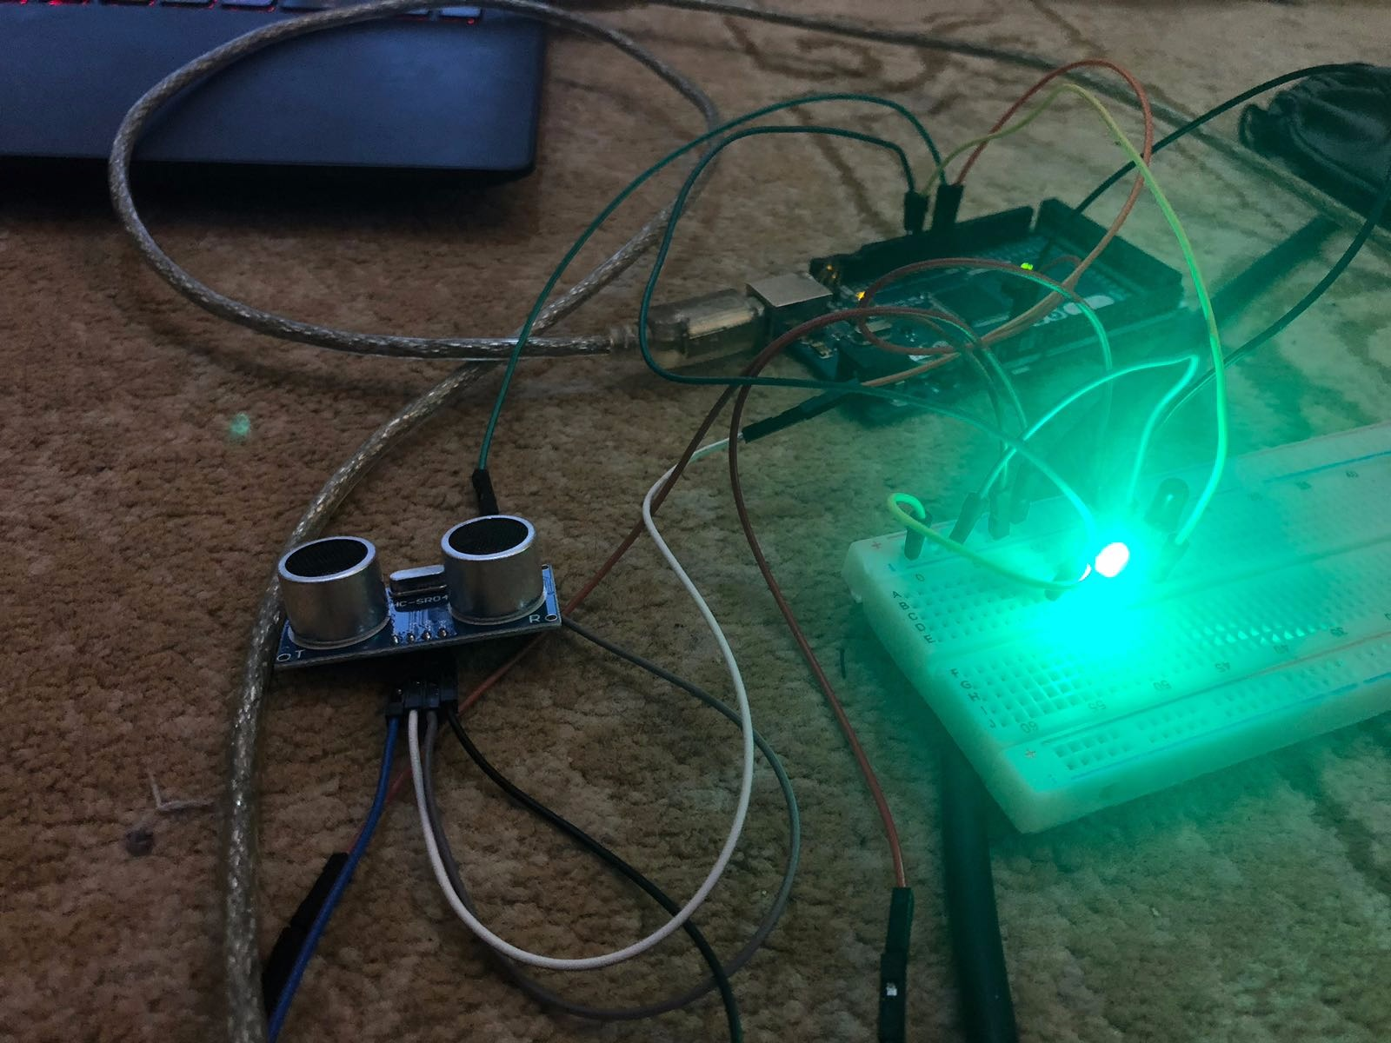

Figure 53 Figure 54 actual image of parking availability indicators (reserved parking)

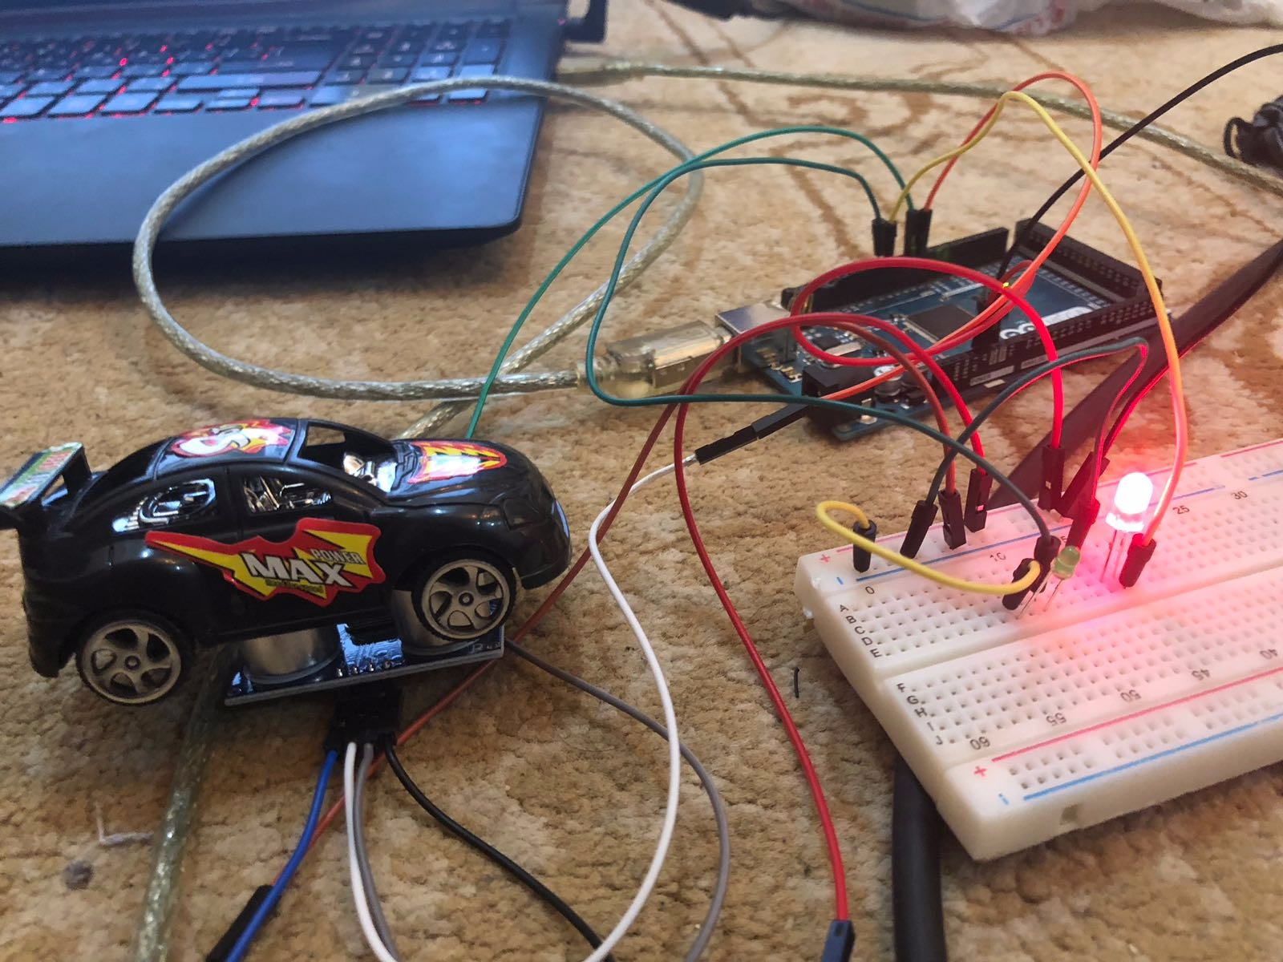

## 5.5 Actual Design description with pictures and diagrams

Figure 55 : wiring diagram of the whole hardware design

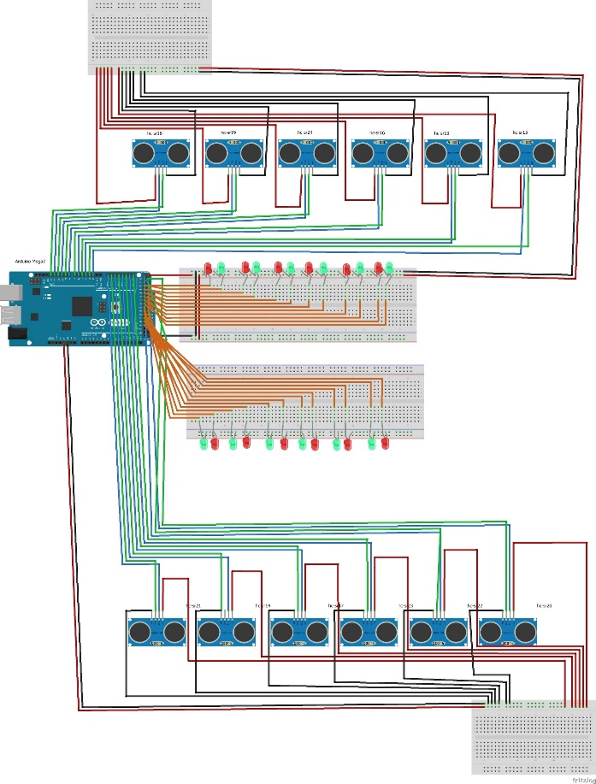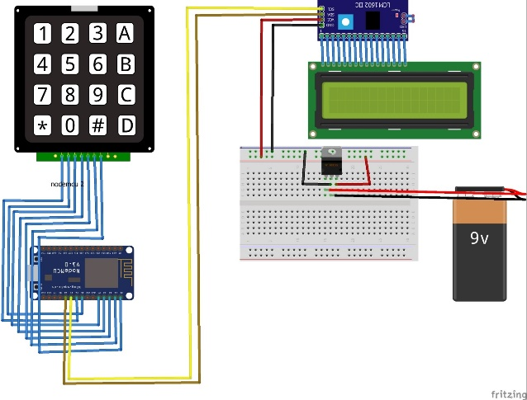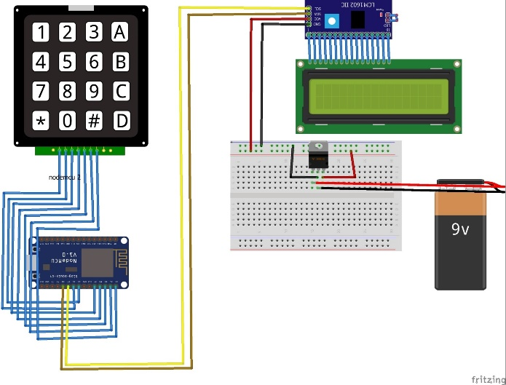





the design we made composed of small scale model of parking area and bunch of micro controllers and electric components such as ultra-sonic sensors and servo motors. The above image can show the actual modules that used in the design. We combine all of parking indicators module, barrier module and user authentication module.

# Testing

## 6.1 Black box testing

In our project, we have decided to use black box testing as our main method of testing, it was used to test each use case in our system. This area of testing is focused only on the software used in the system excluding the hardware. We use manual post requests in this section to simulate the hardware effect on the software. In the table below, we wrote a small description of the use cases, gave it a test case id and we show if it had passed the functional requirements and non-the functional requirements. finally, all the details of the test cases will be found at the appendix (see.2.Test cases)

This section also covers our UI testing, since all functionalities in the application were tested during the test cases.

* Create account

Table 13 Black box testing

|  |  |  |  |
| --- | --- | --- | --- |
| **Test Case ID** | **Description** | **Functional Requirements** | **Non-Functional Requirements** |
| Create account 01 | User successfully creates account with supplied details | Passed | Password encryption using salt and hash (2.2) (met)  Creating accounts takes about 2 seconds or less  (4.a) (met ) |
| Create account 02 | Users informed when they try to use an already existing email | Passed | No requirement is needed |
| Create account 03 | Users informed when they enter any invalid details that do not meet system requirements | passed | No requirement is needed |
| Create account 04 | Users informed when they try leave empty required fields when they create their account | passed | No requirement is needed |

* Edit profile

|  |  |  |  |
| --- | --- | --- | --- |
| **Test Case ID** | **Description** | **Functional Requirements** | **Non-Functional Requirements** |
| Edit profile 01 | User successfully edits information in his profile | Passed | Updating user’s information takes less than 2 seconds (4.f) (met) |
| Edit profile 02 | Notify user if he enters invalid information | Passed | No requirement is needed |

* Reset password

|  |  |  |  |
| --- | --- | --- | --- |
| **Test Case ID** | **Description** | **Functional Requirements** | **Non-Functional Requirements** |
| Reset password 01 | User successfully changes his password | Passed | Password encryption using salt and hash (2.2) (met) |
| Reset password 02 | Users informed if they enter incorrect details while changing their password. | Passed | No requirement is needed |
| Reset password 03 | Users are informed if they leave empty fields | Passed | No requirement is needed |
| Reset password 04 | Users are informed if they enter incorrect old password | Passed | No requirement is needed |

* Delete account

|  |  |  |  |
| --- | --- | --- | --- |
| **Test Case ID** | **Description** | **Functional Requirements** | **Non-Functional Requirements** |
| Delete account 01 | User successfully deletes his account | Passed | Users accounts gets deleted less than 2 seconds (4.h) (met) |
| Delete account 02 | Users are informed if they cannot delete account when they already checked in a mall | Passed | No requirement is needed |
| Delete account 03 | If a user currently has a reservation and the reservation status is “Reserved” , the reservation gets cancelled and account gets deleted. | Passed | No requirement is needed |

* View profile

|  |  |  |  |
| --- | --- | --- | --- |
| **Test Case ID** | **Description** | **Functional Requirements** | **Non-Functional Requirements** |
| View profile 01 | User successfully views his account | Passed | it takes less than 2 seconds to view personal information (4.e) (met) |

* View reservation history

|  |  |  |  |
| --- | --- | --- | --- |
| **Test Case ID** | **Description** | **Functional Requirements** | **Non-Functional Requirements** |
| View reservation history 01 | User successfully views his reservation history | Passed | it takes less than 2 seconds to view personal information (4.e) (met) |

* View Transaction history

|  |  |  |  |
| --- | --- | --- | --- |
| **Test Case ID** | **Description** | **Functional Requirements** | **Non-Functional Requirements** |
| View Transaction history 01 | User successfully views his transaction history | Passed | it takes less than 2 seconds to view personal information (4.e) (met) |

* Take me there

|  |  |  |  |
| --- | --- | --- | --- |
| **Test Case ID** | **Description** | **Functional Requirements** | **Non-Functional Requirements** |
| Take me there 01 | Google maps is successfully launched, and user is directed to the mall | Passed | No requirement is needed |

* Pick mall

|  |  |  |  |
| --- | --- | --- | --- |
| **Test Case ID** | **Description** | **Functional Requirements** | **Non-Functional Requirements** |
| Pick mall 01 | sections information is viewed to the user | Passed | Malls information are displayed less than 2 seconds  (2.b) (met) |

* Choose section

|  |  |  |  |
| --- | --- | --- | --- |
| **Test Case ID** | **Description** | **Functional Requirements** | **Non-Functional Requirements** |
| Choose section 01 | User successfully chooses section and has the option to reserve in it | Passed | No requirement needed |

* View payment

|  |  |  |  |
| --- | --- | --- | --- |
| **Test Case ID** | **Description** | **Functional Requirements** | **Non-Functional Requirements** |
| View payment  01 | User successfully views his payment information | Passed | No requirement is needed |
| View payment  02 | Payment cannot be viewed for more than two minutes | Passed | Avoid users from leaving the facility without paying the actual amount that they need to pay. (2.7) (met) |

* Pay later

|  |  |  |  |
| --- | --- | --- | --- |
| **Test Case ID** | **Description** | **Functional Requirements** | **Non-Functional Requirements** |
| Pay later  01 | Users are redirected to their reservation page successfully | Passed | No requirement is needed |

* Reserve parking

|  |  |  |  |
| --- | --- | --- | --- |
| **Test Case ID** | **Description** | **Functional Requirements** | **Non-Functional Requirements** |
| Reserve parking  01 | Users successfully reserve their parking and receive a pin code and receive notification with their pin code | Passed | Reservation time takes less than 2 seconds on average  (2.g) (met) |
| Reserve parking  02 | Users are notified if they already have a reservation and they are informed that they cannot reserve | Passed | Users are allowed only to reserve one parking space (2.6) (met) |
| Reserve parking  03 | Users are notified if there are no available parking spaces in the section that they choose | Passed | No requirement is needed |
| Reserve parking  04 | Users receive two remainders until they reach the mall | Passed | No requirement is needed |
| Reserve parking  05 | Users reservation get cancelled if they did not reach on time and they receive a notification | Passed | No requirement is needed |
| Reserve parking  06 | Mall’s information and section’s information’s are updated to all users when the first test case passes | Passed | Data changes are real time  (4.i) (met) |
| Reserve parking 07 | If (Reserve parking  05) test case and it was the third time that this happened, user gets banned and logged out of the system | Passed | Users do not have the option to keep reserving a space without using it  (2.5) (met) |

* Cancel reservation

|  |  |  |  |
| --- | --- | --- | --- |
| **Test Case ID** | **Description** | **Functional Requirements** | **Non-Functional Requirements** |
| Cancel reservation  01 | Reservation is cancelled successfully, and user is notified | Passed | Cancellation takes less than 2 seconds (3.j) (met) |
| Cancel reservation 02 | User is banned and logged out of the system if it’s his third cancellation | Passed | Avoiding users from wasting recourses of the mall  (2.5) (met) |
| Cancel reservation 03 | Mall’s information and section’s information are updated successfully when the first test case passes. | Passed | Data changes are real time  (4.i) (met) |

* Check out

|  |  |  |  |
| --- | --- | --- | --- |
| **Test Case ID** | **Description** | **Functional Requirements** | **Non-Functional Requirements** |
| Check out  01 | Payment is successful, and user receives exit pin code | Passed | Check out is quick and reliable using Stripe api, it takes less than 4 seconds (4, j) (met)  Avoid saving credit card information. (2.3) (met) |
| Check out  02 | Users who enter invalid information are notified by the system | Passed | No requirement is needed |
| Check out  03 | Users who did not fill all information are notified by the system | Passed | No requirement is needed |
| Check out  04 | Users need to pay again if they did not leave in time | Passed | Avoid users from leaving the facility without paying the actual amount that they need to pay. (2.7) (met) |
| Check out  05 | User receives two remainders informing the amount of time left until he exits the facility | Passed | No requirement is needed |

* Check in main

|  |  |  |  |
| --- | --- | --- | --- |
| **Test Case ID** | **Description** | **Functional Requirements** | **Non-Functional Requirements** |
| Check in main  01 | User checks in mall and receives notification | Passed | No requirement is needed |
| Check in main  02 | Users are notified when they enter a non-existing pin code | Passed | No requirement is needed |
| Check in main  03 | User entering an existing pin code that has been used to check in, the pin code will be rejected, and user will be notified | Passed | Minimize guessing of pin code and unauthorized users to check in (2.4) |

* Check in section

|  |  |  |  |
| --- | --- | --- | --- |
| **Test Case ID** | **Description** | **Functional Requirements** | **Non-Functional Requirements** |
| Check in section  01 | User checks in section and receives notification | Passed | No requirement is needed |
| Check in section  02 | Users are notified when they enter a non-existing pin code | Passed | No requirement is needed |
| Check in section  03 | User entering a pin code that already have been used to check in the section, the pin code will be rejected, and user will be notified | Passed | Minimize guessing of pin code and unauthorized users to check in (2.4) |
| Check in section  04 | User entering an existing pin code, but the owner of that pin code did not check in the main gate yet, the pin code will be rejected | Passed | Minimize guessing of pin code and unauthorized users to check in (2.4) |
| Check in section  05 | User enters an existing pin code that is related to another section, pin code will be rejected, and user will be notified | Passed | Minimize guessing of pin code and unauthorized users to check in (2.4) |

* Exit section

|  |  |  |  |
| --- | --- | --- | --- |
| **Test Case ID** | **Description** | **Functional Requirements** | **Non-Functional Requirements** |
| Exit section  01 | User checks out of mall and receives notification | Passed | No requirement is needed |
| Exit section  02 | Users are notified when they enter a non-existing exit pin code | Passed | No requirement is needed |
| Exit section  03 | User entering an existing exist pin code that has been used to check out, pin code will be rejected, and user will be notified | Passed | Minimize guessing of pin code and unauthorized users to check in (2.4) |
| Exit section  04 | Mall’s information and section’s information are updated successfully when the first test case pass. | Passed | Data changes are real time  (4.i) (met) |
| Exit section  05 | User enters an existing exit pin code that is related to another section, pin code will be rejected, and user will be notified | Passed | Avoid users from leaving the facility without paying the actual amount that they need to pay. (2.7) (met) |

## 6.2 Performance testing

For performance testing, we tested the response time for each of our nonfunctional requirements in the performance section using j meter software tool. JMeter is an Apache project that is commonly used for load testing tool for analyzing the performance of a variety of services.

In the table below, we have tested ten samples, each sample representing a test case where we measure the response time for a specific nonfunctional requirement. Moreover, for each sample or test case, the table summarizes information such as: “status” which represents whether the request has passed or failed, “sample time” which represents the response time.

Table 14 Summary table

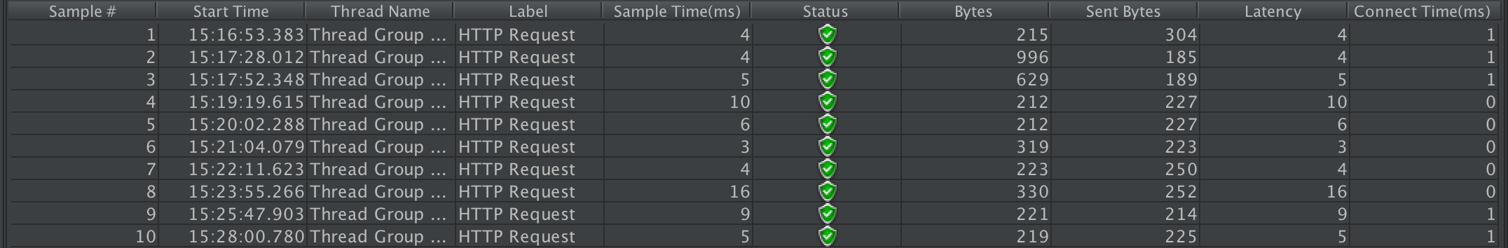

summary table

Sample 1: represents “Create account”: (non-functional requirement: 4.a)

Sample 2: represents “Retrieving mall and viewing it to the user”: (non-functional requirement: 4.b)

Sample 3: represents “Retrieving sections within a mall”: (non-functional requirement: 4.c)

Sample 4: represents “Retrieving user’s reservations”: (non-functional requirement: 4.e)

Sample 5: represents “Retrieving user’s transactions”: (non-functional requirement: 4.e)

Sample 6: represents “Retrieving user’s information”: (non-functional requirement: 4.e)

Sample 7: represents “Editing user’s information”: (non-functional requirement: 4.f)

Sample 8: represents “Creating a reservation for a user: (non-functional requirement: 4.g)

Sample 9: represents “Canceling user’s reservation” (non-functional requirement: 4.j)

Sample 10: represents “Deleting a user’s account” (non-functional requirement: 4.h

Response time graph representing above data:

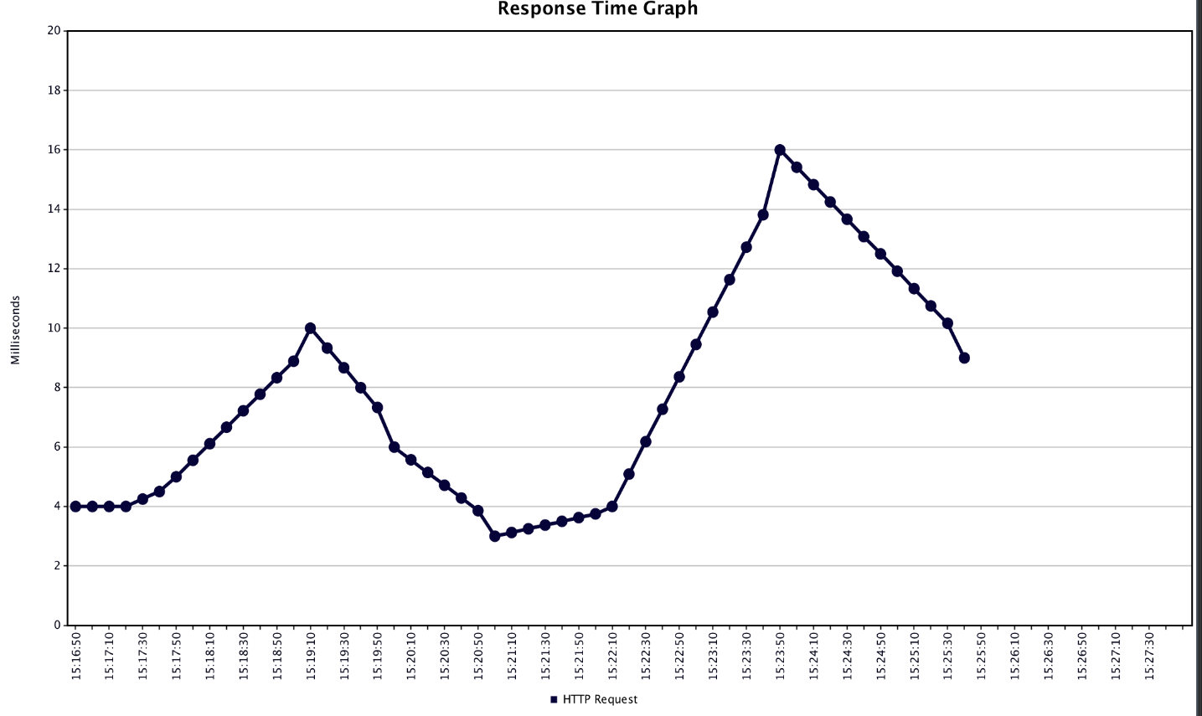

Figure 56 Response time graph

The above graph shows the response time in milliseconds for all test cases, as you can see in the graph above, our highest response time was 16 milliseconds which means that all the non-functional requirements that were tested had passed.

## 6.2 Hardware components testing

### 6.2.1 ultrasonic sensor hc-sr04 testing

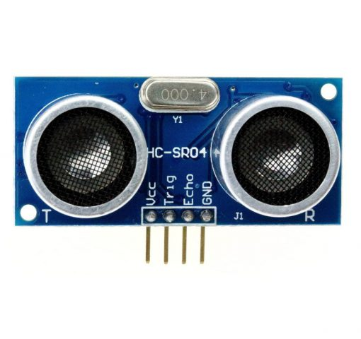

hc-sr04 is an ultrasonic sensor, the main use of it is to calculate distance between an object placed a distance from the sensor by sending a pulse signal and receiving an echo signal. We used this sensor to indicate if a car placed in the right spot. However, these sensors known by its sensitivity and its many problems, for example sometimes it reads wrong values because lack of voltage or sometimes it gets dusty which lead to a wrong reading. To solve these issues, we test the module separately and check the reading.

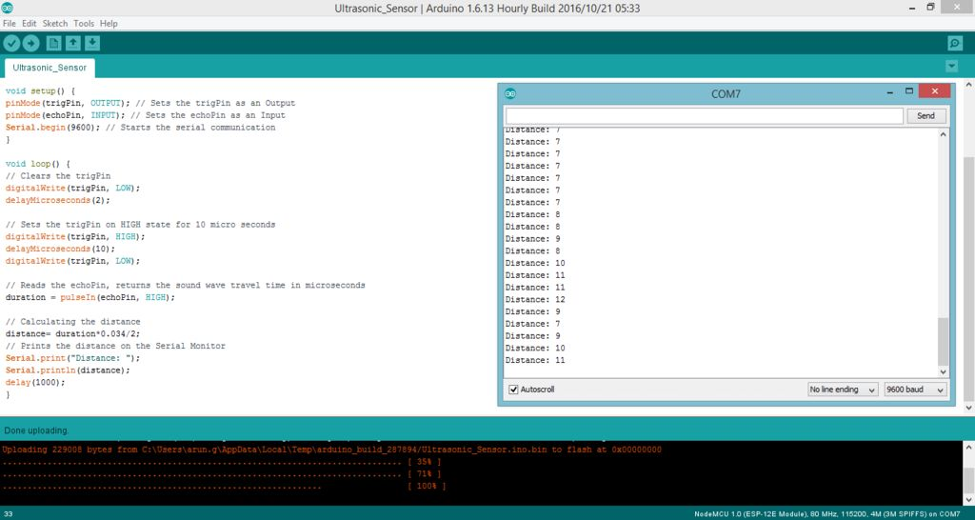

Figure 57 : Ultrasonic testing serial printer

### 4×4 matrix keypad testing

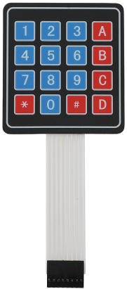

Figure 58 keypad

The keypad used to take the user’s input with the matrix keypad, we simply need to connect both its columns and rows to the pins of the NodeMCU any missing pin could lead to the entire row or column to be disabled so we have to make sure to get the connections right by testing the key pad module.

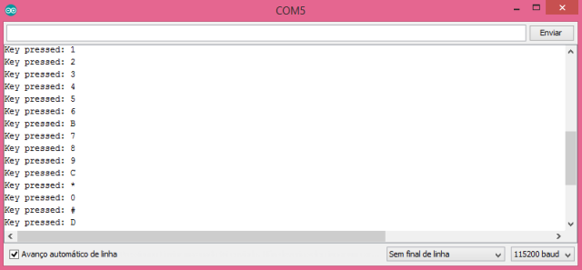

Figure 59 keypad testing using serial printer

### 6.2.3 Servo motor testing

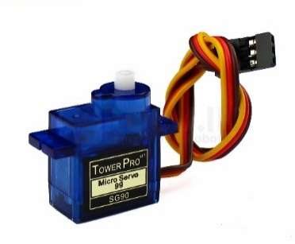Figure 60 :servo motor

Servos are so simple in terms of implementation it has only 3 pins GND,VCC and data the only thing that we observe when we tested the motors that it vibrate so roughly when we supplied it with 3.3v where it needs 5v to work properly.

### 16x2 LCD display using I2C testing

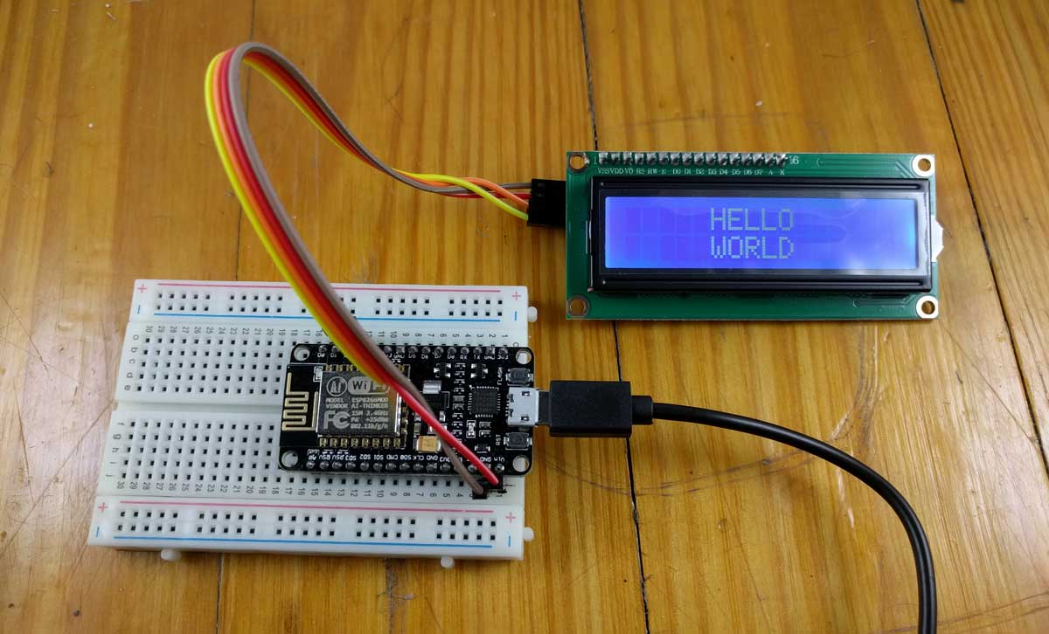

Figure 61 actual image of lcd testing

Testing LCD and make sure it actually displays, these screens are sensitive in terms of coding and wiring. The first thing we do is construct a LiquidCrystal_I2C object and pass it the I2C address, width in characters, and height in characters. The address is likely always 0x3F for NodeMCUs. while testing we found out that two of our screens are using 0x27 and two are using 0x3F.

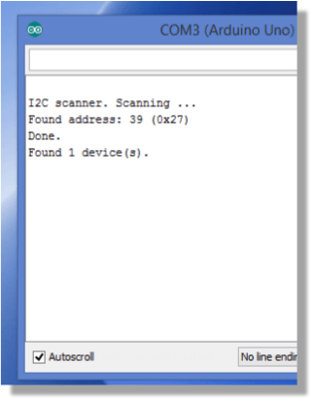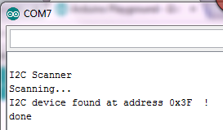

Figure 62 LCD scanner

## 6.3 normal senario testing

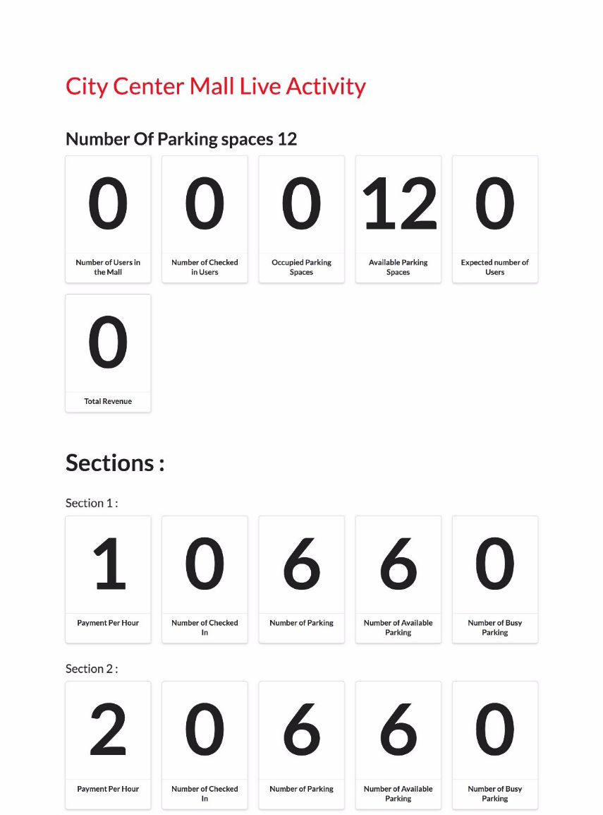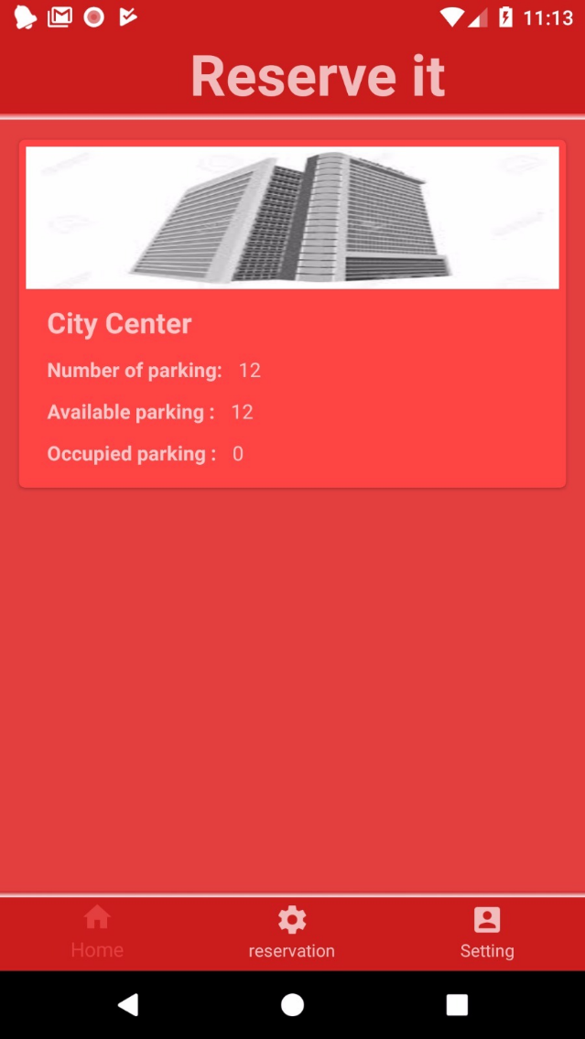Now, after we test all the components we are ready to merge the all above component with the software application.

As you can see in the above images, these are the default settings for that mall. The application image shows that all the parking slots are available and the mall’s interface showing the default statistics of the mall. User can now click on the mall’s image so that sections information is viewed, and the user has the option to make a reservation.

After the user makes his reservation, user receives his pin code as shown in the image above. Moreover, the mall’s statistics are updated, as you can see, expected number of user has changed to 1, available parking spaces changed to 11, occupied parking spaces changed to 1 and the same updates happened in section’s one information.

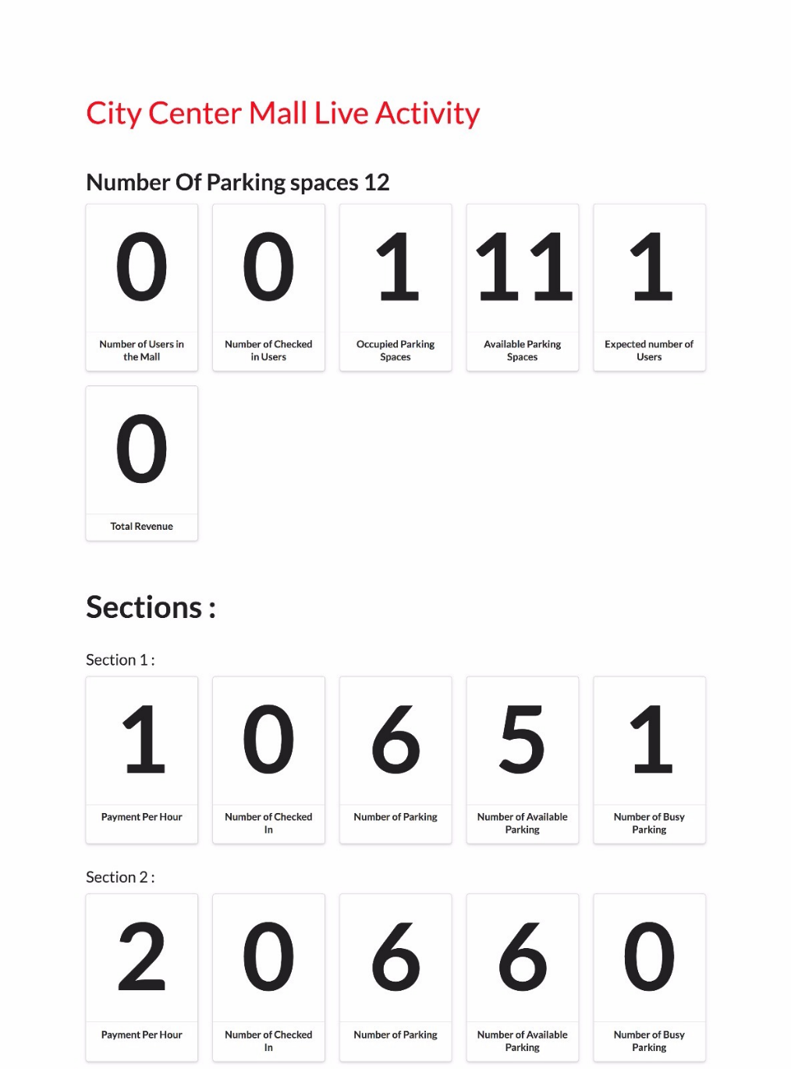

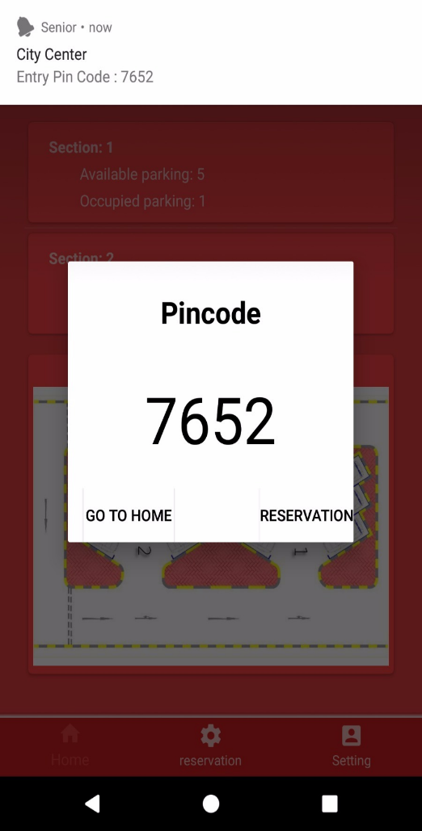

When the user enters the main gate, the reservation fragment will be refreshed and the mall’s statistics will update, as you can see the number of users in the mall has changed to one.

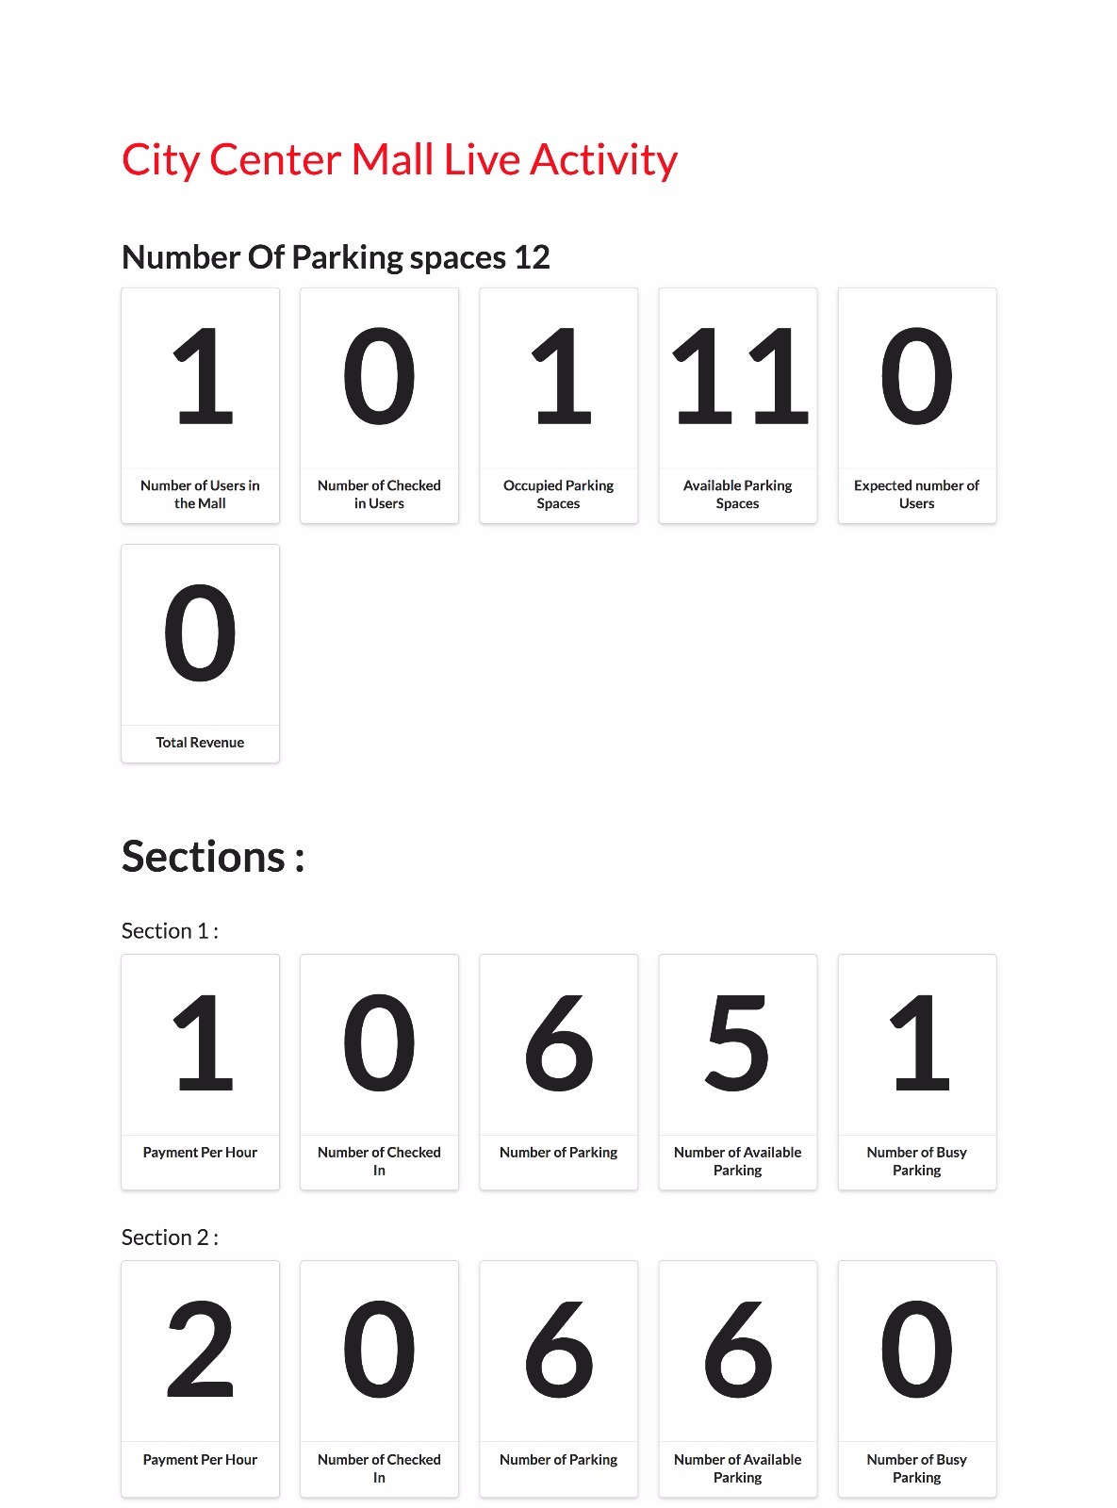

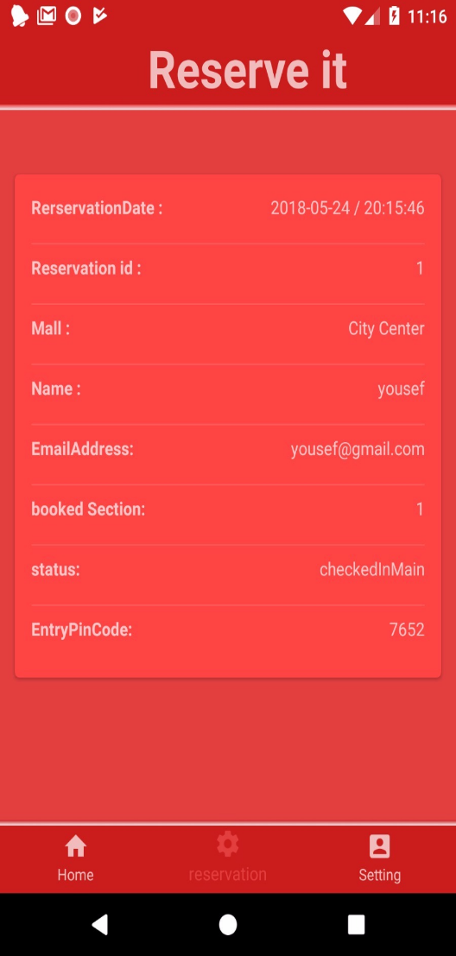

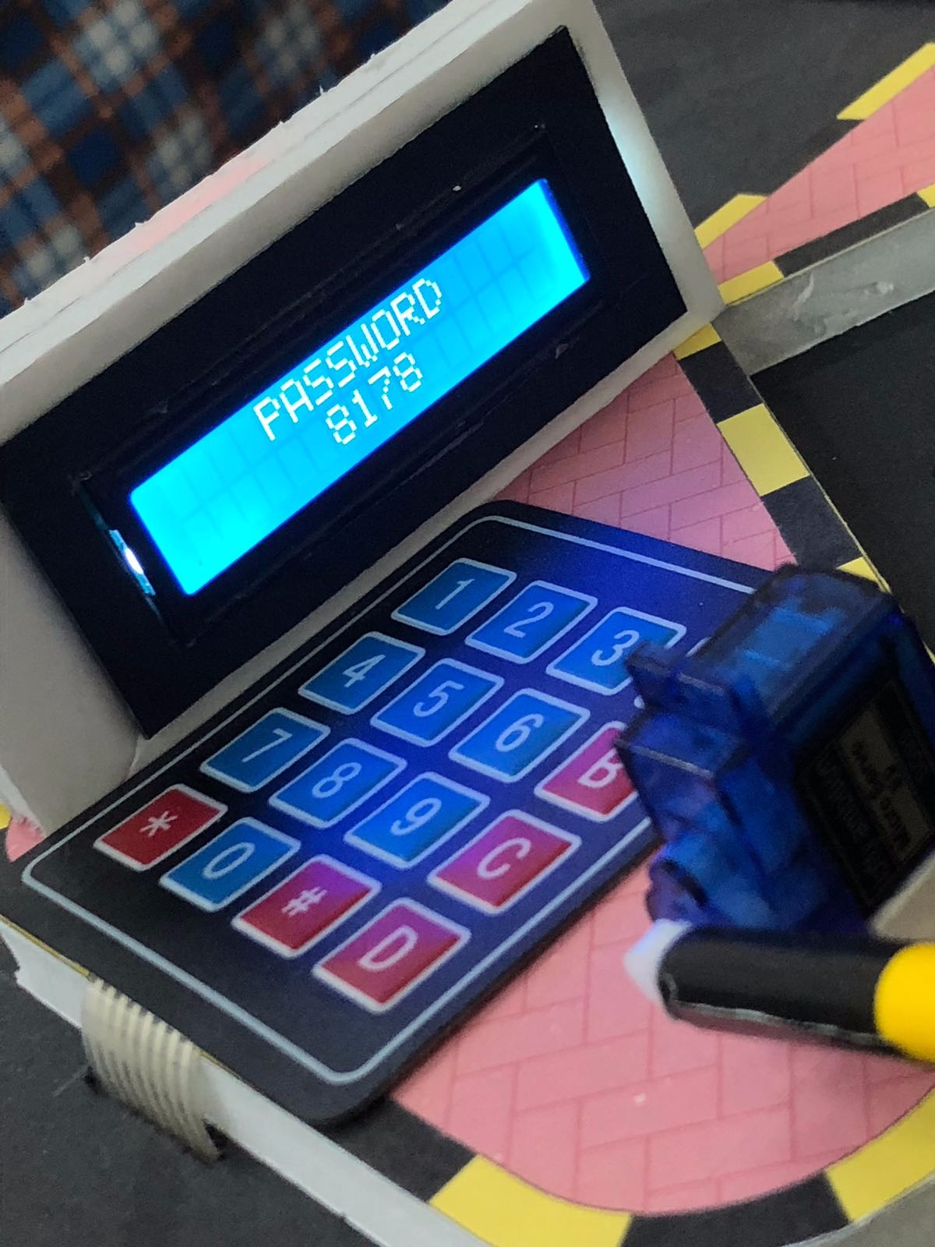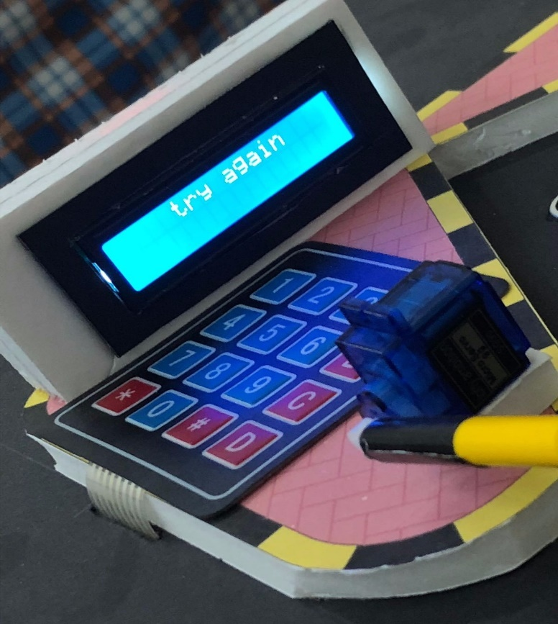

We can clearly see that the user enters a wrong pincode in the top-left image. After the user submits the code, the pin code is sent to the server and the pin code is not found in the database. The LCD screen prints “try again” in the top right photo. In the bottom -left photo the user types the correct pin code.In this senario , the pincode is found in the database. The screen now prints “Accepted” in bottom-right image.

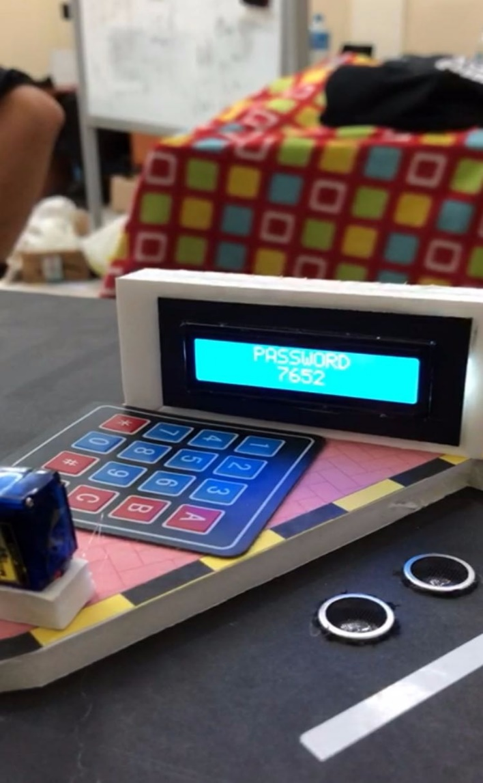

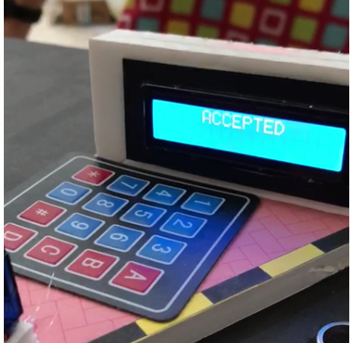

After user authenticatoin , the ultrasonic will be triggered which leads to the servo motor rotating which opens the gate as shown on the left image.The user has now the option to view his payment details . Finally , the malls statistics are updated where the number of checked in users is incremented.

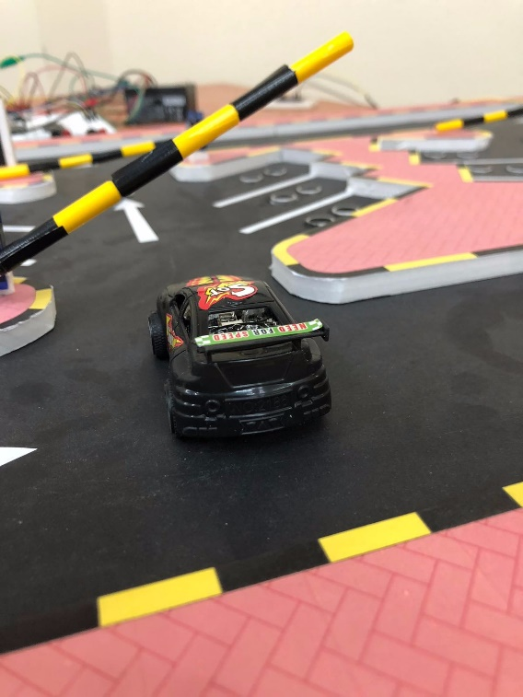

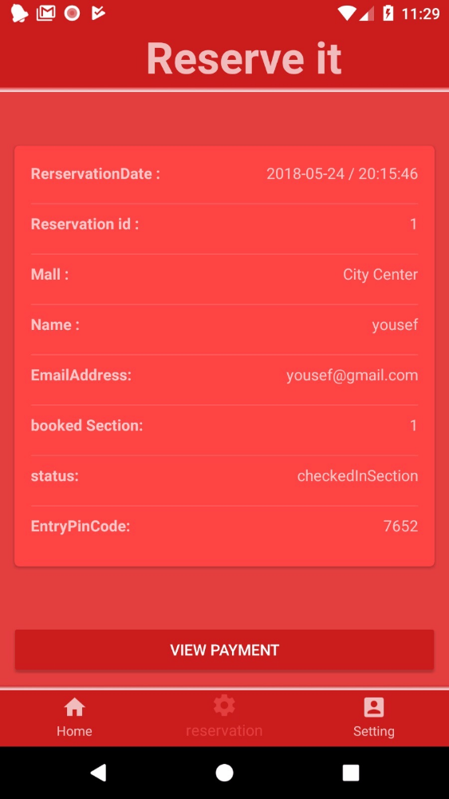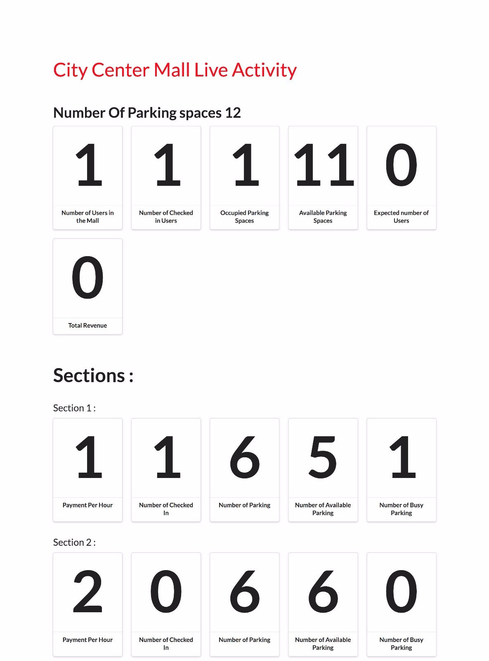

The user decides to leave now so he views his payment, and then checks out. The image on the right side shows the updated mall’s information after the user has made his payment. As you can see, the total revenue field is updated successfully.

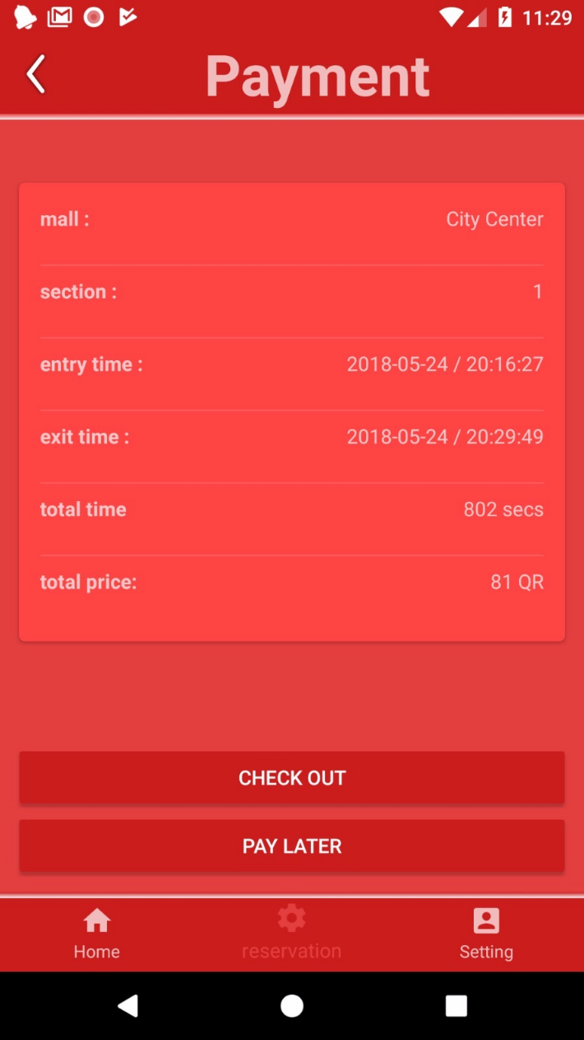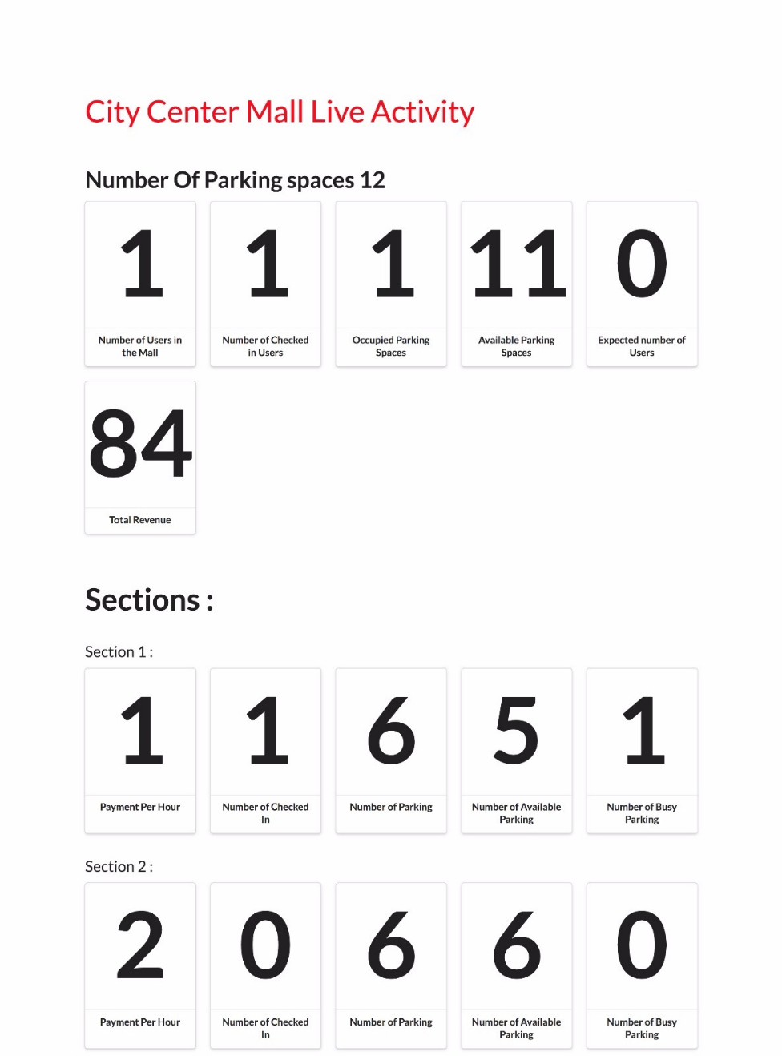

This is the procedure that happens when the user makes his transaction.

Step 1: user enters the credit card number and name Step 2: Then he input the expiery date

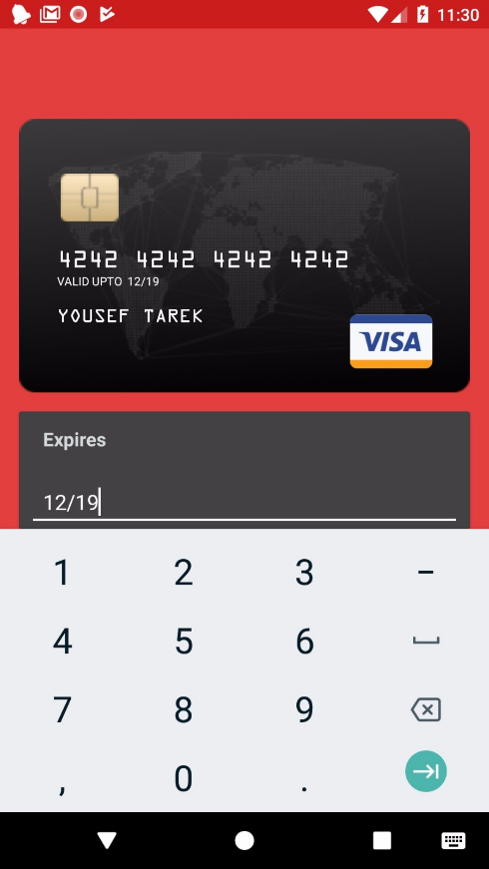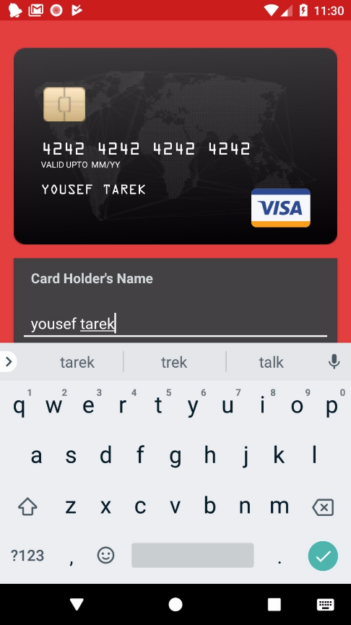

Step 3: The user EnterS CVV/CVC number

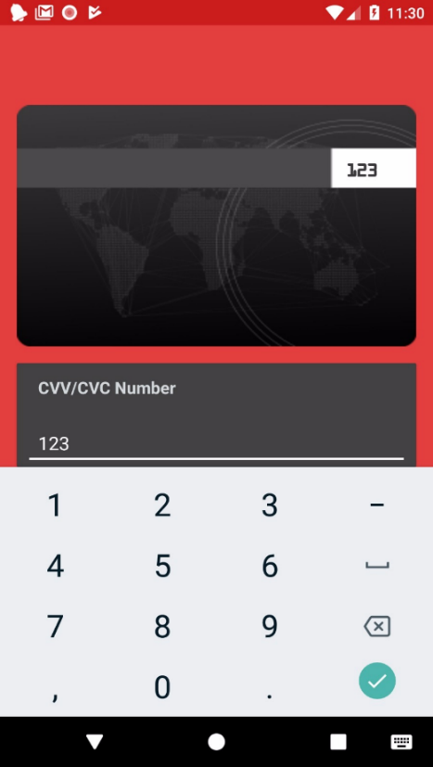

After the user pays , the transaction is regiesterd in mall’s stripe account.

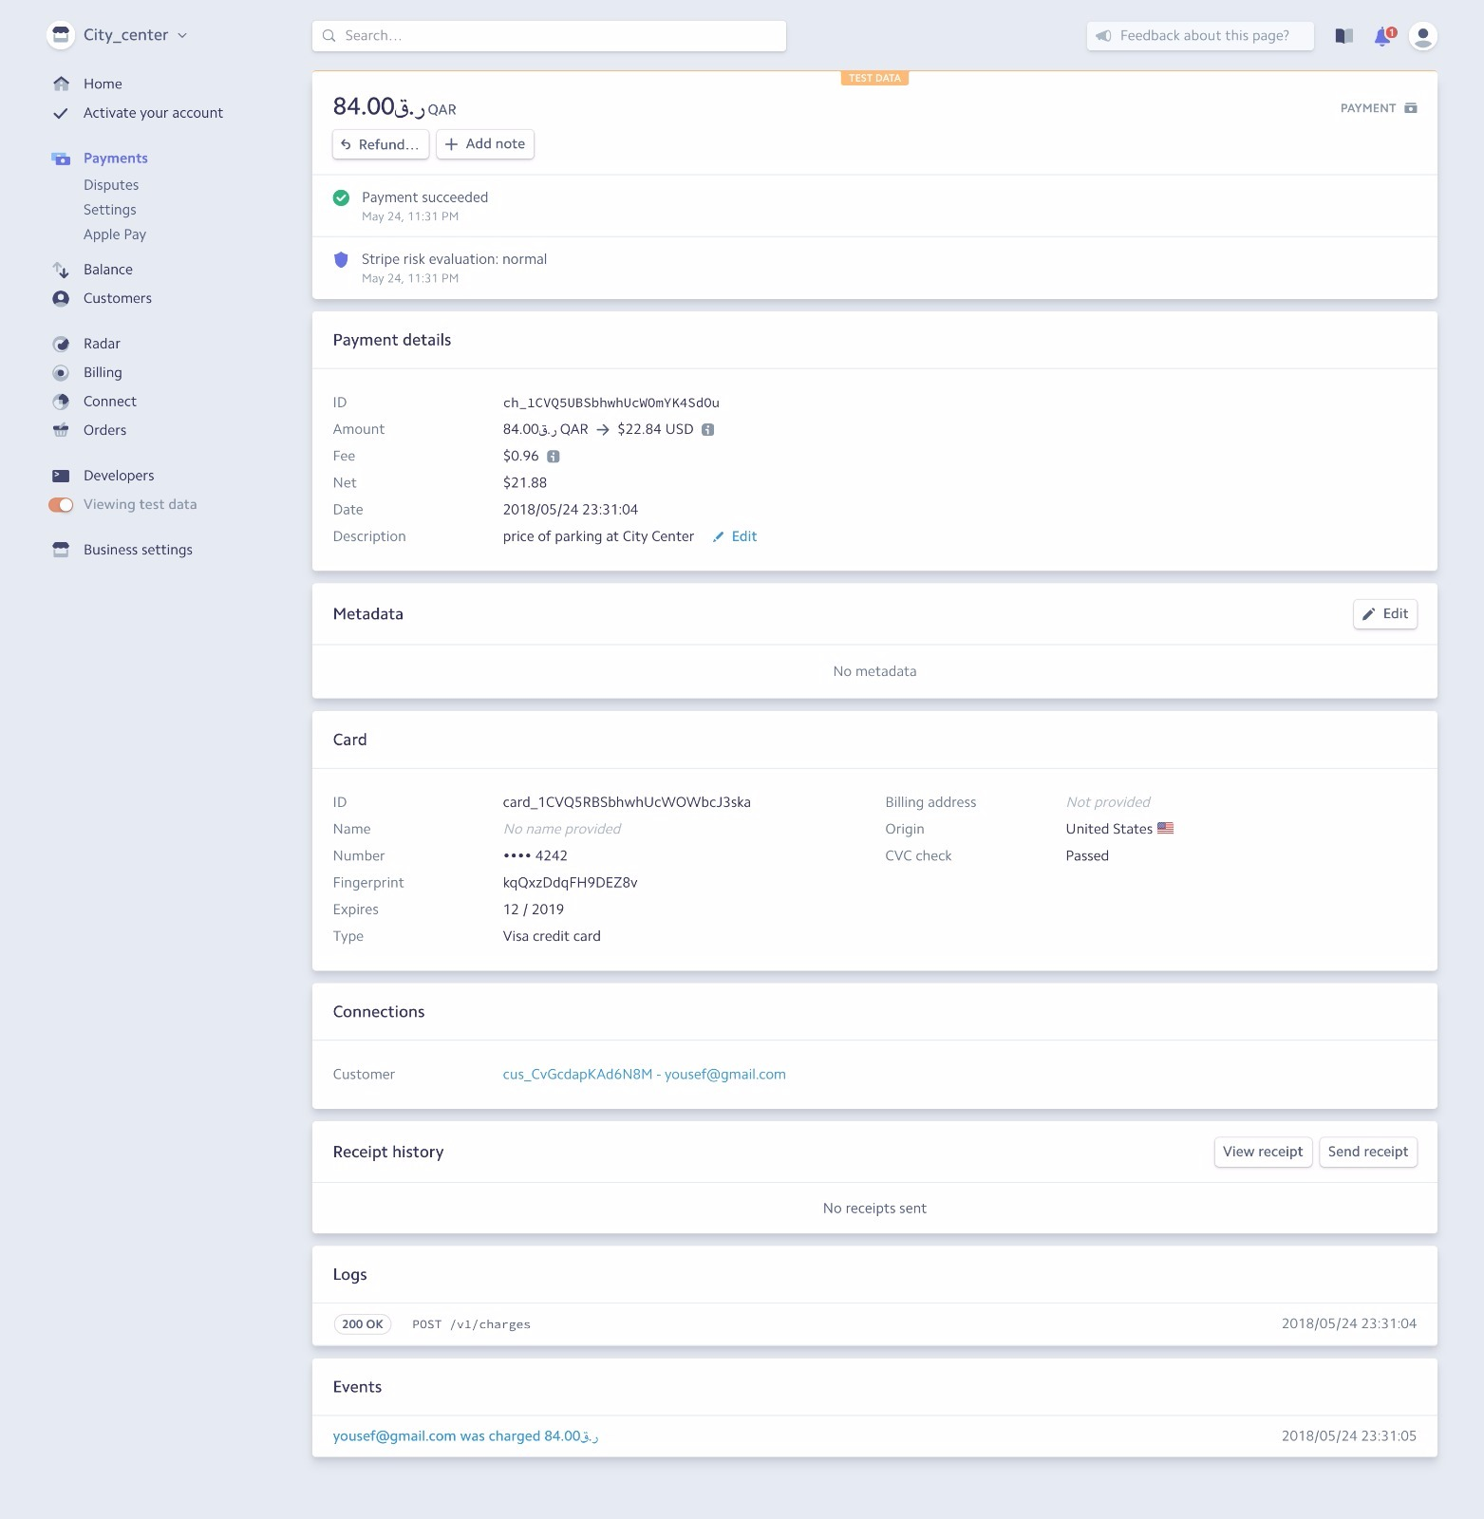

Figure 63: mall’s stripe account

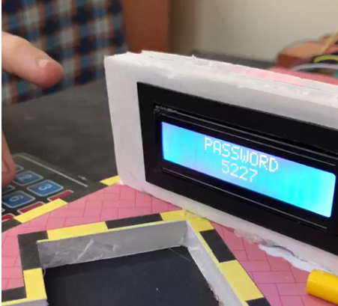After the user has made his payment , he recives his exit pin code as seen in the left image and a count down timer starts which shows the user how much he has left to exit the section otherwise , he will have to pay again. User enters his exit pin code on the keypad and same procedure happens as described before.

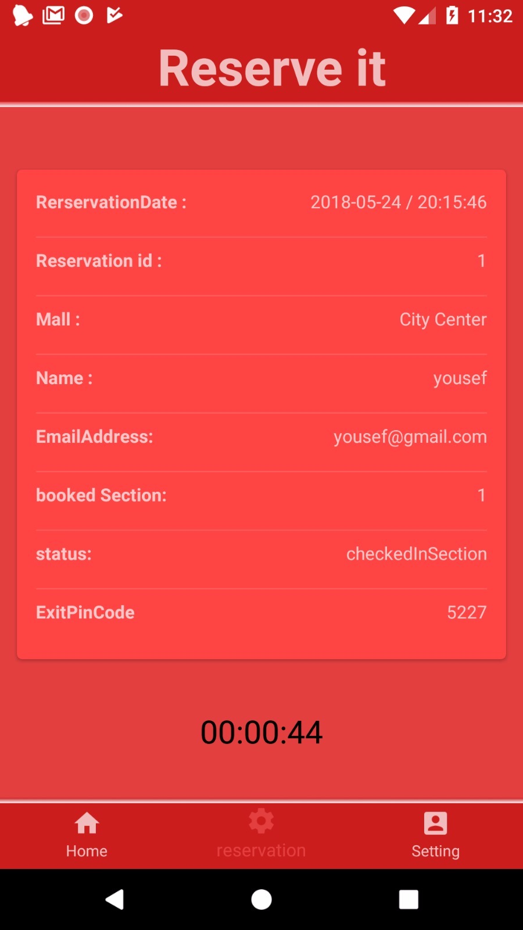

When the user exits the section gate, updates will occur to the mall’s statistics. Number of users in the mall, number of checked in user, occupied parking spaces and expected number of users will reset to zero.

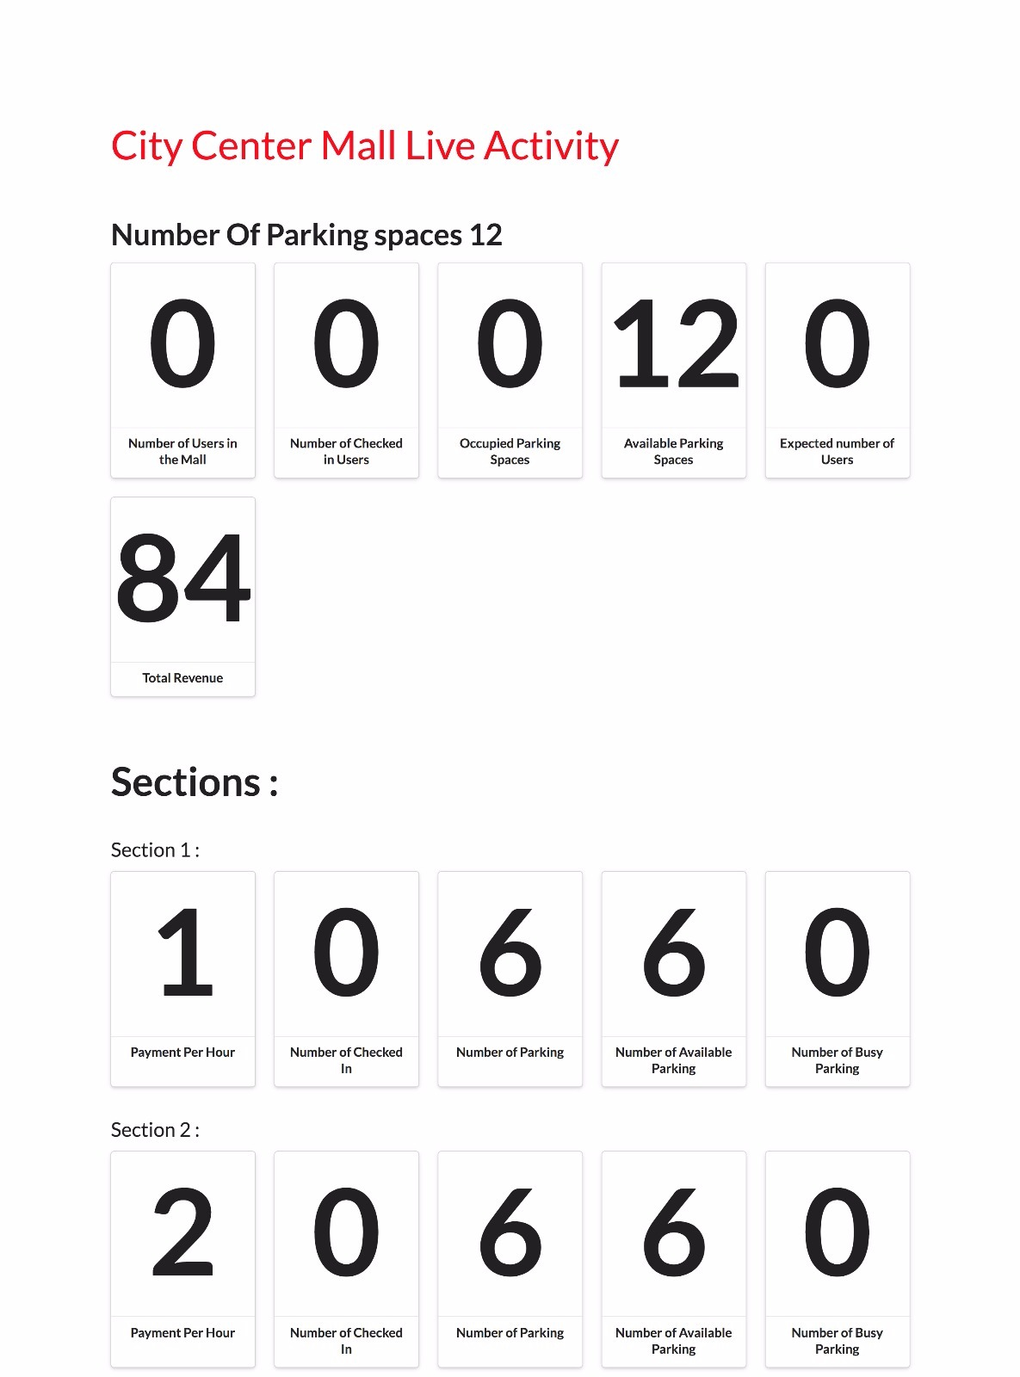

# Evaluation of the impact of the engineered solution

Main features are:

• Low power consumption.

• High quality sensor and long-life RGP LEDS.

• Very clear display and efficient controller.

• Easy to install and maintain.

• Easily designed system to minimize the cost.

we will see whether this project was effective, achieved its goals and the results had any impacts in term of global, economic, environmental and societal impacts. The table below discusses the level of impact for specific contribution through the project.

Table 15 :7. Evaluation of the impact of the engineered solution

|  |  |  |  |
| --- | --- | --- | --- |
|  | Evaluation Context | Specific Contribution through the Project | level of impact (High, Medium, low |
| 1 | Global | The project will benefit the society all over the world as it will help individuals to have a nice parking experience.  And since the system is primarily in English language, then it can be used in the majority of the countries. Arabic version of the Mobile application will be implemented as a future work. | High |
| 2 | Economical | It will save time for users which results in saving money. On the owner side, this project will consume very little power to operate.  Save petrol which mean saving money  The components of the project are low-cost making the whole system affordable by individuals and associations. | medium |
| 3 | Environmental | As the project will reduce parking congestion, it will certainly decrease cars pollution  Section 1or 2  All components used, such as sensors and controllers, have no negative effect on the environment. | low |
| 4 | Societal | This project could spread awareness to people to change their idea about parking through technology. People will tend to use SPRS to make their parking experience more efficient. | medium |

# 8. Project plan

## 8.1. Project milestones

Table 16 Project milestones

|  |  |
| --- | --- |
| Senior II: Implementation and testing of the SMART PARKING RESERVATION SYSTEM | |
| Milestone Number | **Milestone Description** |
| Milestone 2.1 | Design and architecture of the **SPRS**   1. Detailed architecture of the SPRS 2. Preparing hardware components and software. |
| Milestone 2.2 | **Implementation of the parking modules.**   1. **user module.** 2. **Server module.** |
| Milestone 2.3 | **Implementation of the server modules.**   1. **Node JS.** 2. **Mongo DB.** |
| Milestone 2.4 | Implementation of the Android application.   1. Design. 2. Background Java code. |
| Milestone 2.5 | Integrating modules and Testing of the SPRS.   1. Integrating modules together 2. Testing Components with application. 3. Whole system working. |
| Milestone 2.6 | finalizing the final report. |
| *Deliverable: Full operational prototype of the smart parking reservation system and the final report.* | |

## Project timeline

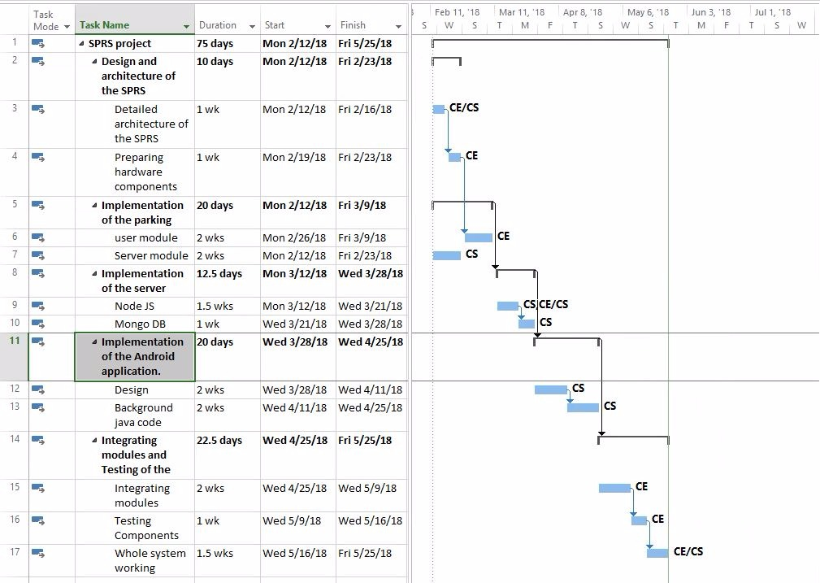

Figure 64 :gantt chart

## 8.3. Anticipated risks

Table 17: Anticipated risks

**Risk Assessment Formula** = P × P × P

P = Probability of Occurrence

And can be assign a numeric value:

Table 18: risk levels

|  |  |
| --- | --- |
| Impact | Value |
| Fatality | 10 |
| Very serious | 7.5 |
| Serious | 5 |
| Important | 1 |
| minor | 0.5 |

P= Preparedness

|  |  |
| --- | --- |
| Impact | Value |
| Continuous | 10 |
| Frequent | 6 |
| Occasional | 3 |
| Unusual | 2 |
| Rare | 1 |
| Very rare | 0.5 |

P= Possible Damage

|  |  |
| --- | --- |
| Impact | Value |
| collapse | 10 |
| Heavy | 7 |
| Moderate | 3 |
| Light | 5 |
| None | 0 |

|  |  |  |  |  |  |  |
| --- | --- | --- | --- | --- | --- | --- |
| **RISK** | **Impact** | | | |  | |
| Very Low | Low | Medium | High | | Very High |
| **0 - 4** | **5 -14** | **15 - 99** | **100 - 499** | | **500- 1000** |

Table 19 : Anticipated risks

|  |  |  |  |
| --- | --- | --- | --- |
| Risk | Description | Minimize the Risk | Risk Assessment Rating |
| Damaging components | Damaging because of Rush or lack of experience | * Order a backup component | 5*2*3 = 30 |
| Unavailable Hardware components | receiving the component late leading to a delay in the project | Ordering the component earlier | 5*0.5*3 = 7.5 |
| Dropping the  Course | One of the team project drops the course Due to illness or any other reason | Creating a Backup plan by dividing the work on the remining students | 7.5*3*10 =225 |
| Choosing the wrong components | The ordered components don’t fit our project requirement or maybe have minimal documentation | * Knowing the feature of each component before ordering * Knowing enough information about all the components | 5*1*3 = 15 |
| Devices overheat | Some components produce excessive heat which may cause damage to the user or the piece | Avoid being in hot places and avoid leaving the components powered on outside development time. | 0.5*2*10= 10 |
| Electric shock | electric shock can burn the circuit. | Avoid leaving component powered outside of development time. | 0.5*2*10= 10 |

# Conclusion

In conclusion, the project’s purpose was to enhance user’s experience when it comes parking in a private facility. The aim of this project was to create a reservation system to users where they can reserve a parking slot before going to the mall so that the user is certain that he has a reserved place just for him and avoid wasting time looking for one. Another aim was to avoid congestion and traffic within a private mall facility by ensuring that every user knows exactly where to go. The team decided to use the most advanced tools and frame works like node js , react j and using a no sql database such mongo dB.

We believe that our main objective was met in this project which is making the whole experience of parking in a private facility much easier than usual. Although we have so much to improve in our project and many future works to done, for example, we need to enhance our application interface, build more functionalities to mall’s system. To conclude, we have learned a lot from this project and it was an unforgettable experience to work in such project.

1. **Future work**

This project shows only a simulation of what would be a parking reservation system will look like and it clearly shows the full process in small scale and that is because of the limited necessary components and availability of resources needed to make a full-scale project possible. In future work, we hope that we can implement the project in full scale, so it would be possible to be used by people. Other than that, there are some features to be added to the design that will increase its functionalities such as:

1. Adding plate number verification that will placed instead of the keypad that will make the user verification more easily.
2. Make a whole section for handicaps and people with special needs that will be a slightly different than the normal design and satisfies handicaps needs.
3. Adding map in the mobile application to direct the user in the specific section he chooses.
4. Add a VIP sections that will allow the users to reserve a specific parking in the vip section.
5. Enhancing the overall user interface: we would like to try to improve the applications UI design so that the user has a better experience using our application.
6. Developing a desktop system for users who arrive to the mall that do not use the application so that they can choose their parking using a screen which is running the system.
7. Developing an admin interface where they can do some functionalities such as adding a mall to the system.
8. Adding malls is done manually at the moment using json files, we would like to add a functionality where admins can add new malls using the admin’s website.
9. Another problem we had was that we had to manually define the pixels area for each section in the sections image so that the user can click on the desired section on the image and then he is able to reserve in that section. Eventually we could find a way where this could be done automatically.
10. The mall’s interface was added at the last few days of the project since it was not planned, we have to work on the mall’s website and add more functionalities to it.

# Student reflections

## 9.1. Yousef’s reflection

During this year, I learned many astonishing things regarding android and web development. Working with android development, node js and react js was a special experience that will surely help me in my future. Working with team mates that I have never worked with before was nothing but a great opportunity which prepares me for what may occur in my future soon after I graduate. Furthermore, the senior project had taught me how to work under great amount of pressure and It taught me how to learn new things as quickly as possible in order to meet deadlines. Moreover, I had gained a great amount of knowledge about hardware which I have never came across during my university years. Finally, the hardest part I found in the senior project was how the tasks was divided between the teams and how we managed to combine our work and make everything work.

To conclude, the senior project was a pretty tough experience, but it surely taught many helpful things in life and finally I would like to thank everyone who participated in this project.

## 9.2. Abdelaziz’s reflection

During my senior project journey, I have learned a lot of things in many aspects of academic life. Communication skills between me and other group members who are involved to my project has been raised due to frequently communicating with each other. Another lesson learned from my supervisor Dr. Osama Shata, is the professional way of writing, reading, and emailing as well. The new skills I have gained this semester is the mobile app designing while dealing with the layout, components and attributes. One more experience that I had is dealing with Visual Paradigm and how to design solving problem through the diagrams that we had in senior project such as class diagram, Sequence Diagrams, State diagrams and Activity diagrams and how they make life easier to make the developer understand how the system going on. New technical skills I had added during this year, is handling large projects and being able to organize, and divide the tasks between the group members. Working in this project was one of the dreams that came true, I learned from my whole team how to be professional in writing reports, presenting, and exchanging opinions and ideas. Finally, I would like to thank my major mate Yousef Tarek for his hard work and my other team members. Hoping that this experience will be such a great achievement in our life.

## 9.3. Ameer’s reflection

Many things I have learned during this course, I have used about 80% of all my knowledge through my study of computer engineering major. I have learned many other skills such as contribution with CS students and how to manage our skills and combine ideas and thoughts and work as team to create this project. I'm so happy that the project works and I'm happier that our idea could be implemented in real life and benefit society. I was going through many technical challenges and struggles in term of implementation the project, but I never give up and I have come over them by searching through the internet and asking for advices from expert people. The work was so enjoyable and fun, I enjoy everything related to senior project most of it was the senior meeting where we have nice social experiment by discussing ideas and solving problem with the supervisor.

In the end, I'm so thankful that I reach this level and I couldn't do it without my family and my team’s support.

## 9.4. Mostafa’s reflection

The course was interesting and challenging to me, it was interesting to use the knowledge that I have earned to build a real circuit which is based on theories and engineering problems A strategy that really helped me  learn better is to divide the work into small tasks and use a timeline that gives specific dates and the action steps that will take place on those dates   , also I had devolved my experience    dealing with embedded systems node mcu and  Arduino language which is considered a great gain Which opens up so many fields in IOT  beside learning some knowledge about servers and application, some of the shortcomings that I want to avoid in the future study the  components s before start working on them  .

 finally, I want to thank my group mates Yousef Ameer and Abdelaziz. I say a big “thank you” to you for the big effort You are the best group.

# References

**[1]**                P. Sohil, "Automatic car parking system with and without password " 2016. Available:<https://www.slideshare.net/SOHILPATEL20/automatic-car-parking-system-with-and-without-password-report?from_action=save>

**[2]**                J. Prasad, "Smart parking reservation system using SMS " 2016. Available:<https://www.slideshare.net/JithinPrasad1/smart-parking-reservation-system-using-sms-32069257>

**[3]**                 " Parking Monitoring Control System " 2012-13 KSA.  Available:<http://www.pmu.edu.sa/Attachments/Academics/PDF/UDP/COE/Dept/EE/Senior%20Design%20Projects/Final%20Report%20(Parking%20Project).pdf>

**[4]**                "Automatic Car Parking Indicator System ". Available:<https://www.projectsof8051.com/automatic-car-parking-indicator-system/>

**[5]**                "SDLC – Waterfall model". Available: https://www.tutorialspoint.com/sdlc/sdlc_waterfall_model.htm

**[6]**                "Chetna, Priyanka, Jaisica, Shefli, “Smart parking system " 2014. Available:

**https://www.slideshare.net/nightmarechetna/smart-parking-system**

**[7]**                S. Krushna, S. Krishna " Automatic car parking system "2017. Available:

<https://www.slideshare.net/SaikrishnaKanamarlap/automatic-car-parking-system-ppt-71706049>

**[8]**                " Automated Car Parking With Empty Slot Detected “. Available:

<http://nevonprojects.com/automated-car-parking-with-empty-slot-detection/>

**[9]** “Home,” aREST, 01-May-2018. [Online]. Available:

https://arest.io/.

**[10]** “Material Design for Android | Android Developers,” Android Developers. [Online]. Available:https://developer.android.com/guide/topics/ui/look-and-feel/.

**[11]** “Firebase Cloud Messaging | Firebase,” Google. [Online]. Available:https://firebase.google.com/docs/cloud-messaging/.

**[12]** “Stripe: Docs & developer documentation,” Atlas: Software as a Service, as a business. [Online]. Available:

https://stripe.com/docs.

# Appendix

## 1.Use case specification:

|  |  |  |
| --- | --- | --- |
| **Use case Id:** UC**01** | Create account | |
| **Brief Description** | Unregistered users want to register in the system, they enter needed information to successfully create a new account. | |
| **Primary actors** | Unregistered users | |
| **Preconditions:** | | |
| **Post-conditions:**   1. User’s account is added to the system successfully. | | |
| **Main Success Scenario:** | | |
| **Actor Action** | | **System Response** |
| 1. Unregistered user wants to create an account | | 2. Ask the user to enter needed information (name, email, address, phone number) |
| 3. User enters needed information | | 4. Check if all information were entered |
|  | | 5. System checks for the validity of the information (see 5.a) |
|  | | 6. Encrypt user’s password using hash and salt (see. 6.a) |
|  | | 7.Register the user |
| **Alternative flows:**  5.a. Ask user to renter any missing information.  6.a. Ask user to renter any invalid information. | | |
|  |  |  |

|  |  |  |
| --- | --- | --- |
| **Use case Id:** UC**02** | change password | |
| **Brief Description** | User wants to change his current password to a new one. | |
| **Primary actors** | users | |
| **Preconditions:**  1-User is registered | | |
| **Post-conditions:**  **1-**User password is changed successfully | | |
| **Main Success Scenario:** | | |
| **Actor Action** | | **System Response** |
| 1. registered user wants to change his password | | 2.    Ask the user to enter his old password and new password |
| 3. User enters old password and new password | | 4.Retrieve user’s information |
|  | | 5.   Check if current password is correct and new password is valid |
|  | | 6. Set user’s password as the new password entered (see 6.a) |
|  | | 7. Update user’s password. |
|  | | 8.notify user with the changes. |
| **Alternative flows:**  6.a. ask user to enter correct information. | | |
|  |  |  |

|  |  |  |
| --- | --- | --- |
| **Use case Id:** UC**03** | Cancel reservation | |
| **Brief Description** | If the user reserved a parking but does not need it any more, he can cancel his reservation. | |
| **Primary actors** | users | |
| **Preconditions:**  1-      User is registered  2-      User has a reservation | | |
| **Post-conditions:**  **1-**User’s reservation is canceled successfully. | | |
| **Main Success Scenario:** | | |
| **Actor Action** | | **System Response** |
| 1. User wants to cancel his reservation | | 2. Retrieve user’s, user’s reservation, and booked mall’s information. |
|  | | 3. Check if user’s reservation status is “Reserved” |
|  | | 4. Set user’s reservation status to “Cancelled” (see.4. a) |
|  | | 5. add user’s reservation id to user’s reservation history. |
|  | | 6. update user’s number of cancelled reservation |
|  | | 7. check if user cancelled three reservations |
|  | | 8. add ban date to user’s information (see 8.a) |
|  | | 9.ban user and force the user to log out if the user is currently logged in. |
|  | | 10. notify user that he is banned. |
|  | | 11.Set user’s reservation id to empty |
|  | | 12. remove user’s pin code from the booked section’s information |
|  | | 13. remove user’s id from booked mall’s information |
|  | | 14. remove reservation id from booked mall’s information |
|  | | 15. decrement booked mall’s occupied parking spaces by 1 |
|  | | 16. increment booked mall’s available parking spaces by 1 |
|  | | 17. decrement booked mall’s expected number of incoming user’s by 1 |
|  | | 18. update booked section’s number of available parking by 1 |
|  | | 19. decrement booked section’s number of occupied parking by 1 |
|  | | 20. update mall’s data for all users who are currently viewing malls data |
|  | | 21. update sections data for all users who are currently viewing sections data |
|  | | 22. notify user that reservation is cancelled. |
| **Alternative flows:**  4.a. notify the user that he already checked in and cannot cancel reservation.  8.a skip step 8, 9 and 10 | | |
|  |  |  |

|  |  |  |
| --- | --- | --- |
| **Use case Id:** UC**04** | Reserve parking | |
| **Brief Description** | User wants to reserve a parking space in the chosen mall | |
| **Primary actors** | user | |
| **Preconditions:**  1-      User is registered  2- User has chosen a mall  3-  User has chosen a section | | |
| **Post-conditions:**  **1-**   User’s reservation is made successfully.  **2-**   User receives pin code | | |
| **Main Success Scenario:** | | |
| **Actor Action** | | **System Response** |
| 1. user wants to reserve a parking (by choosing a mall and a section) | | 2. Retrieve chosen mall’s information |
|  | | 3. Retrieve user’s information. |
|  | | 4. Check if user’s reservation status is empty (user does not have any current reservation) |
|  | | 5. Check if chosen section has available parking spaces (see 5.a) |
|  | | 6.Create a random 4-digit pin code. (see 6.a) |
|  | | 7.Check if the created 4-digit pin code does not already exist in the chosen section’s pin code list |
|  | | 8.Add user’s 4-digit pin code to section’s pin codes list (see 8.a) |
|  | | 9.update user’s information with his new pin code. |
|  | | 10.increment user’s number of reservations made by 1 |
|  | | 11.get system’s current date |
|  | | 12. set reservation status to “Reserved” |
|  | | 13 Create a new reservation using needed information (mall id, section id, pin code, current date and status) |
|  | | 14. get last reservation id number |
|  | | 15.increment last reservation id number by 1 |
|  | | 16. set new reservation id to user’s reservation |
|  | | 17. add reservation the system. |
|  | | 18. decrement booked mall’s available parking spaces by 1 |
|  | | 19. increment booked mall’s occupied parking spaces by 1 |
|  | | 20. decrement chosen section’s number of available parking by 1 |
|  | | 21. increment chosen section’s number of occupied parking by 1 |
|  | | 22. increment mall’s expected number of incoming user’s by 1 |
|  | | 23. add reservation id to mall’s information |
|  | | 24. add user’s id to mall’s information |
|  | | 25. add reservation id to user’s data |
|  | | 26.update booked mall’s data for all users who are currently viewing malls data |
|  | | 27. update chosen section’s data for all users who are currently viewing section’s data |
|  | | 28. Create a new notification with the generated pin code |
|  | | 29. send notification to the user’s phone. |
|  | | 30. notify user with his pin code |
|  | | 31. after 30 minutes, check if the user did not check in yet |
|  | | 32. create new notification informing the user of how much time is left until the reservation gets cancelled (30 minutes) and user’s pin code and send it to the user (see 32.a) |
|  | | 33. after 50 minutes, check if the user did not check in yet |
|  | | 34. create new notification informing the user of how much time is left until the reservation gets cancelled (10 minutes) and user’s pin code and send it to the user (see 34.a) |
|  | | 35. after 1 hour, check if the user still did not check in. |
|  | | 36. Create notification and send to the user to notify him that the reservation is cancelled and how many cancellations left until getting banned. |
| **Alternative flows:**  5.a. notify the user that he has a reservation and cannot make another one  6.a notify the user that there are no available parking spaces now.  8.a repeat step 6 and 7  32.a ignore step 32  34.a ignore step 34 | | |
|  |  |  |

|  |  |  |
| --- | --- | --- |
| **Use case Id:** UC**05** | View profile | |
| **Brief Description** | User wants to see his account information | |
| **Primary actors** | users | |
| **Preconditions:**  1-User is registered | | |
| **Post-conditions:**  **1-**User’s views his account information successfully. | | |
| **Main Success Scenario:** | | |
| **Actor Action** | | **System Response** |
| 1. user wants to see his profile information | | 2. Retrieve user’s information |
|  | | 3. show user his information such as (name, email, address, number of reservations made and number of cancellation made) |
| **Alternative flows:** | | |
|  |  |  |

|  |  |  |
| --- | --- | --- |
| **Use case Id:** UC**06** | Edit profile | |
| **Brief Description** | User wants to edit some of his information in his profile | |
| **Primary actors** | users | |
| **Preconditions:**  1-      User is registered | | |
| **Post-conditions:**  **1-**User’s information is updated successfully. | | |
| **Main Success Scenario:** | | |
| **Actor Action** | | **System Response** |
| 1. user wants to edit his profile information | | 2. Retrieve user’s information |
|  | | 3. notify user with his previous information |
| 4. user updates new information | | 5.check if new information is valid |
|  | | 6.ask user to confirm (see 6.a) |
| 7.user confirms | | 8.update user’s information (see 8.a) |
|  | | 9. notify user that information has been changed successfully |
| **Alternative flows:**  6.a if information is not valid, ask user to re-enter data  8.a if user did not confirm, do not change his information | | |
|  |  |  |

|  |  |  |
| --- | --- | --- |
| **Use case Id:** UC**07** | View transaction history | |
| **Brief Description** | User wants to view all transactions he made. | |
| **Primary actors** | users | |
| **Preconditions:**  1-      User is registered | | |
| **Post-conditions:**  **1-**User’s transaction history is viewed successfully. | | |
| **Main Success Scenario:** | | |
| **Actor Action** | | **System Response** |
| 1. user wants to view his transaction history information | | 2. Retrieve user’s information |
|  | | 3.Retrieve user’ payments information |
|  | | 4.Only collect payments that are successful |
|  | | 5. return payments to user |
| **Alternative flows:** | | |
|  |  |  |

|  |  |  |
| --- | --- | --- |
| **Use case Id:** UC**08** | Choose section | |
| **Brief Description** | User wants to choose a section in chosen mall | |
| **Primary actors** | users | |
| **Preconditions:**  1-      User is registered  2-      A mall is chosen | | |
| **Post-conditions:**  **1.**    user can reserve in that section | | |
| **Main Success Scenario:** | | |
| **Actor Action** | | **System Response** |
| 1. user chooses a section | | Give the user the option to reserve in that section |
| **Alternative flows:** | | |
|  |  |  |

|  |  |  |
| --- | --- | --- |
| **Use case Id:** UC**09** | Pick a mall | |
| **Brief Description** | User wants to choose a mall from the mall’s list | |
| **Primary actors** | users | |
| **Preconditions:**  1-User is registered | | |
| **Post-conditions:**  1-show sections details for the user | | |
| **Main Success Scenario:** | | |
| **Actor Action** | | **System Response** |
| 1. user choose a mall | | 2. Retrieve mall’s information |
|  | | 3.View mall’s sections information to the user. |
| **Alternative flows:** | | |
|  |  |  |

|  |  |  |
| --- | --- | --- |
| **Use case Id:** UC**10** | Check out | |
| **Brief Description** | User want to pay so that he can check out | |
| **Primary actors** | Users, Stripe | |
| **Preconditions:**  1-      User is registered.  2-      User checked in section.  3- payment is viewed. | | |
| **Post-conditions:**  **1.**   User receives exit pin code | | |
| **Main Success Scenario:** | | |
| **Actor Action** | | **System Response** |
| 1. user wants to check out | | 2- Ask user to insert payment details |
| 3- user enters payment details | |  |
|  | | 4. validate user’s information |
|  | | 5.retreive booked mall’s information (see. 5.a) |
|  | | 6.Ask stripe to check user’s information and create token for the user using mall’s stripe account public key |
| 7- Stripe validates and creates token | |  |
| 8- stripe sends token to system | |  |
|  | | 9.retireve user’s information |
|  | | 10.retreive user’s reservation information |
|  | | 11. retrieve user’s last viewed payment. |
|  | | 12. create new customer for stipe using user’s email and using stripe token |
|  | | 13.charge customer and create payment using information such as price, description, currency |
| 14. stripe validates data | |  |
|  | | 15.Check return value from stripe |
|  | | 16. Create a random 4 digit exit pin code (see 16.a) |
|  | | 17.check if the section already has this exit pin code |
|  | | 18.update mall’s total revenue (see 18.a) |
|  | | 19.add user’s exit pin code to chosen section’s information |
|  | | 20. update payment status to successful |
|  | | 21.update reservation’s payment status to successful |
|  | | 22.update réservations exit pin code |
|  | | 23.create notification informing user with the following information (payment was successful, exit pin code and how much user got charged) |
|  | | 24. send notification to user’s phone |
|  | | 25. notify user with the exit pin code. |
|  | | 26 after five minutes, check if the user exited the section gate |
|  | | 27. remind the user with a notification with his exit code and how much time he has left to exit the gate otherwise user will pay again (see 27.a) |
|  | | 28. after nine minutes, check if the user exited the section gate |
|  | | 29. remind the user with a notification with his exit code and how much time he has left to exit the gate otherwise user will pay again (see 29.a) |
|  | | 30. after 10 minutes, check if the user exited the section gate |
|  | | 31. update reservation’s payment status to empty (see 31.a) |
|  | | 32.update reservation’s exit code to empty |
|  | | 33. remove exit pin code from sections information |
|  | | 34.update reservation’s check in time to current date |
|  | | 35. update reservation information if user is currently on the reservation page |
|  | | 36.Create notification to inform the user that he needs to pay again. |
|  | | 37. send notification to the user. |
| **Alternative flows:**  5.a) ask user to renter correct information.  16.a) notify user that there was no enough balance and end the use case  18.a) repeat step 16 and 17 again  27.a) ignore the 27th step  29.a) ignore the 29th step  31.a) ignore the 31th step and end the use case | | |
|  |  |  |

|  |  |  |
| --- | --- | --- |
| **Use case Id:** UC**011** | View reservation history | |
| **Brief Description** | User wants to view all his previous reservations | |
| **Primary actors** | users | |
| **Preconditions:**  1-      User is registered | | |
| **Post-conditions:**  **1-**User’s reservation history is viewed successfully. | | |
| **Main Success Scenario:** | | |
| **Actor Action** | | **System Response** |
| 1. user wants to view his reservation history information | | 2. Retrieve user’s information |
|  | | 3.Retrieve user’s reservations information |
|  | | 4.collect the reservations that are cancelled or completed (ignore the reservation that is currently taking place) |
|  | | 5. return reservations to the user |
| **Alternative flows:** | | |
|  |  |  |

|  |  |  |
| --- | --- | --- |
| **Use case Id:** UC**012** | View Payment | |
| **Brief Description** | User wants to see how much he needs to pay up to this moment. | |
| **Primary actors** | users | |
| **Preconditions:**   1. User is registered 2. User is checked in section | | |
| **Post-conditions:**  **1-**User’s views his payment successfully | | |
| **Main Success Scenario:** | | |
| **Actor Action** | | **System Response** |
| 1. user wants to view his payment | | 2. Retrieve user’s information |
|  | | 3.Retrieve user’ reservations information |
|  | | 4. Retrieve booked mall’s information |
|  | | 5. Get current date |
|  | | 6.Subtract current date from user’s check in time (get difference in hours) |
|  | | 7. get booked section’s price per hour |
|  | | 8. calculate total price by multiplying number of hours with booked section’s price per hour. |
|  | | 9. Create payment using the following information (user’s id, mall id , entry date, time spent, exit date, section id, reservation id and total price) |
|  | | 10. Check if there is a previous payment that the user has viewed before |
|  | | 11. Remove the previous payment from the data base (see 11.a) |
|  | | 12. add new payment to the data base |
|  | | 13. return payment to the user. |
| **Alternative flows:**  11.a) ignore step 11 | | |
|  |  |  |

|  |  |  |
| --- | --- | --- |
| **Use case Id:** UC**013** | Delete account | |
| **Brief Description** | User want to delete his account. | |
| **Primary actors** | users | |
| **Preconditions:**   1. User is registered | | |
| **Post-conditions:**  **1-**User’s account is deleted successfully | | |
| **Main Success Scenario:** | | |
| **Actor Action** | | **System Response** |
| 1. user wants to delete his account | | 2. Retrieve user’s information |
|  | | 3.check if user has a reservation. |
|  | | 4.Retrieve user’s reservation (see 4.a) |
|  | | 5. Check if user has already checked in the mall (see 5.a) |
|  | | 6. Cancel user’s reservation by calling “cancel reservation” use case |
|  | | 7. Delete user’s information |
|  | | 8. force user to logout |
| **Alternative flows:**  4.a) if user does not have a reservation, go to step 7 and then 8  5.a) if user already checked in the mall, notify him that he cannot delete his account until he checks out of the mall | | |
|  |  |  |
| **Use case Id:** UC**014** | Take me there | |
| **Brief Description** | User want directions to the mall | |
| **Primary actors** | Users, mapping system | |
| **Preconditions:**   1. User is registered 2. User has a reservation | | |
| **Post-conditions:**  **1-**User’s gets directions to mall | | |
| **Main Success Scenario:** | | |
| **Actor Action** | | **System Response** |
| 1. user wants get directions to mall | | 2. Retrieve booked mall’s information |
|  | | 3.retreive mall’s coordinates |
|  | | 4.pass coordinates to mapping system |
| 5.mapping system gives directions | |  |
| **Alternative flows:** | | |
|  |  |  |
| **Use case Id:** UC**015** | Pay later | |
| **Brief Description** | User viewed his payment but decides to pay later | |
| **Primary actors** | Users, | |
| **Preconditions:**   1. User is registered 2. User checked in sections 3. Payment is viewed | | |
| **Post-conditions:**  **1-**User goes back to the reservation page | | |
| **Main Success Scenario:** | | |
| **Actor Action** | | **System Response** |
| 1. user wants to pay later | | 2. Take user back to see his reservation. |
| **Alternative flows:** | | |
|  |  |  |

|  |  |  |
| --- | --- | --- |
| **Use case Id:** UC**016** | Check in main | |
| **Brief Description** | User reaches the main gate and would like to check in | |
| **Primary actors** | Users, (lcd,keypad) module , motor | |
| **Preconditions:**   1. User is registered. 2. User has a reservation. | | |
| **Post-conditions:**   1. User has checked in successfully. 2. User receives notification | | |
| **Main Success Scenario:** | | |
| **Actor Action** | | **System Response** |
| 1. user wants to check in the mall | | 2. Ask user to enter his pin Code |
| 3-User enters pin code using keypad | |  |
| 4-(lcd,keypad) module sends pin code, mall id | |  |
|  | | 5-Retieve booked mall’s information using mall’s id and pin code. |
|  | | 6-Retieve user’s reservation using pin code and make sure that his status is reserved (see 6.a) |
|  | | 7.Retrieve user’s information using his reservation id. |
|  | | 8. send command to motor to open the gate |
| 9. motor opens the gate | |  |
|  | | 10.update user’s reservation status to checked in main gate |
|  | | 11. update user’s reservation check in time to current date |
|  | | 12. update user’s status to checked in main gate |
|  | | 13. increment number of users who check in the mall by 1 |
|  | | 14. check if user is currently viewing his reservation on his phone |
|  | | 15. update reservation info, and remove the “take me there” button (see 15.a) |
|  | | 16. Create notification informing the user that he checked in the main gate |
|  | | 17. send notification to user’s phone |
|  | | 18. return success message to (lcd,keypad) module |
| 19 (lcd,keypad) module updates LCD screen. | |  |
| **Alternative flows:**  **6.a** pin code does not exist in that section, return error message to (lcd,keypad) module (update lcd screen showing error message)  15.a ignore step 15 and move to step 16. | | |
|  |  |  |

|  |  |  |
| --- | --- | --- |
| **Use case Id:** UC**017** | Check in section | |
| **Brief Description** | User reaches the section gate and would like to check in | |
| **Primary actors** | Users, (lcd,keypad) module , motor | |
| **Preconditions:**   1. User is registered. 2. User has a reservation. 3. User checked in main gate | | |
| **Post-conditions:**   1. User checked in section gate successfully 2. User receives notification | | |
| **Main Success Scenario:** | | |
| **Actor Action** | | **System Response** |
| 1. user wants to check in his section | | 2. Ask user to enter his pin Code |
| 3-User enters pin code using keypad | |  |
| 4-(lcd,keypad) module sends pin code, mall id and section id | |  |
|  | | 5- Retrieve booked mall’s information using mall’s id. |
|  | | 6- Retrieve chosen section data |
|  | | 7.retrieve user’s reservation data using pin code, status (checked in main) and section id. |
|  | | 8. retrieve user’s information using reservation’s id (see 8.a) |
|  | | 9. update reservation’s status to checked in section gate |
|  | | 10. update user’s status to checked in section gate |
|  | | 11. remove user’s pin code from section’s data |
|  | | 12. add check in time to reservation by adding current date |
|  | | 13 increment mall’s number of user’s who checked in their section by 1 |
|  | | 14. send command to motor, to open the section’s gate |
| 15.motor opens the gate | |  |
|  | | 16. check if user is currently viewing his reservation on his phone |
|  | | 17. update reservation info, and add “view payment” button (see 17.a) |
|  | | 18. Create notification informing the user that he checked in the section gate |
|  | | 19. send notification to user’s phone |
|  | | 20. return success message to (lcd,keypad) module |
| 21. (lcd,keypad) module updates LCD screen. | |  |
| **Alternative flows:**  **8.a** pin code does not exist in any reservation, return error message to (lcd,keypad) module (update lcd screen showing error message  17.a ignore step 17, and move to step 18 | | |
|  |  |  |
| **Use case Id:** UC**018** | Exit section | |
| **Brief Description** | User exits section successfully | |
| **Primary actors** | Users, (lcd,keypad) module , motor | |
| **Preconditions:**   1. User is registered. 2. User payed successfully | | |
| **Post-conditions:**  . 1- user exits the section successfully  .. 2- User receives notification | | |
| **Main Success Scenario:** | | |
| **Actor Action** | | **System Response** |
| 1. user wants to check out of his section | | 2. Ask user to enter his exit pin Code |
| 3-User enters pin code using keypad | |  |
| 4-, (lcd,keypad) module sends exit pin code, mall id and section id | |  |
|  | | 5- Retrieve booked mall’s information using mall’s id. |
|  | | 6- Retrieve chosen section data |
|  | | 7.Retrieve user’s reservation data using pin code and status (checked in section) and section id. |
|  | | 8. retrieve user’s information using reservation’s id (see 8.a) |
|  | | 10. retrieve user’s payment where it’s status is successful |
|  | | 11. end command to motor, to open the section’s gate |
| 12. motor opens the gate | |  |
|  | | 13.update reservation’s check out time |
|  | | 14-update reservation’s status to “completed” |
|  | | 15. update user’s data: (reservation id, pin code, status) to empty |
|  | | 16.remove exit pin code from section’s data |
|  | | 17.update malls data; (remove user id, reservation id) |
|  | | 18. increment available parking spaces by 1, decrement occupied parking spaces by 1, |
|  | | 19. increment section’s available parking spaces by 1, decrement section’s occupied parking spaces by 1 |
|  | | 20. decrement number of users in mall by 1 |
|  | | 21. decrement number of users who checked in by 1 |
|  | | 22. update Mall’s information for users who are currently viewing mall’s data |
|  | | 23.update section’s information for users who are currently viewing sections data |
|  | | 24. redirect user to main menu if he is currently viewing his reservation |
|  | | 25. Create notification and send it to user’s phone |
|  | | 26. return success message to (lcd,keypad) module |
| 27. (lcd,keypad) module updates LCD screen. | |  |
| **Alternative flows:**  **8.a** pin code does not exist in any reservation, return error message to (lcd,keypad )module ( module updates lcd screen to show error message) | | |

## 2.Test cases.

* Register

|  |
| --- |
| **Test case Id:** Create account 01 |
| **Test Purpose** | To test the creation of the account |
| **Success criteria** | User account is created |
| **Test steps:**   * + 1. Select sign up     2. Enter email and other needed information     3. Click sign up | |
| **Post-conditions:**   1. User is authorized to use the system. 2. User information is added to the database correctly. 3. User is redirected to login page. | |

* Register

|  |
| --- |
| **Test case Id:** Create account 02 |
| **Test Purpose** | To test when the user enters a used email address |
| **Success criteria** | User is notified that they entered a used email address |
| **Test steps:**   * + - 1. Select sign up page       2. Enter a used email address       3. Enter other information correctly       4. Click submit | |
| **Post-conditions:**   1. User is prompted that the email address used is invalid. | |

* Register

|  |
| --- |
| **Test case Id:** Create account 03 |
| **Test Purpose** | To test system when user enters invalid information such as: 10-digit phone number. |
| **Success criteria** | User is prompted to change the email, and show user hints for the required information. |
| **Test steps:**   * + 1. Select sign up     2. Enter an invalid email address     3. Enter a 10-digit phone number     4. a password made out 3 digits     5. retype a different password     6. Enter a 2-letter name     7. Click sign up | |
| **Post-conditions:**   * + - 1. User is prompted that he needs to enter an 8-digit number       2. user needs to enter name with minimum three letters       3. user needs to enter a password between 4 and 10 digits       4. user needs to enter match both passwords       5. user needs to enter a valid email address | |

* Register

|  |
| --- |
| **Test case Id:** Create account 04 |
| **Test Purpose** | To test system when user leaves empty fields |
| **Success criteria** | User is prompted to enter empty fields |
| **Test steps:**   1. Select sign up page   2-Intentionally leave empty fields  3-Click submit | |
| **Post-conditions:**   1. User is prompted to enter fill all information | |

* Edit profile

|  |
| --- |
| * **Test case Id:** Edit profile 01 |
| **Test Purpose** | To test system when the user updates his personal information |
| **Success criteria** | User data is updated |
| **Test steps:**   1. Go to setting page 2. Choose edit profile 3. Change phone number and name 4. Click submit | |
| **Post-conditions:**   1. User data is updated successfully | |

* Edit profile

|  |
| --- |
| * **Test case Id:** Edit profile 02 |
| **Test Purpose** | To test system when the user updates his personal information and enters invalid information |
| **Success criteria** | User is prompted with hints explaining what he needs to enter |
| **Test steps:**   1. Go to setting page 2. Choose edit profile 3. Enter a 10-digit phone number 4. Enter a 2-letter name 5. Click submit | |
| **Post-conditions:**  1-User is prompted that he needs to enter an 8-digit number  2-User needs to enter name with minimum three letters | |

* Reset password

|  |
| --- |
| * **Test case Id:** reset password 01 |
| **Test Purpose** | To test system when the user wants to reset his password |
| **Success criteria** | User password is changed successfully |
| **Test steps:**   1. Go to setting page 2. Go to reset password 3. Enter old password 4. Enter new password 5. Enter repeated new password 6. Click submit | |
| **Post-conditions:**   1. User password is updated in the database 2. User is notified that his password has changed successfully | |

* Reset password

|  |
| --- |
| * **Test case Id:** reset password 02 |
| **Test Purpose** | To test system when the user wants to reset his password but enters invalid information |
| **Success criteria** | User is informed with hints about invalid details |
| **Test steps:**   1. Go to setting page 2. Go to reset password 3. Enter old password 4. Enter invalid new password (3-digit password) 5. Enter different new password 6. Click submit | |
| **Post-conditions:**  1-User is prompted to enter a password between 4 to 10 digits  2-User is prompted that the passwords are different. | |

* Reset password

|  |
| --- |
| * **Test case Id:** reset password 03 |
| **Test Purpose** | To test the system when users leave empty fields |
| **Success criteria** | User is informed to fill all information |
| **Test steps:**   1. Go to setting page 2. Go to reset password 3. Intentionally leave fields empty 4. Click submit | |
| **Post-conditions:**   1. User is promoted to fill all empty fields | |

* Reset password

|  |
| --- |
| * **Test case Id:** reset password 04 |
| **Test Purpose** | To test when user enters incorrect old password |
| **Success criteria** | User is informed that is old password in correct |
| **Test steps:**   1. Go to setting page 2. Go to reset password 3. Enter incorrect old password 4. Enter new password 5. Reenter new password 6. Click submit | |
| **Post-conditions:**   1. User is informed that his old password is incorrect | |

* Delete account

|  |
| --- |
| * **Test case Id:** Delete account 01 |
| **Test Purpose** | To test when user wants to delete his account |
| **Success criteria** | User account is deleted |
| **Test steps:**   1. Go to setting page 2. Go to delete account 3. Confirm deleting account | |
| **Post-conditions:**   1. Database updated 2. User is logged out of the system | |

* Delete account

|  |
| --- |
| * **Test case Id:** Delete account 02 |
| **Test Purpose** | To test when user wants to delete his account while he checked in a mall. |
| **Success criteria** | User cannot delete his account |
| **Test steps:**   1. Go to Main menu 2. Pick mall 3. Pick section 4. Add reservation 5. Check in main gate (post request to the server) 6. Check in section gate (post request to the server) 7. Go to settings 8. Choose delete account 9. Confirm delete account | |
| **Post-conditions:**   1. User is informed that he cannot delete his account until he checks out of the mall. | |

* View profile

|  |
| --- |
| * **Test case Id:** View profile 01 |
| **Test Purpose** | To test when user wants to view his account details |
| **Success criteria** | User cannot delete his account |
| **Test steps:**   1. Go to settings menu 2. Choose view profile | |
| **Post-conditions:**   1. Users information are viewed successfully | |

* View reservation history

|  |
| --- |
| * **Test case Id:** View reservation history 01 |
| **Test Purpose** | To test when user wants to view his reservation history. |
| **Success criteria** | User views his previous reservations |
| **Test steps:**   1. Go to settings menu 2. Choose view profile | |
| **Post-conditions:**   1. Users reservation are viewed successfully | |

Note: Only reservations are cancelled or completed are seen in the reservation history, current reservations are viewed (we have tested both cases), if the user does not have any reservation it will show an empty page.

* View transaction history

|  |
| --- |
| * **Test case Id:** View transaction history 01 |
| **Test Purpose** | To test when user wants to view his transaction history |
| **Success criteria** | User views his previous transactions |
| **Test steps:**   1. Go to settings menu 2. Choose view profile | |
| **Post-conditions:**   1. Users transaction are viewed successfully | |

Note: if the user does not have any previous transactions, an empty page will be viewed.

* Take me there

|  |
| --- |
| * **Test case Id:** Take me there 01 |
| **Test Purpose** | To test when user wants directions to the mall |
| **Success criteria** | User gets directions to the mall |
| **Test steps:**   1. Add reservation as shown in the reserve parking test case 2. Go to reservation page 3. Click on “take me there” button | |
| **Post-conditions:**   1. Google maps are launched showing direction to the user. | |

* Pick mall

|  |
| --- |
| * **Test case Id:** Pick mall 01 |
| **Test Purpose** | To test when user wants to view mall’s information |
| **Success criteria** | User sees all sections information in that mall |
| **Test steps:**   1. Go to main menu 2. Click on chosen mall | |
| **Post-conditions:**   1. Sections information are viewed successfully | |

* Choose section

|  |
| --- |
| * **Test case Id:** Choose section 01 |
| **Test Purpose** | To test when user want to choose to a section |
| **Success criteria** | User has the option to reserve in that section |
| **Test steps:**   1. Do steps in “Pick mall 01” test case. 2. Click on section on the image displayed. | |
| **Post-conditions:**   1. User has the option to reserve in that section. | |

* View payment

|  |
| --- |
| * **Test case Id:** View payment   01 |
| **Test Purpose** | To test when user wants to view his payment. |
| **Success criteria** | User views his payment successfully |
| **Test steps:**   1. Do steps in “check in section 01” test case 2. Click on view payment | |
| **Post-conditions:**   1. Payment information are viewed to the user successfully 2. Check out button is added. | |

* Pay later

|  |
| --- |
| * **Test case Id:** Pay later 01 |
| **Test Purpose** | To test when user wants to pay late |
| **Success criteria** | User is redirected to reservation page |
| **Test steps:**   1. Do steps in “View payment 01” test case 2. Click on pay later | |
| **Post-conditions:**   1. User is redirected to the reservation page | |

* Reserve parking

|  |
| --- |
| * **Test case Id:** Reserve parking 01 |
| **Test Purpose** | To test when users reserve a parking |
| **Success criteria** | User receives pin code and has the option to go to his reservation page or main menu page |
| **Test steps:**   1. Do steps in “choose section 01” test case 2. Click on reserve parking | |
| **Post-conditions:**   1. database is updated 2. user receives notification 3. user receives pin code 4. user has the option to go to main page or reservation page | |

* Reserve parking

|  |
| --- |
| * **Test case Id:** Reserve parking 02 |
| **Test Purpose** | To test when users make a reservation while they currently have one |
| **Success criteria** | Users are informed that they cannot reserve since they already have a reservation. |
| **Test steps:**   1. Do steps in “Reserve parking “test case twice | |
| **Post-conditions:**   1. User is informed that he has made a reservation already. | |

* Reserve parking

|  |
| --- |
| * **Test case Id:** Reserve parking 03 |
| **Test Purpose** | To test when users make a reservation while the section is currently full. |
| **Success criteria** | Users are informed that they cannot reserve because the section is full. |
| **Test steps:**   1. Do steps in “Reserve parking 01” test case, repeat it six times booking in section one 2. Repeat the test case one more time | |
| **Post-conditions:**   1. Users are notified that they are currently no available parking spaces in that section. | |

* Cancel reservation

|  |
| --- |
| * **Test case Id:** Cancel reservation 01 |
| **Test Purpose** | To test when users make a reservation and then decides to cancel his reservation |
| **Success criteria** | Users are redirected to the main page. |
| **Test steps:**   1. Do steps in “reserve parking 01” test case 2. Go to reservation page 3. Click on cancel reservation | |
| **Post-conditions:**   1. User is redirect to the main menu 2. Mall’s data is updated 3. Reservation’s data is updated 4. User’s data is updated. | |
| **Changes made to test: 02/03**  for “cancel reservation 02” we repeated the steps in “reserve parking 01” test case three times and the user was notified and logged out of the system.  (reservation’s data was updated; mall’s data was updated and user’s data was updated)  for “cancel reservation 03” test case, we used another two phones (one phone viewing sections data and one viewing malls data) both data fields were updated once main user cancelled his reservation. | |

* Check out

|  |
| --- |
| * **Test case Id:** Check out 01 |
| **Test Purpose** | To test when the users wants to check out |
| **Success criteria** | User receives exit pin code and redirected to reservation page and user can see the countdown timer. |
| **Test steps:**   1. Do steps in “view payment 01” test case 2. Click on check out 3. Enter account number 4. Enter name on card 5. Enter expiry date 6. Enter CCV number 7. Click “submit” | |
| **Post-conditions:**   1. User is redirect to reservation page where he can see a countdown timer showing him how much time he has left to exit the section gate. 2. Data base is updated. 3. User receives notification 4. User receives exit pin code 5. Payment added to mall’s stripe account successfully | |
| **Changes made to test: 02/03/04/05**  -for “check out 05” test case, we just waited until both notifications were received by the phone  -for “check out 04” test case, we just waited the countdown timer finished, the user was redirected to the reservation page, view payment button appeared again and user received a notification  -for “check out 02” test case, we repeated the steps but intentionally entered invalid information, the user was informed that the information entered was incorrect.  for “check out 03” test case, we repeated the steps but intentionally left some of the data fields empty, the user was informed that all information is required. | |

* Check in main

|  |
| --- |
| * **Test case Id:** Check in main 01 |
| **Test Purpose** | To test when users want to check in the main gate of a mall |
| **Success criteria** | Users receive a notification and reservation page is refreshed |
| **Test steps:**   1. Do steps in “reserve parking 01” test case 2. Go to reservation page 3. Send post request to server with (mall id, pin code) to main gate link | |
| **Post-conditions:**   1. User receives notification 2. User reservation page is refreshed 3. Database updates 4. “Take me there” button is removed. | |
| **Changes made to test: 02/03**  -for “check in main 02” test case, we repeat steps above but send an invalid pin code, user is notified that this pin code does not exist.  -for “check in main 03” test case, we made two accounts, for the first account we made the steps above and user checked in successfully, for the second account, we made the steps above but we send the post request using the first pin code of the first account that has been already used, the user got notified that he is not authorized to enter the main gate.  -Further testing for this section:  1- we made accounts that had checked out and currently have exit pin code, we used that pin code on the main gate and users were not authorized to enter. | |

* Check in section

|  |
| --- |
| * **Test case Id:** Check in section 01 |
| **Test Purpose** | To test when users want to check in their section gate |
| **Success criteria** | Users receive a notification and reservation page is refreshed |
| **Test steps:**   1. Do steps in “check in main 01” test case 2. Send post request to with (pin code, section id, mall id) | |
| **Post-conditions:**   1. User receives notification 2. User reservation page is refreshed 3. Database updates 4. “View payment” button is added. | |
| **Changes made to test: 02/03/04/05**  -for “check in section 02” test case, we repeat steps above but send an invalid pin code, user is notified that this pin code does not exist.  -for “check in section 03” test case, we made two accounts, for the first account we made the steps above and user checked in successfully, for the second account, we made the steps above but we send the post request using the first pin code of the first account that has been already used, the user got notified that he is not authorized to exit the section gate.  for “check in section 04” test case, we added a reservation to a user and we sent a post request with his pin code to the section gate, user was notified that he is not authorized to enter this section until he checks in the main gate.  - for “check in section 05” test case, we made accounts that had checked out and currently have exit pin code, we used their pin codes on the section gate and users were not authorized to enter. | |

* Exit section

|  |
| --- |
| * **Test case Id:** Exit section 01 |
| **Test Purpose** | To test when users want to check out of their section gate |
| **Success criteria** | Users receive a notification and user is redirected to main menu. |
| **Test steps:**   1. Do steps in “check out 01” test case 2. Send post request to with (exit pin code, section id and mall id) | |
| **Post-conditions:**   1. User receives notification. 2. Database updates. 3. User is redirected to main menu. | |
| **Changes made to test: 02/03/04/05**  -for “exit section 02” test case, we repeat steps above but send an invalid exit pin code, user is notified that this pin code does not exist.  -for “exit section 03” test case, we made two accounts, for the first account we made the steps above and user checked out successfully, for the second account, we made the steps above but we send the post request using the first exit pin code of the first account that has been already used, the user got notified that he is not authorized to enter the section gate.  for “exit section 04” test case, we used another two phones (one phone viewing sections data and one viewing malls data) both data fields were updated once the post request was sent and the database  - for “exit section 05” test case, we made accounts that had checked out and currently have exit pin code, we used their pin codes on the exit gate and users were not authorized to exit the gate, also we tried to use the user’s entry pin code rather than the exit pin code and the user was informed that he is not allowed exit the section gate. | |